Nanofiltration removal of perfluorohexanoic acid: the role of salts concentration and pH
Álvaro Soriano, Daniel Gorri, Ane Urtiaga
Department of Chemical and Biomolecular Engineering, University of Cantabria. Av. Los Castros 46, Santander 39005, Spain
* Corresponding author: urtiaga@unican.es
Highlights
- The removal of PFHxA from industrial process waters by two NF membranes was studied.
- Excellent PFHxA rejection and intermediate fluxes when treating model PFHxA solutions were observed.
- Presence of salts in the water matrix severely decreased PFHxA rejection.

1. Introduction
Perfluoroalkyl substances (PFASs) are a family of man-made organic compounds classified as persistent organic pollutants due to their recalcitrance in the environment and their high bioaccumulation potential [1]. For these reasons, chemical manufacturers are progressively replacing regulated long-chain PFASs by 6:2 fluorotelomers and shorter-chain perfluoroalkyl homologues such as perfluorohexanoic acid (PFHxA) [2]. On the other hand, PFHxA can also be a 6:2 fluorotelomer alcohol biodegradation product [3]. Thus, increasing production of substitutive compounds is leading to rising concentrations of persistent PFHxA in the environment. Since conventional wastewater treatments are ineffective in PFASs treatment, current research efforts are focused on separation (nanofiltration (NF), reverse osmosis and adsorption) and advanced oxidation technologies. However, most of the studies focus on already phased-out long-chain PFASs at very low concentrations. Treatment of industrial process streams, that constitute the major source of PFASs emissions to the environment, is rarely studied. Hence, this work studies the separation of PFHxA by nanofiltration at industrial emission levels
2. Methods
PFHxA (C5F11COOH) molecular weight is 314.05 g mol⁻¹. Accordingly, two NF commercial membranes, ESNA1-LF and ESNA1-LF2 (Hydranautics), recommended for water softening and pesticides removal were selected. The NF membranes were evaluated in terms of PFHxA rejection and permeate flux, in the pressure range 2.5-20 bar. The flat-sheet membrane coupons were housed in a cross-flow filtration test cell (SEPA-CF, GE Osmonics). The feed solution was maintained at constant temperature (20°C) in a jacketed tank connected to a refrigeration system and the cross-flow velocity was kept at 24.7 cm s⁻¹ using a variable-speed diaphragm pump. Two types of feed samples were prepared: (i) 100 mg L⁻¹ PFHxA aqueous solutions at neutral pH, and (ii) model solutions to emulate the salts content of real process waters with 100 mg L⁻¹ of PFHxA, 36 mg L⁻¹ of NaCl, 575 mg L⁻¹ of CaSO₄, and 98 mg L⁻¹ of NaHCO₃, at pH = 7.84 ± 0.1. PFHxA was quantified using UPLC-MS/MS.

3. Results and discussion
Figure 1 shows the influence of the water matrix on the PFHxA observed rejection (R_{obs}) and the volumetric flux (J). For both membranes, PFHxA rejection was severely affected by the chemistry of the solution while the permeability remained reasonably constant. Whilst very high PFHxA rejection values were obtained when treating pure PFHxA aqueous solutions (ESNA1-LF: 96.1 – 99%; ESNA1-LF2: 95.4 – 97.9%), the presence of salts considerably reduced the rejection performance (ESNA1-LF: 67.2 – 70.4%; ESNA1- LF2: 70.2 – 76.5%). This could be attributed to the high counter-ion concentration in the feed side of the membranes that could induce a shielding effect on the negatively-charged surface of the two NF membranes. Thus, the diminished electrostatic repulsion between the charged NF membranes surface and the perfluorohexanoate anion form of PFHxA in solution at neutral pH, would leave the steric-exclusion role as the dominant separation mechanism.
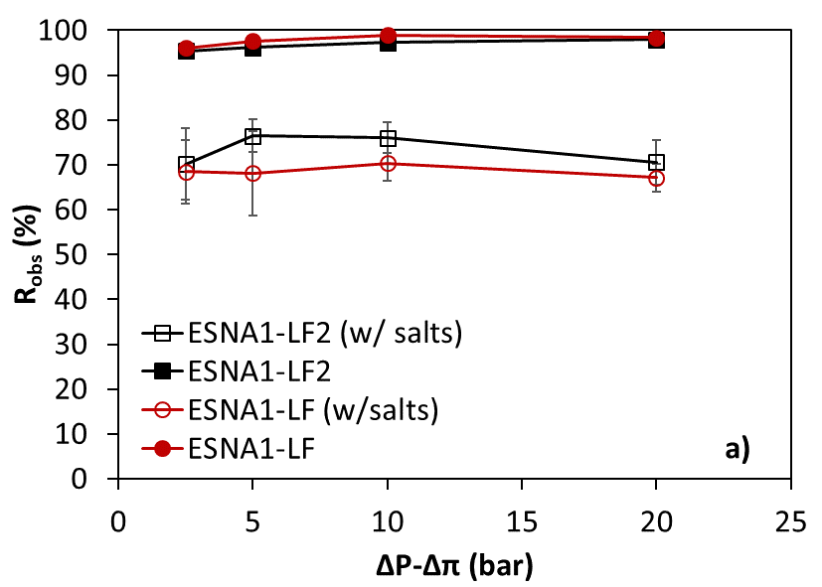 | 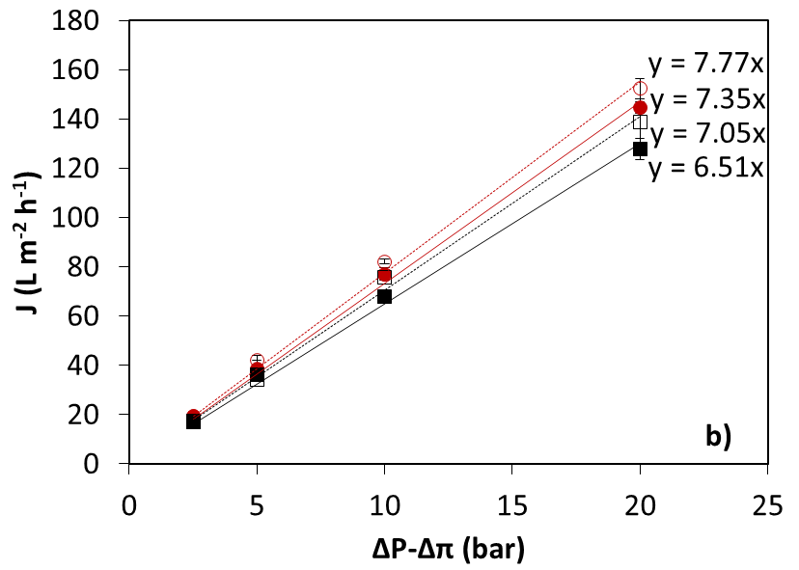
Figure 1. (a): PFHxA observed rejection (R_{obs}) and (b): water flux (J_{v}) versus the effective pressure gradient. 100 mg L⁻¹ of pure PFHxA aqueous solutions and PFHxA synthetic process water feed with salts.
4. Conclusions
Two nanofiltration membranes (ESNA1-LF and ESNA1-LF2, Hydranautics) were tested in the separation of persistent perfluorohexanoic acid (PFHxA) at concentration levels typically found in industrial process waters. Both membranes showed excellent PFHxA rejection performance and intermediate water productivity when treating pure aqueous PFHxA solutions at neutral pH. However, the presence of salts in the water matrix severely decreased PFHXA rejection. These findings point to a drastic change in the electrostatic repulsion mechanism between the dissociated PFHxA and the charged membranes surfaces, negatively influenced by the presence of positive divalent counter-ions. Decontamination of complex water matrixes impacted with PFHxA that are generated in the chemical process industry could need tighter and more selective nanofiltration or reverse osmosis membranes.

Acknowledgments. Funding of project CTM2016-75509-R (MINECO Spain/FEDER) is gratefully acknowledged
References
- Á. Soriano, D. Gorri, A. Urtiaga, Water Res. 112 (2017) 147–156.
- A. Urtiaga, Á. Soriano, J. Carrillo-Abad, Chemosphere 201 (2018) 571–577.
- A. Soriano, D. Gorri, A. Urtiaga, Sep. Purif. Technol. 208, (2019) 160–168.

