Prediction of hesperidin content in orange peel extract using artificial neural network model
Stela Jokić¹, Silvija Šafranko¹, Martina Jakovljević¹, Ana-Marija Cikoš¹, Mate Bilić¹, Maja Molnar¹
¹Josip Juraj Strossmayer University of Osijek, Faculty of Food Technology Osijek, Franje Kuhača 20, 31000 Osijek, Croatia
*Corresponding author: stela.jokic@ptfos.hr
Highlights
- Citrus peel is a by-product, which represent a potential source of valuable components.
- A three layer FFBP-ANN was investigated for hesperidin prediction in orange peel extract.
- The ANN model was found to be a useful tool for hesperidin yield prediction.

1. Introduction
During industrial citrus processing, large quantities of waste material is produced mainly as citrus peels [1]. These food industry by-products represent a potential source of valuable components being important raw materials in the food, chemical and pharmaceutical industries. Hence, the utilization of these citrus residues rich in bioactive and functional components has become a study of interest. In recent years, artificial neural networks (ANNs) are receiving more attention from researchers as an effective predictive tool. It has also been reported that ANN models can be used to predict extraction yields [2]. So in this study, the prediction of hesperidin content as the main bioflavonoid in orange peel extracts was studied by ANN.
2. Methods
In this work, an ultrasound-assisted extraction (UAE) was performed from reused orange peel (after SC-CO₂ extraction) in order to obtain the extracts rich in hesperidin - bioflavonoid with wide range of pharmacological properties. A three-layer feed-forward backpropagation artificial neural network (FFBP-ANN) was proposed to investigate the influence of four operating parameters: extraction temperature (30, 50, 70 °C), time (15, 30, 45 min), ethanol/water ratio (20%, 50%, 80% v/v) and solvent-solid ratio (10, 30 and 50 mL/g) on the extraction yield of hesperidin in UAE extracts. The performance of the developed ANN predictive models was evaluated based on the obtained mean square error (MSE) and coefficient of determination (R²) parameters. The experimental hesperidin yield was determined by reversed-phase high performance liquid chromatography (HPLC) and its content was in the range from 3.3 to 23.0 µg/mg.
3. Results and discussion
Comparing developed models based on the AAD (Average Absolute Deviation), MSE (Mean Square Error), and R² coefficient (Coefficient of determination), the best performing ANN model was determined. These statistical parameters are useful in assessing model performance. The obtained AAD of 5.24 %, R² value of 0.9769 and 0.9837 and minimum MSE of 0.0108 and 0.00796 during training and testing stage indicated that developed 4-5-1 FFBP-ANN model is the best performing model in predicting the hesperidin yield for studied dataset.
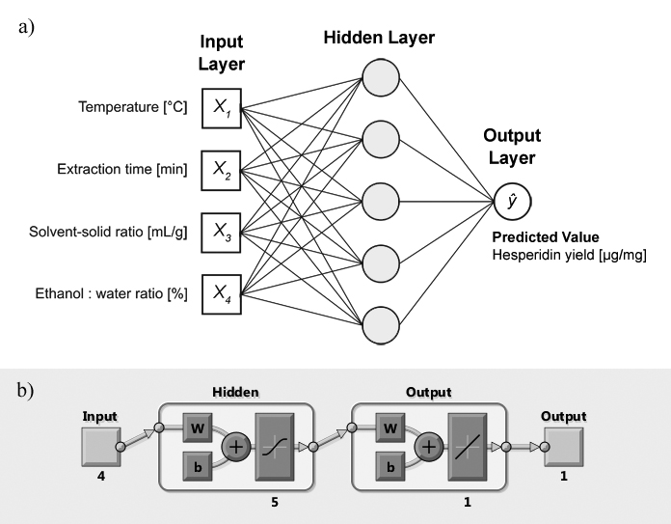
Figure 1. Configuration of the developed ANN [4-5-1], a) schematic representation and b) diagram automatically generated by MATLAB software.
4. Conclusions
Yield prediction of target components is of great importance and the first step for defining the optimal operating conditions, but also necessary for a successful regulation of extraction processes. It is well-known that citrus peel is a rich source of bioactive natural compounds, therefore it is essential to find an appropriate technique for optimization of extraction process. The ANN predictive model was found to be a suitable performing model for extraction hesperidin yield prediction from orange peel extract, as indicated by the statistical analysis.

Acknowledgments
This work has been supported by Croatian Science Foundation under the project “Application of innovative techniques of the extraction of bioactive components from by products of plant origin” (UIP-2017-05-9909)
References
- Y. Shan, Comprehensive Utilization of Citrus by-Products, first ed., Academic Press, London, 2016.
- A. Toboc, V. Lavric, Rev. Chim. 63 (2012) 743-748.

