Non-routine operation management in biorefineries using an operator training simulator with automatic tuning of operating procedures
Joseph Isimite¹, Frank Baganz², Volker, C. Hass^{*1,2}
¹Department of Biochemical Engineering, University College London, Gordon Street, London, WC1H 0AH
²Furtwangen University of Applied Sciences, Jakob-Kienzle-Straße 17, D-78054 Villingen-Schwenningen, Germany
*Corresponding author: volker.hass@hs-furtwangen.de
Highlights
- Process models incorporating start-up, shut-down and normal operations
- Nelder-Mead algorithm for process optimization and SOP tuning
- OTS with capability to automatically re-parameterize SOPs
- Enables operators to take corrective action to quickly recover from upset events

1. Introduction
The increasing complexities in process configurations, starting raw material options, and the variety of product offerings in modern biorefineries present peculiar challenges for operators and plant process automation systems [1]. Existing operator training simulators (OTS) provide a safe simulated environment for developing the skills of operators, amongst other benefits. In this paper, the usefulness of the traditional OTS is extended by incorporating an algorithm that helps operators effectively manage process upsets and changes in feed properties through automatic tuning and adjustment of standard operating procedures (SOPs).
2. Methods
The C++ based modelling tool C-eStIM [2] was used to develop and parameterize process models for feed pre-treatment, fermentation and distillation. A commercial process control and automation software, WinErs [3], was used to integrate all unit operations into a single functioning biorefinery, with accompanying heat exchangers, pumps, and control valves. Biorefinery standard operating procedures (SOPs) were used to create sequential function charts in GRAFCET [4] for biorefinery operations. Furthermore, a parameterizable SOP for automatic adjustment of enzyme loading in response to fluctuations in inlet feed composition was also implemented using GRAFCET. The Nelder-Mead algorithm [5] for the minimization of multi-dimensional functions was developed for process optimization and automatic tuning of SOPs in response to upsets during fermentation and distillation unit operations.
3. Results and discussion
Modelling results for hydrolysis and fermentation were consistent with published data while the distillation model incorporates a cold start-up, normal batch, semi-batch and continuous operations, and unit shutdown. The developed OTS can be used to train biorefinery operators for both normal and non-routine operations. Automatic SOP adjustment shows that hydrolysis enzyme dosage is automatically adjusted in response to fluctuations in solids loading concentration (Figure 1).
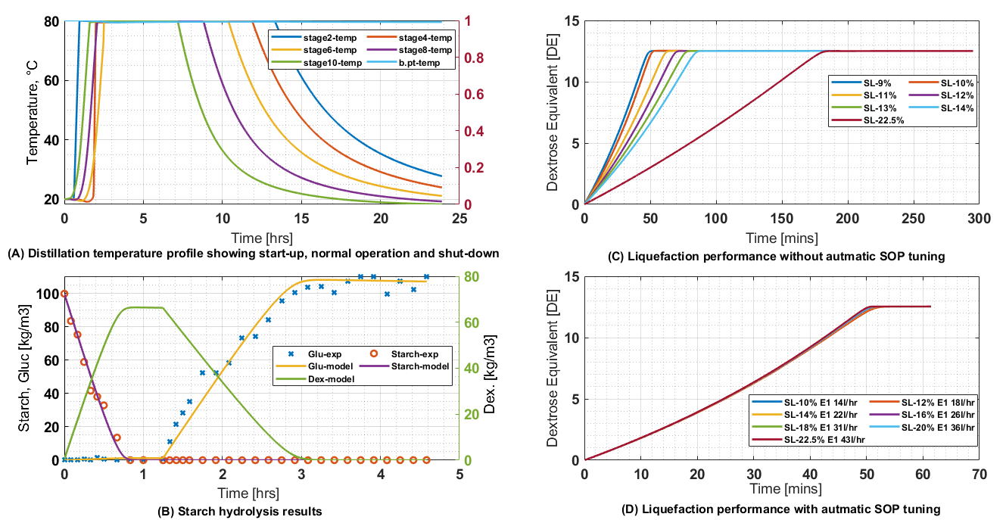
Figure 1. Model results (A & B) and automatic SOP tuning results (C & D)
4. Conclusions
This paper presents the results of the first attempt to incorporate an algorithm for process optimization and automatic tuning of SOPs into an operator training simulator. This extends the usefulness of the traditional OTS beyond operator training to include automatically adjusting production recipe inputs that inform operator corrective action, thereby minimizing material losses and process downtime.
References
[1] Isimite, J.O., Baganz, F. & Volker, C.H. 2018, "Operator training simulators for biorefineries: current position and future directions", Journal of Chemical Technology & Biotechnology, vol. 93, no. doi:10.1002/jctb.5583, pp. 1529-1541.
[2] Hass, VC, Kuhnen, F & Schoop, K-M, 2005, "An environment for the development of operator training systems (OTS) from chemical engineering models", Computer Aided Chemical Engineering, vol. 20, pp. 289-293.
[3] Schoop, K-M, 2008, WinErs: Process control and automation system on PC under Windows. Available: http://www.schoop.de/index.php/en/software/winers [2016, Online, Acc. Jan. 2018].
[4] IEC Working Group 3B/WG14 2002, IEC 60848:2013 - GRAFCET specification language for sequential function charts, 2nd [Available online http://snmaicpc.chez.com/pdf_zip/MAI2/cours/norme%20grafcet.pdf] edn, International Electrotechnical Commission, Sweden.
[5] Nelder, J.A., Mead, R. (1965), A Simplex Method for Function Minimization, The Computer Journal 7 (4):308–313, Available online https://doi.org/10.1093/comjnl/7.4.308

