Price-based coordination of shared resources with external suppliers
Christian Klanke^{1*}, Lukas S. Maxeiner¹, Sebastian Engell¹
1 Process Dynamics and Operations Group, Department of Biochemical- and Chemical Engineering, TU Dortmund University, 44221 Dortmund

*Corresponding author: Christian.klanke@tu-dortmund.de
Highlights
- Ecological and economical savings via coordination of plants at chemical production sites
- Incorporation of access to global commodity markets
- Confidentiality in case of competing enterprises by employing a distributed coordination scheme

- Introduction
Worldwide, chemical production sites are significant consumers of energy and resources and improving their efficiency has been pursued continuously over the past decades. Optimizing plant operations is an economically attractive way of improving their efficiency because the investments are relatively low, and the duration of the projects is not overly long. In large chemical sites, the plants are interconnected by networks of raw and intermediate materials and of carriers of energy, especially steam at different pressure levels. Coordinating the production and consumption of these shared resources provides an impactful lever towards a more efficient production.
While the site-wide optimization of the operation of the interconnected plants is theoretically feasible, practically it is desirable to perform a distributed optimization with some central coordination. One strong argument in favour of such schemes is that information on the internals of the individual plants, e.g. their demands, revenues and profit functions does not have to be shared so that such schemes can also be applied if the plants are operated by different business units. This can be achieved by so-called price-based coordination schemes in which a central coordinator balances the networks by adapting the transfer prices, which enter in the individual cost functions [1].
A limitation that the previously proposed coordination schemes suffer from is that many of the shared resources produced and/or consumed on the site are also available via external suppliers on short notice or can be sold on the spot market.
Such exchanges of materials and carriers of energy are subject of medium- or long-term contractual agreements. What we propose here is a scheme that determines dynamic transfer prices in the context of such agreements without providing the parties involved access to sensitive data, thus improving flexibility and enhancing fairness. This is an essential agreement of the practical implementation of industrial symbiosis.

- Methods
A dual decomposition-based method entitled price-based coordination forms the core approach within this work [2]. Mathematically speaking, it is based on dual decomposition, interpreting the Lagrange multipliers as correct transfer prices of the resources and utilities under consideration [3]. As a result of applying dual decomposition the mass balances that govern the connecting networks are transformed into economical incentives for the individual plants. This way the network balances are satisfied and confidentiality is guaranteed [4].
The scheme uses a gradient-based update step that computes the equilibrium prices in an iterative procedure. At these equilibrium prices, the network balances are satisfied.
- Results and discussion
Based upon an industrial case study, existing price-based coordination schemes have been extended to deal with complex pricing structures that are imposed by suppliers on external commodity markets. The investigated pricing structure covers two resources, where the purchase price of one resource depends on the purchase amount of both resources and vice versa.
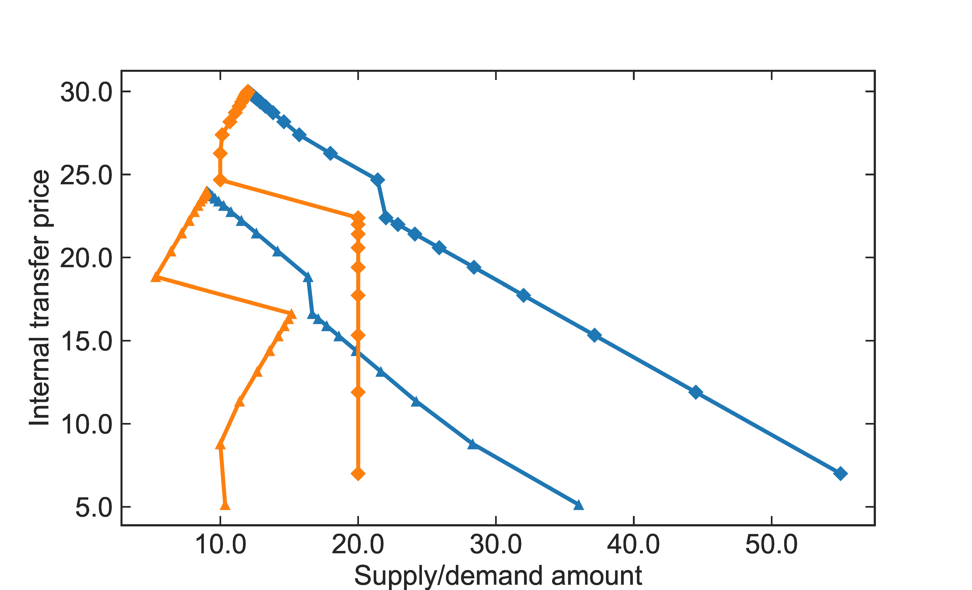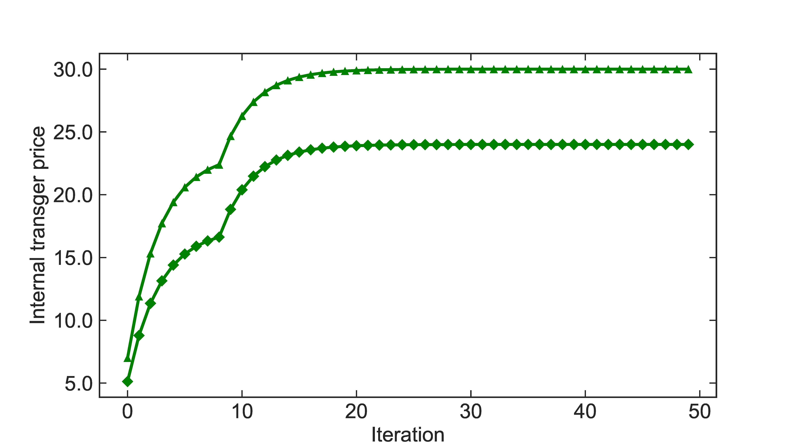Despite of this coupling of the purchase prices, it is possible to derive a distributed coordination algorithm, which finds the optimum of the resulting mixed-integer problem. The algorithm reliably converges to equilibrium prices, as can be seen in Figure 1 right. At the equilibrium price, the supplies and demands of all resources match, as shown in Figure 1 on the left. At the same time, optimal amounts of external purchases of both resources are determined.

Figure 1. Supply (▲/◆) and demand (▲/◆) curves of two resources depending on the internal transfer price (left). Internal transfer price (▲/◆) plotted against iteration number for both resources (right).
4. Conclusions
By characterizing the solution structure of the centralized solutions to the coordination problem taking access to external markets into account, it is possible to find operating conditions and purchases at which the site operates optimally. Future work will include how to distribute the savings between the participating units on the site.

Acknowledgement
The project leading to this publication has received funding from the European Union’s Horizon 2020 research and innovation programme under grant agreement No 723575 (CoPro, spire2030.eu/copro) in the framework of the SPIRE PPP.

References
- S. Wenzel, R. Paulen, G. Stojanovski et al., at – Automatisierungstechnik 64 (2016) 428-442.
- L.S. Maxeiner, S. Wenzel, S. Engell, Computer Aided Chemical Engineering 40 (2017) 1897-1902
- D. Palomar, M. Chiang, IEEE Journal on Selected Areas in Communications 24 (2006) 1439-1451
- R. Jose, L. Ungar, AIChE Journal 46 (2000) 575-587

