The effect of liquid film thickness on the mass transfer of a single catalyst pellet in a scaled down trickle bed reactor
Jonathan White¹, Frans Muller¹, Thomas Chamberlain¹, Richard Bourne¹, Colin Brennan², David Taylor²
1 Institute of Process Research & Development, University of Leeds, Leeds, LS2 9JT, UK; 2 Syngenta, Jeallot’s Hill International Research Centre, Bracknell, Berkshire, RG42 6EY, UK
*Corresponding author: cp15jpw@leeds.ac.uk
Highlights
- Single pellet trickle bed reactor presented
- Liquid film thickness limits hydrogen diffusion to the catalyst
- Model relating mass transfer rate of hydrogen to liquid flow rate developed
1. Introduction
Heterogeneous hydrogenations are an important class of catalytic reactions, used extensively within the fine chemical, agrichemical and pharmaceutical industries [1]. Though these reactions are often performed in batch due to better understanding of the limiting regimes, continuous hydrogenation has the potential to offer increased economic, safety and quality improvements [2]. Trickle bed reactors (TBR) are an attractive option for continuous manufacturing due to simple operation and lower back mixing enhancing selectivity. However, due to the complex relationship that exists between the kinetics and hydrodynamics, these reactors can be challenging to study at laboratory scale [3]. This article presents a method for scaling a TBR down to the scale of a single catalyst pellet to investigate the effects of liquid film thickness during the reduction of styrene.
2. Methods
A single pellet TBR was developed by immobilizing a 1% Pd/C extrudate within a packed bed of glass beads (shown in Figure 1). A reactor column of similar diameter to the length of the extrudate was used to minimize liquid bypassing. Hydrogen gas and a styrene solution in methanol were passed co-currently through the bed and the styrene conversion was monitored via gas chromatography. Liquid flow rates were chosen based on the liquid holdup within the reactor and corresponded to Reynolds numbers between 1 and 5. The gas flow rate remained constant throughout this study. To examine the extent to which diffusion though the liquid film effects the overall mass transfer rate of hydrogen (MTR_{H2}), hydrogenations were conducted with both hydrogen saturated and unsaturated methanol. To visually investigate the film thickness as liquid trickles over the catalyst, a small number of pellets were glued together to form a stack. Liquid was passed over the stack at various flow rates and filmed using an optical microscope to observe changes in the film thickness.
3. Results and discussion
The film thickness and single pellet TBR results are shown in Figure 1. As confirmed by the pellet stack experiment, at increased liquid flow rates the methanol film on the surface of the catalyst becomes thicker. When unsaturated, hydrogen must diffuse through this film and the increase in thickness is thought to give rise to the apparent decease in MTR_{H2}. With liquid presaturation the MTR_{H2} increases almost linearly with increasing liquid flow rate. As diffusion through the film is no longer limiting the reaction, increased turbulence is thought to enhance mass transfer and contribute to the observed increase in MTR_{H2}.
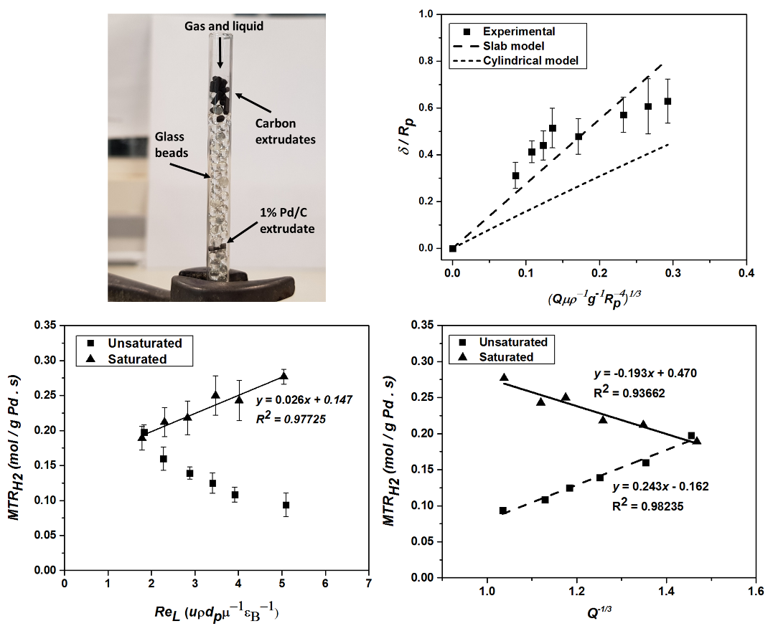
Figure 1. Top left; the single pellet TBR used. Top right; recorded liquid film thickness on the pellet stack at various liquid flow rates. Bottom left; mass transfer rate of hydrogen against different liquid flow rates. Bottom right; correlation between the mass transfer rate of hydrogen and the reciprocal cubic root of liquid flow rate.
The effect of volumetric liquid flow rate on film thickness was modelled and subsequently a relationship between the MTR_{H2} and liquid flow rate was found. This model was shown to fit both the liquid film and single pellet TBR experimental data well.
$${MTR}_{H2 }=\frac{ADC_{H2, l}}{δ} and δ=\sqrt[3]{\frac{3μQ}{ρgS_{A}}} ∴{MTR}_{H2 }∝ \frac{1}{\sqrt[3]{Q}}$$
4. Conclusions
A single pellet trickle bed reactor has been used to investigate the liquid film thickness trickling over a catalyst pellet. Increasing the liquid flow rate results in a thicker film and thus exhibits a greater limiting effect due to the increased diffusion distance. A model was developed to describe the relationship between the overall mass transfer rate and the volumetric liquid flow rate.
References
- A. Faridkhou, J.-N. Tourvieille and F. Larachi, Chem Eng Process, 110 (2016) 80-96.
- J.G.V. Alsten, M.L. Jorgensen and D.J. am Ende, Org. Process Res. Dev., 13 (2009) 629-633.
- F.S. Mederos, J. Ancheyta and J. Chen, Appl. Catal., A., 355 (2009) 1-19.

