Towards Sustainable Marine Biorefineries: Macroalgae Continuous Fractionation with Pulsed Electric Fields and Mechanical Press.
Alexander Golberg, Klimentiy Levkov
Porter School of Environment and Earth Sciences Tel Aviv University, Tel Aviv, Israel.
*Corresponding author: agolberg@tauex.tau.ac.il
Highlights
- Pulsed electric field generator with gravitation press electrodes was developed
- PEF parameters 4kV, 1kAmp, 1-100µs duration and total power dissipation of 20W
- Macroalgae Ulva sp. was electroporated with ~2kV/cm, 12µs duration 200A.

1. Introduction
Of the major technological challenges for bioeconomy is biomass fractionation, or biorefining: similar to oil or gas cracking or refining. An important step in those biomass fractionation processes is the breakdown of cell membranes. This breakdown allows for efficient separation of water from organic material (drying) and also it enables to extract for various uses intercellular components such as proteins, amino acids, lipids, carotenoids and other molecules each of which already has significant market values. One type of these technologies is based on the use of high voltage, short pulsed electric fields (PEF) [1]. However, unique physical characteristics of each species of plant biomass, the dynamics and nature of their changes in the process of electroporation require case by case adaptation of PEF parameters such as applied voltage, number of pulses, pulse duration, frequency and temperature for successful and energy efficiency biomass fractionation. The goal of this work was to develop a laboratory device with adaptive electrical and mechanical components to allow electroporation of the marine macroalgae biomass, an emerging feedstock for biorefinery. Indeed, macroalgae fractionation with pulsed electric fields, once available, could lead to non-thermal, chemical-free extraction of valuable phytochemicals from cells such as proteins, amino acids and carbohydrates [2]. In this work, we report on the development of a laboratory PEF system with asymmetric voltage multiplying and gravitation-press electrode device that enables electroporation of a highly conductive marine macroalgae, a promising but challenging feedstock for the biorefinery.
2. Methods
2.1 Macroalgae Ulva sp. Biomass. Ulva sp.was grown under controlled conditions in using 40 L macroalgae photobioreactors (MPBR) incorporated in a building’s south wall under daylight conditions. Nutrients were supplied by adding ammonium nitrate (NH₄NO₃) and phosphoric acid (H₃PO₄), (Haifa Chemicals Ltd, IS) to maintain 6.4 g m⁻³ of total nitrogen and 0.97 g m⁻³ of total phosphorus in the seawater. The sole CO₂ source was bubbled air.
2.2 Ulva sp. biomass electroporation. Ulva sp. biomass was harvested and centrifuged in the manual kitchen centrifuge to remove the surface water 3 times for 2 min. The biomass was loaded in the electroporation cell, pressurized with the moving the electrodes and exposed to the external constant electric field from generated by the applied voltage of 600 – 4000 Volt and the 1 – 20 mm gaps between the electrodes. The voltage drop was measured at the electroporation cell and at the resistor connected in series with a known resistance (5Ohm). Voltages and currents were measured with a PicoScope 4224 Oscilloscope with a Pico Current Clamp (60A AC/DC) and analyzed with Pico Scope 6 software (Pico technologies Inc., UK). Extracted juice was collected at the bottom of the device. The experiment was repeated three times.
3. Results and discussion
The developed system, allows applying for up to 4kV, 1kAmp pulses with 1-100µs and total power dissipation of 20W and up to 10kg of mechanical load. The system has two novel elements: asymmetric voltage charger for energy consumption minimization (Fig. 1a) and gravitation-driven press electrode device for continuous fractionation (Fig. 1b). The developed device uses a charge source, which consists of a step-up transformer of 220/2000 Volts, a voltage doubler, and an ESC voltage regulating unit. The developed device uses an asymmetric voltage doubling circuit (Fig. 1a), which consists of two high-voltage diodes and two capacitors allowing to control the applied voltage at each pulse. This is a new feature, we did not found in the literature. The first is a charging capacitor that, in addition to the voltage doubling function, performs the function of current limitation when the ESC is charged. The second capacitor is the ESC. Images of the voltage and current pulses as recorded applying 2kV (field ~2kV/cm), 12µs duration 200A on 10 g of wet macroalgae are shown in Fig. 1c. This is in the range of electric field requirement shown in our previous work to extract proteins from this biomass [3].
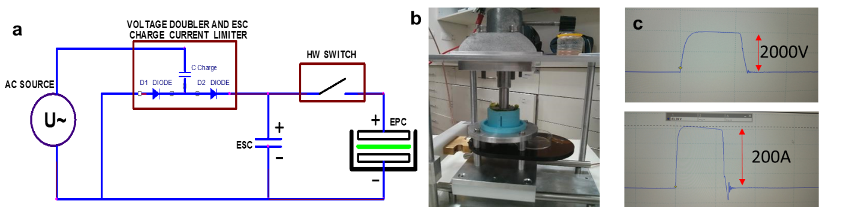
Fig. 1. a. Principle components of the develop laboratory biomass electroporation device. b. The gravitational press-electrode device with loaded biomass. c. Voltage (top image) and current (bottom image) of Ulva biomass exposed to pulsed electric fields of 2kV
4. Conclusions
Macroalgae biomass is the most challenging feedstock for PEF application in industry because of high salinity which leads to very low resistance of the biomass and very high currents in the system at fields that lead to cell membrane permeabilisation. In this work we developed the device which enables the control over the applied voltage at each pulse, reducing the energy consumption of the electroporation-driven biomass fractionation.
References
[1] A. Golberg, M. Sack, J. Teissie, G. Pataro, U. Pliquett, G. Saulis, T. Stefan, D. Miklavcic, E. Vorobiev, W. Frey, S. Töpfl, D. Miklavcic, E. Vorobiev, W. Frey, Energy Efficient Biomass Processing with Pulsed Electric Fields for Bioeconomy and Sustainable Development., Biotechnol. Biofuels. 9 (2016) 1. doi:10.1186/s13068-016-0508-z.
[2] A. Robin, A. Golberg, Pulsed Electric Fields and Electroporation Technologies in Marine Macroalgae Biorefineries, (2016) 1–16. doi:10.1007/978-3-319-26779-1_218-1.
[3] M. Polikovsky, F. Fernand, M. Sack, W. Frey, G. Müller, A. Golberg, Towards marine biorefineries: Selective proteins extractions from marine macroalgae Ulva with pulsed electric fields, Innov. Food Sci. Emerg. Technol. (2016). doi:10.1016/j.ifset.2016.03.013.

