DFT, microkinetic and experimental study of lignin model compound hydrotreatment over noble metals on C
Miha Grilc¹, Ana Bjelić¹, Matej Huš¹, Blaž Likozar¹
1 Department of Catalysis and Chemical Reaction Engineering, National Institute of Chemistry, Hajdrihova 19, 1000 Ljubljana, Slovenia
*Corresponding author: Miha.Grilc@ki.si
Highlights
- Experimental and ab-initio study of eugenol HDO over Pt, Pd, Rh, Ru on C.
- Micro-kinetics modelling of adsorption, desorption, bulk and surface reactions.
- The lowest hydrogenation/deoxygenation ratio found for Ru/C, the highest for Pd/C.
- Ru closest to the top of the volcano dependency: TOF vs. eugenol adsorption energy

1. Introduction

The present study represents an integrated theoretical and experimental assessment of the catalytic hydrotreatment of eugenol, a representative lignin monomer model compound, over the Ru/C catalyst. A micro-kinetic model has been developed to describe experimental observations at more fundamental level accompanied by DFT calculations.

2. Methods
Experiments have been performed in a cylindrical stainless steel slurry reactor (Autoclave Engineers) in a completely batch regime. A typical experiment was performed with 5 wt% (4.5 g) of eugenol, 0.2 wt% (0.2 g) of the Ru, Pd, Pt, Rh on C and 94.8 wt% (85.3 g) of the solvent (hexadecane) at 275 °Ca and 5 MPa of initial hydrogen pressure under vigorous mixing of 1000 min^{–1}. Reactions proceeded for 3 h at the final temperature (heating up period 30 – 45 min). During the experiment, sampling of the liquid and gas phase took place. Liquid samples were analyzed by using a gas chromatograph with flame ionization detector (GC–FID) coupled with a mass spectrometer detector (GC–MS), while gas samples were analyzed by using gas chromatography (GC) and Fourier Transform Infrared (FTIR) Spectroscopy.
Based on a reaction pathway network, proposed according to the experimentally-determined intermediates and DFT study, a microkinetic model of hydrotreatment in a three-phase slurry reactor has been developed, that includes the influence of i) thermodynamics, ii) hydrodynamics, iii) mass transfer (gas – liquid, liquid – solid surface), iv) adsorption and desorption kinetics, v) surface reaction kinetics, vi) reaction kinetics in bulk phase on the global reaction rate [1-3]. Mass balances for each component in every phase (gas, liquid, catalyst surface) have been written as a set of ordinary differential equations (ODE) and were solved numerically. Kinetic, mass transfer and thermodynamic parameters were obtained either by empirical correlations, DFT calculations or regression analysis.
Density functional theory calculations have been performed in a Quantum Espresso open-source software using computationally-cheap approaches, specifically; Plane-Wave DFT with Perdew–Burke–Ernzerhof functional (PBE) and Grimme-D2 for van der Waals interactions. Unit cell consisted of 96 Ru atoms (4x6x4). Approximately 500.000 core-hours were spent for 500 stable and transition-state structures search and optimization [2].
3. Results and discussion
Ru/C catalyzed hydrotreatment of eugenol yielded 2-methoxy-4-propylphenol (HMPB), 4-propylphenol (HPB), 2-methoxy-4-propylcyclohexanol (HMPC), 4-propylcyclohexanol (HPC), propylbenzene (PB), propylcyclopentane (PCP), propylcyclohexane (PC), 4-propylcyclohexanone (KPC), 4-propyl-1,2-cyclohexanediol (HHPC), trans-isoeugenol (IHMAB), 2-metyl-1-propylcyclopentate (MePCP) and 2-methoxy-4-propylcylohexanone (KMPC). Blank experiment reviled that allyl double bond isomerization and hydrogenation proceed also without the catalyst, what has been supported by DFT calculations. Reaction network of eugenol hydrotreatment over the Ru/C has been established based on the product evolution over the reaction time and experiments performed with intermediates [1]. The proposed reaction network has been confirmed by the DFT calculations.
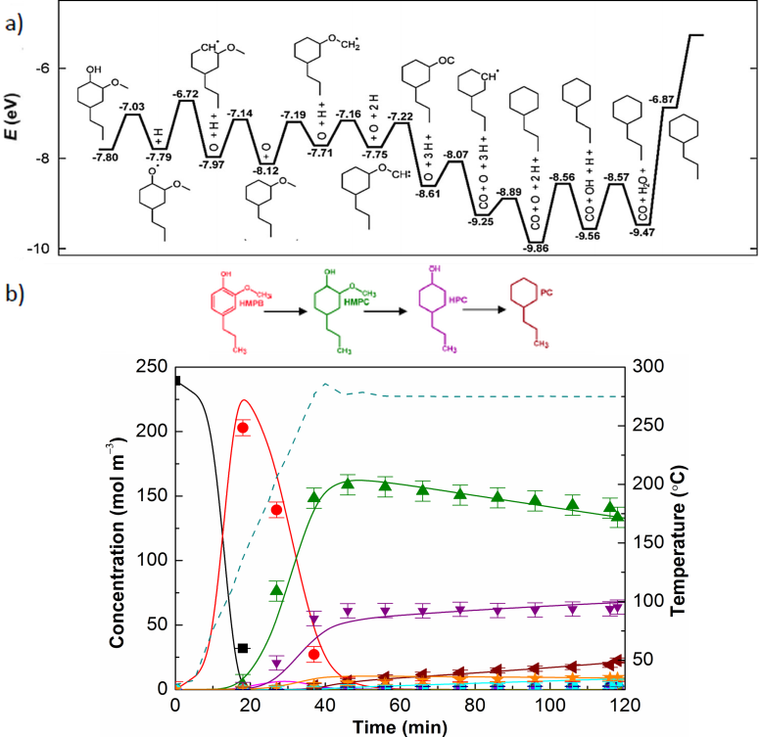
Temperature variation influenced the product distribution the most significantly. Hydrogenation reactions took place predominantly at lower temperatures as a consequence of low activation energies (approx. 50 kJ mol^{–1}) estimated by the model. On the other side, deoxygenation reactions were significantly promoted at higher temperatures due to greater activation energies (approx. 100 kJ mol^{–1}). Pressure change affected primarily the yield of hydrogenated products. Agitation speed variation indicated absence of the external mass transfer limitations in the tested range. The catalyst loading promoted all reactions, as expected. Demethoxylation and dehydroxylation rate constants have been estimated 36- and 42-fold higher for aromatics relative to oxygen-containing cycloalkanes. Energy diagram, determined for HMPC deoxygenation by the DFT, has been provided in Fig 2a, while Fig. 2b demonstrats integrated experimental and micro-kinetic model results obtained for the experiment performed at 275 °C.

References
[1] A. Bjelić, M. Grilc, B. Likozar, Chemical Engineering Journal 333 (2018) 240-259.
[2] M. Huš, A. Bjelić, M. Grilc, B. Likozar, Journal of Catalysis 358 (2018) 8-18.
[3] A. Bjelić, M. Grilc, S. Gyergyek, A. Kocjan, D. Makovec, B. Likozar, Catalysts 8 (2018) 425.

Figure 1. a) Potential energy surface for the minimum energy pathway of the HMPC deoxygenation obtained by the DFT b) eugenol hydrotreatment over the Ru/C at 5 MPa H₂.

