Supercritical water desalination (SCWD) for treatment of multicomponent brine streams.
Surika van Wyk¹, Aloijsius G.J. van der Ham¹, Sascha R.A. Kersten¹
1 Sustainable Process Technology. Faculty of Science and Technology, University of Twente, Drienerlolaan 5, Posbus 217, 7500 AE, Enschede, The Netherlands
*Corresponding author: s.vanwyk@utwente.nl
Highlights
- Desalination of multicomponent waste streams with zero liquid discharge.
- Phase behavior of various multicomponent brines under supercritical conditions.
- Selective removal of different salts from multicomponent brines.

1. Introduction
Supercritical water desalination (SCWD) is a promising zero liquid discharge (ZLD) technology that utilizes the non-polar nature of water under supercritical conditions (T > 374 ºC, Pressure > 22.1 MPa). SCWD is based on the formation of vapour-liquid equilibrium (VLE) where a supercritical water (SCW) phase (< 750 ppm NaCl) is separated from a concentrated liquid brine phase (30 – 40 wt.% NaCl). This approach to desalination has been investigated on both laboratory and pilot plant scale for different feed concentrations of NaCl (3.5 – 16 wt.%)¹. Most large scale studies have been done with aqueous type I salt solutions such as NaCl and CaCl₂, however, in industry brine streams contain multiple salts. Different salts exhibit varying phase behaviour under supercritical conditions such as VLE or vapour (fluid) - solid equilibrium (VSE)². As stated, VLE needs to be established for SCWD and therefore the formation of VSE could be problematic as this will lead to plugging and equipment failure. A manner in which this can be overcome, is to dissolve the formed solids in the brine originating from the presence of a type I salts^{2,3}. In this manner VLE can be re-establish. This presentation will focus on the separation and treatment of typical brine waste streams found in industry namely, NaCl (type I) -Na₂SO₄ (type II) -H₂O (mining industry), NaCl (type I)-CaCl₂ (type I)-H₂O (desalination waste) and NaCl (type I)-KCl (type I)-H₂O (dairy industry). Firstly, the separation efficiency of water from the concentrated brine streams will be investigated. Subsequently, the feasibility of separating different salts from the multicomponent concentrated brine streams will be studied. The solubility of different salts in supercritical water can be easily manipulated by varying temperature and pressure and could therefore be used for the selective removal of certain salts from multicomponent brines.
2. Methods
The experimental procedure is divided into two steps, namely qualitative (step 1) and quantitative (step 2) analysis. Qualitative experiments are performed using quartz capillaries to ensure that all the solids are dissolved in the brine during separation, so as to avoid plugging of the system. Once it has been ensured that a VLE system will be obtained at the selected separation conditions (250 – 350 bar; 370 – 450 ºC) for the given mixtures, quantitative phase equilibria measurements are done, using a laboratory scale SCWD unit ⁴. During the quantitative analysis salt composition and concentration of each phase is measured and the separation efficiency for each step is calculated.
3. Results and discussion
The qualitative capillary results for different NaCl:Na₂SO₄ ratios are shown in Figure 1.
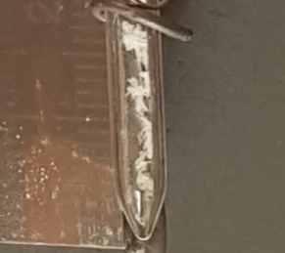  Solid  a)  T_{wall} = 427 ºC  (P~ 376 bar)  Na₂SO₄ - 3.5 wt.% | 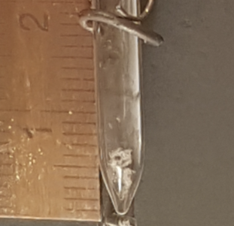  Solid  b)  T_{wall} = 431 ºC  (P~ 320 bar)  NaCl: Na₂SO₄ – 6:4  Total salt - 3.5 wt.% | 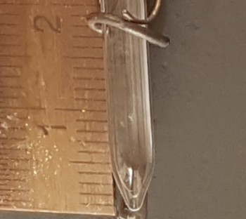  c)  T_{wall} = 431ºC  (P ~ 316 bar)  NaCl: Na₂SO₄ – 7:3  Total salt - 3.5 wt.% | 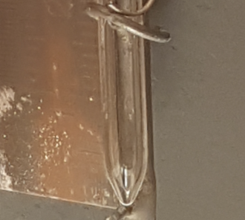  d)  T_{wall} = 429 ºC  (P ~ 250 – 350 bar)  NaCl - 3.5 wt.%
Figure 1. Phase behaviour of NaCl-Na₂SO₄-H₂O mixtures a) VSE b) vapour-liquid-solid equilibrium (VLSE) c) VLE d) VLE
The results show that for NaCl-Na₂SO₄-H₂O mixtures with mass ratios of 7:3 (NaCl:Na₂SO₄) 8:2 and 9:1, VLE is achieved. The quantitative results show that under supercritical conditions, Na₂SO₄ remains in the concentrated liquid phase and that the SCW phase has a low concentration of NaCl (400 - 1100 ppm) and trace amounts of Na₂SO₄. In general, the SCW concentration and recovery is comparable to that for NaCl-H₂O systems for the given operating conditions. Separation of the remaining concentrated NaCl-Na₂SO₄-H₂O brine will be further investigated. For the other multicomponent streams, the same procedure will be followed i.e. qualitative screening to ensure VLE followed by quantitative phase equilibria measurements to determine the separation efficiency of water from brine and that between different salts.
4. Conclusions
The conclusions made based on the experimental results for NaCl-Na₂SO₄-H₂O systems, is that water can be separated from the brine solutions, using the currently developed SCWD process for the treatment of brine streams with ZLD. An additional step will have to be added to separate certain salts for the remaining concentrated brine depending on solubility. The selective removal of salts from multicomponent brine could present an additional benefit to SCWD and could be an alternative method of separation to retrieve certain salts.

References
- S.van Wyk, A.G.J. van der Ham, S.R.A. Kersten, Desalination. 439 (2018) 80-92.
- M.M. DiPippo, K. Sako, J.W. Tester, Fluid Phase Equilibria. 157 (1999) 229-255.
- V.M. Valyashko, Pure & Applied Chemistry. 69 (1997) 2271-2280.
- S.O. Odu, A.G.J. van der Ham, S. Metz, S.R.A. Kersten, Ind. Eng. Chem. Res. 54 (2015) 5527-5535.

