Formation of BiFeO₃ and LaPO₄ nanoparticles during heat treatment of hydroxides co-precipitated in an impinging jets microreactor
O.V.Proskurina^{1,2}, R.S. Abiev^{2,3*}, M.O. Enikeeva², A.A. Sirotkin², V.V.Gusarov¹
1 Ioffe Institute, Politekhnicheskaya st. 26, 194021, Saint Petersburg, Russia;
2 St. Petersburg State Institute of Technology, Moskovskii pr.26, 190013, Saint Petersburg, Russia;
3 Institute of Silicate Chemistry of RAS, Makarova emb. 2, 199034, Saint Petersburg, Russia;
*Corresponding author: abiev.rufat@gmail.com
Highlights
- BiFeO₃ nanoparticles were obtained using an impinging jets microreactor.
- The synthesized BiFeO₃ particles about 20 nm in size are single-crystal.
- BiFeO₃ nanoparticles obtained without impurities of other phases.
- LaPO₄ nanoparticles were obtained using an impinging jets microreactor.

1. Introduction
Synthesis of nanocrystalline BiFeO₃ without admixtures of other compounds is a great challenge. It is hindered by the fact that reducing the number of impurity phases Bi₂₅FeO₃₉ and/or Bi₂Fe₄O₉ requires, as a rule, an increase in temperature and/or duration of heat treatment of the initial reagents, which leads to the growth of particles of the target product. In recent years, the impinging jets method has begun to attract attention as a tool for nanoscale particles synthesis [1-4]. It was shown [4] that the use of the impinging jets microreactor can significantly lower the synthesis temperature and reduce the crystallite size of the CoFe₂O₄ nanopowder. This fact was associated with a high rate of energy dissipation in the collision volume of impinging jets resulting in perfect mixing of reagents, which is a characteristic of this method.
The objective of this work was to study the possibility and conditions of using the method of impinging jets for co-precipitation of hydroxides to obtain single-phase powders based on nanocrystalline BiFeO₃ and LaPO₄.
2. Methods
A homemade glass microreactor with nozzles of 0.55 mm and 0.65 mm inner diameter was used. A mixture of Bi(NO₃)₃∙5H₂O and Fe(NO₃)₃∙9H₂O water solutions in HNO₃ was prepared as a first liquid. The second liquid was KOH water solution. Two jets of the liquids with velocities of 17.5 m/s and 12.5 m/s correspondingly were collided in the reactor. Co-precipitation products were then heat treated in air at 420°C-600°C within 15 minutes. X-ray diffraction, scanning (SEM) and transmission (TEM) electron microscopy, energy dispersive X-ray spectroscopy (EDS), Mössbauer spectroscopy and IR spectroscopy were used for characterization of co-precipitated and heat treated products.
3. Results and discussion
The Bi:Fe atomic ratio in the initial sample and in the samples after heat treatment according to EDS data remains at the same level Bi:Fe = (52 ± 2):(48 ± 2). After heat treatment at 420°С, reflections characteristic of bismuth orthoferrite appear on the diffraction pattern. The tendency described above is also maintained during heat treatment of co-precipitated hydroxides at temperatures of 440 and 600°C. Nanocrystalls of LaPO₄ having rhabdofan structure and sizes of 2-3 nm have been formed by use of the impinging jets microreactor (without additional heat treatment).

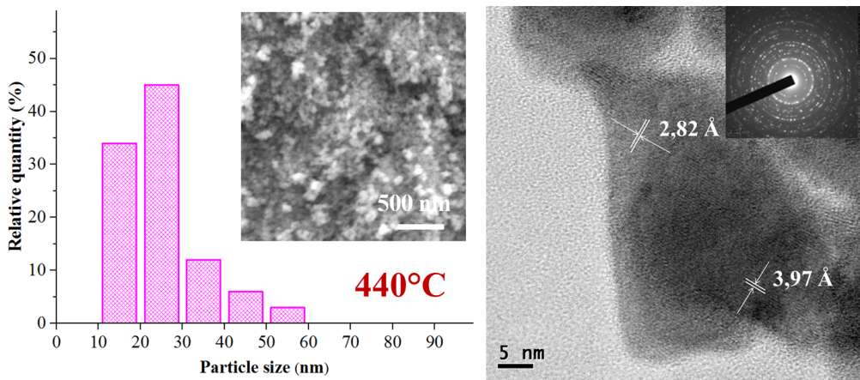
Figure 1. Left: size distribution of BiFeO3 particles obtained by heat treatment at 440°C.The inset shows SEM micrograph. Right: TEM micrograph of the particles. The inset shows selected area electron diffraction pattern
4. Conclusions
By heat treatment of hydroxides co-precipitated in an impinging jets microreactor, nanocrystalline bismuth orthoferrite was synthesized. It was shown that the formation of BiFeO₃ nanoparticles without admixtures of other phases with a narrow crystal size distribution and an average crystal size of about 20 nm is possible after heat treatment at 420-440°C of hydroxides co-precipitated in an impinging jets microreactor. The nanoparticles of BiFeO₃ obtained under these conditions were single-crystal. It was shown that the sizes of the formed bismuth orthoferrite nanocrystals were consistent with the sizes of the nanoparticles that can be formed in microvortices having a minimum Kolmogorov scale that are formed during the collision of the jets of reagent solutions in the microreactor.
Using the microreactor approach, a suspension of LaPO₄ nanoparticles with the structure of rhabdofan was obtained, which turned into a sol after some time, and then into a thixotropic gel. The size of LaPO₄ nanocrystalls in the gel according to X-ray diffraction data was 2-3 nm.
The authors acknowledge the partial financial support of this work in the form of RFBR grant
18-29-12119.
References
- B.K. Johnson, R.K. Prud’homme, AIChE J. 49 (2003) 2264-2282.
- J. Han, Z. Zhu, H. Qian, A.R. Wohl, C.J. Beaman, T.R. Hoye, C.W. Macosko, J. of Pharm. Sci. 101 (2012) 4018-4023.
- D.V. Ravi Kumar, B.L.V. Prasad, A.A. Kulkarni, Ind. Eng. Chem. Res. 52 (2013) 17376-17382.
- R.S. Abiev, O.V. Almyasheva, S.G. Izotova, V.V. Gusarov, J. Chem. Tech. App. 1 (2017) 7-13.

