Application of microCT for the visualization of multiphase phenomena
in small ducts
Julia Schuler¹, Norbert Kockmann¹
¹TU Dortmund University, Equipment Design, Emil-Figge-Straße 68, 44227 Dortmund, Germany
*Corresponding author: julia.schuler@tu-dortmund.de
Highlights
- Micro CT system for the investigation of liquid/liquid flows
- 2D and 3D investigation of liquid/liquid interfaces and transport phenomena
- Detailed analysis in MATLAB

1. Introduction
For process intensification in chemical engineering, miniaturization of equipment to the millimeter or micrometer range offers great potential for high mass and heat transfer and, thus, safer processes. Multiphase applications are often occurring and allow for executing gas/liquid reactions or liquid/liquid separation processes. To ensure successful process intensification via miniaturization, knowledge about the interfaces between the phases is crucial. Usually, interfaces in miniaturized equipment are examined by optical cameras, but often optical access is limited. To overcome this limitation, micro computed tomography (micro CT) is used to investigate interfaces and transport phenomena in miniaturized equipment in this contribution.
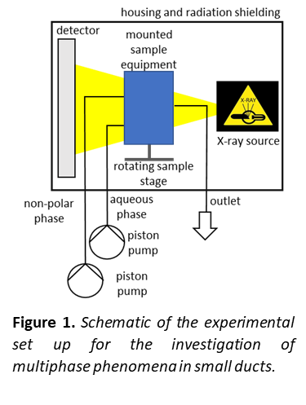
Nowadays, computed tomography CT is widely used not only in medical diagnosis [1], but also in material science [2] and geology [3]. Even in the field of process engineering, CT increasingly becomes an important tool, for example for the investigation of the distribution of liquid distribution in packed columns [4,5,6]. However, the extension of CT imaging to the field of micro process engineering needs high spatial resolution. In this work, we present a methodology that enables 2D and 3D investigation of multiphase flows in capillaries. The focus is set on liquid/liquid applications.
2. Methods
Image acquisition is carried out with the Bruker Skyscan 1275 (RLJ Micro & Analytics, Germany), that allows resolutions up to 4 $μ$m. It is equipped with a stationary
X-ray source and detector and a rotating sample stage, as shown in figure 1. For safety reasons, the image acquisition unit along with the mounted sample equipment is enclosed in a lead housing. For liquid supply and liquid removal, it is additionally equipped with fluorinated ethylene propylene hoses. An aqueous and a non-polar phase are pumped through the scanner using piston pumps and contacted inside the scanner in a narrow duct.
After image acquisition, the images are reconstructed using NRecon, the reconstruction software that comes along with Bruker Skyscan 1275, to obtain 3D information and analyzed using a self-developed procedure in MATLAB. For 2D investigation, image analysis can be performed directly after image acquisition.
3. Results and conclusion
The presented procedure allows the 2D and 3D investigation of liquid/liquid interfaces. Figure 2a) shows a liquid/liquid interface extracted from a stack of reconstructed projection images. In
figure 2 b) a 2D projection image of a liquid/liquid bubbly flow in a low density polyethylene hose (inner diameter 1.5 mm), generated by a stainless steel cannula is shown.
Future work will incorporate a more detailed investigation of liquid/liquid interfaces in different flow regimes, such as parallel flow or periodic bubbly or slug flow. This will be supplemented by first mass transfer experiments inside the CT.
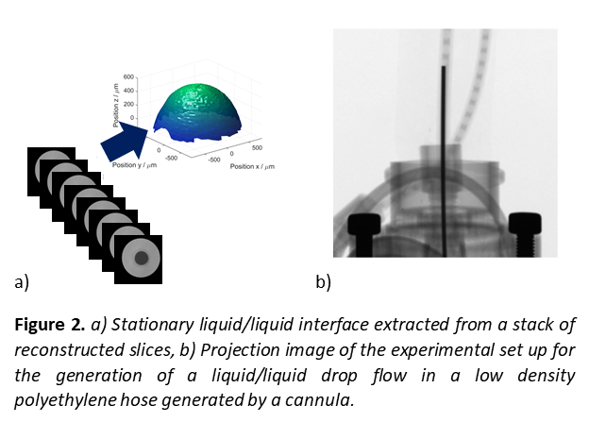
References

[1] D. W. Holdsworth and M. M. Thornton, Trends in Biotechnology, 2002, 20, S34-S39.
[2] J. Bock and A. M. Jacobi, Materials Characterization, 2013, 75, 35–43.
[3] M. Andrew, B. Bijeljic and M. J. Blunt, Advances in Water Resources, 2014, 68, 24–31.
[4] S. Aferka, A. Viva, E. Brunazzi, P. Marchot, M. Crine and D. Toye, Chemical Engineering Science, 2011, 66, 3413–3422.
[5] D. Toye, P. Marchot, M. Crine, A.-M. Pelsser and G. L'Homme, Chemical Engineering and Processing: Process Intensification, 1998, 37, 511–520.
[6] A. Janzen, J. Steube, S. Aferka, E. Y. Kenig, M. Crine, P. Marchot and D. Toye, Chemical Engineering Science, 2013, 102, 451–460.

