Slow-release based exponential fed-batch for MTP screening platform Roman Jansen¹*, Niklas Tenhaef¹, Matthias Moch¹, Wolfgang Wiechert¹, Stephan Noack¹, Macro Oldiges¹
1 Forschungszentrum Jülich, Institute of Bio- and Geosciences – Biotechnology (IBG-1), Jülich, Germany
*Corresponding author: r.jansen@fz-juelich.de
Highlights
- High throughput bioprocess development
- Automated exponential fed-batch
- Slow-release system
- Miniaturized cultivation with online signals
- Microtiter plate

1. Introduction
Tremendous developments in the field of metabolic engineering have strongly increased the throughput in the last decade. Through utilization of advanced techniques such as random mutagenesis and highly specific gene editing tools, large strain libraries can be generated in a very short time [1]. To identify the best strain candidates for in depth process characterization, these strains combined with a set of process parameters, have to be tested. Nonetheless, the number of mandatory experiments adds up to be very large [2]. Consequently, systems with increased cultivation throughput are in great demand. Therefore, micro bioreactor systems become a critical tool for accelerated bioprocess development. While most of these systems enable to screen batch cultivation, they lack the means to perform fed-batch processes, which are often the standard in industrial biotechnology. In this study, a novel approach for feedback-driven control of an enzymatic slow-release system is realized by combining a BioLector-based cultivation setup, a liquid handling system and a custom process control system, allowing for 48 parallel fed-batch cultivations in an automated and miniaturized manner.
2. Methods
BioLector cultivations, integrated in a liquid handling system were performed with a tailor made process control system. After an initial batch phase on free glucose as the sole carbon source, fed-batch cultivations were realized through the specific addition of enzyme. The amyloglucosidase is capable of releasing glucose monomers from a dissolved glucose polymer such as dextrin with a constant release rate. Through adaption of the amount of enzyme added, the substrate release rate and consequently the growth rate could be controlled.
3. Results and discussion
Through utilization of the online signals (biomass from backscatter, pH, DO, GFP) provided by the BioLector cultivation, the process can be feedback controlled. The quasi-continuous pH signal allowed for a single sided pH-control, where a small pulse of controlling agent was added to the cultivation well, when the pH dropped below a pre-defined threshold. This pH control was key to success, since amyloglucosidase activity is very pH sensitive and initial experiments without pH control failed. The backscatter signal of the cultivation was used to calculate the online growth rate as previously described [3]. Once this processed signal fell below another threshold value (growth rate set point µ_{set}) a varying pulse of amyloglucosidase based on the current backscatter signal was added to the medium to increase the glucose release rate again and consequently keep a constant growth rate.
This technology allowed for highly reproducible exponential fed-batch cultivations with C. glutamicum in a modified CGXII medium. Four different growth rate set points were tested regarding reproducibility (Figure 1) and protein production with secreted GFP as a model protein. The lowest exponential growth rate set point resulted in an almost doubled GFP production in comparison to a batch process with the same amount of substrate. To test the applicability of this novel technology, exponential fed-batch cultivations with two other industrial relevant microorganisms, E. coli and P. pastoris, were conducted successfully.
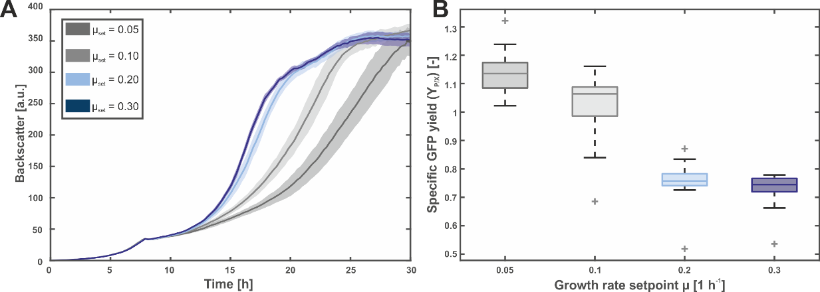
Figure 1. Backscatter curves (A) of C. glutamicum BioLector fed-batch cultivation and specific GFP yield (B) at the end of fed-batch cultivation.
4. Conclusions
In this study, a novel technology allowing for 48 parallel micro bioreactor fed-batch cultivation was developed. Via utilization of the online signals provided by the BioLector, a feedback controlled process was established, which showed high reproducibility for a given range of exponential growth range. This platform technology can be easily and cost effectively applied for screening purposes of up to 48 different cultivations.

References
- A. V. Shivange, J. Marienhagen, H. Mundhada, A. Schenk, and U. Schwaneberg, “Advances in generating functional diversity for directed protein evolution,” Curr. Opin. Chem. Biol., vol. 13, no. 1, pp. 19–25, Feb. 2009.
- Q. Long et al., “The development and application of high throughput cultivation technology in bioprocess development,” J. Biotechnol., vol. 192, pp. 323–338, 2014.
- A. Radek et al., “Miniaturized and automated adaptive laboratory evolution: Evolving Corynebacterium glutamicum towards an improved d -xylose utilization,” Bioresour. Technol., vol. 245, pp. 1377–1385, Dec. 2017.

