Direct epoxidation of linseed oil by hydrogen peroxide:
thermal risk assessment
Wander Y. Pérez-Sena^{1,2}, Pasi Tolvanen², Lionel Estel¹, Tapio Salmi², Sébastien Leveneur^{1,2}
1.Normandie Univ, INSA Rouen, UNIROUEN, LSPC, EA4704, 76000 Rouen, France
2.Johan Gadolin Process Chemistry Centre, Åbo Akademi University, Åbo/Turku, Finland.
*Corresponding author: sebastien.leveneur@insa-rouen.fr
Highlights
- Adiabatic experiments for the epoxidation.
- Thermal risk assessment for different epoxidation routes.
- Kinetic model for the direct epoxidation.

1. Introduction
The use of vegetable oil as industrial feedstock could be a promising substitute to petroleum-derived sources. For instance, production of biodiesel from transesterification of vegetable oils is a well-developed process at the industrial level. Vegetable oils are used in industry because they are renewable, biodegradable, non-toxic and abundant.
One of the first step is the epoxidation of vegetable oils. Epoxidized vegetable oils can be seen as platform molecules because they can be transformed into different chemicals [1] such as polyols, carbonated vegetable oils [2] and polyurethanes [3-4].
Conventionally, production of epoxidized vegetable oils is done by the Prileschajew method. It is a liquid-liquid reaction system, with several consecutive and parallel exothermic reactions [5]. The first step is the production of percarboxylic acid in the aqueous phase. Then, the percarboxylic acid diffuses into the organic phase to epoxidize the unsaturated groups. Due to the presence of several exothermic reactions, the risk of thermal runaway exists [6-7].
The issues of the Prileschajew method are:
-production of organic waste during the process;
-acidity of the reaction mixture favors the side reaction of ring-opening;
-separation step and waste treatment are more demanding;
-formic and acetic acids are the most used and can cause some corrosion.
Hence, direct epoxidation of vegetable oil by oxygen and hydrogen peroxide is seen as the best option concerning thermal safety, waste treatment and selectivity. The objective of this study is to compare the thermal risk for the epoxidation of linseed oil by three chemical systems: Prileschajew oxidation by using peracetic acid, Prileschajew by using performic acid and by the direction epoxidation of hydrogen peroxide on alumina. For the evaluation of the thermal risk on the epoxidation of linseed oil, the TMR_{ad} (Time to Maximum Rate under adiabatic conditions) was chosen as a reliable safety parameter to identify the probability of hazardous scenarios. The adiabatic calorimeter ARSST standing for Advanced Reactive System Screening Tool was used [8] to determine TMR_{ad}. We have decided to use the most conservative assumption implying to determine the TMR_{ad}(Tp) at the initial temperature Tp by using the zero- order approximation.
2. Methods
Experiments were performed in a pseudo-adiabatic calorimeter: ARSST (Advanced Reactive System Screening Tool) following the heat loss compensation principle by using and electrical heating supply [8]. To decrease the evaporation, experiments were performed under high pressure of nitrogen.
3. Results and discussion
We have tested the influence of different parameters on the thermal risk parameter TMR_{ad} such as concentrations of reactants or catalyst. Figure 1 shows the evolution of TMR_{ad} at different catalyst concentrations for the Prileschajew by formic acid catalyzed by sulfuric acid, Prileschajew by acetic acid catalyzed by sulfuric acid and epoxidation by Al₂O₃.
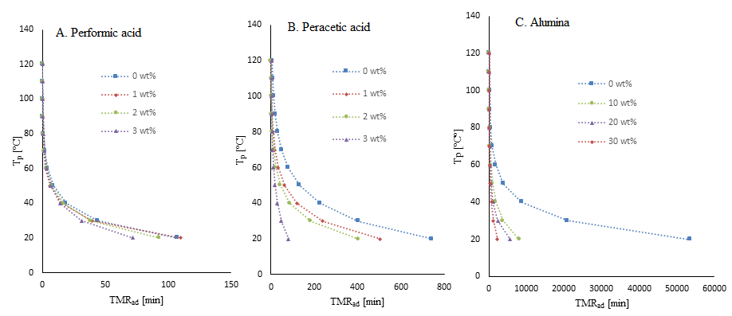
Figures 1. Process temperature Tp versus TMRad for the epoxidation by performic acid (A); by peracetic acid (B) and direct epoxidation by hydrogen peroxide over alumina (C) with different weight percentage of catalyst.
4. Conclusions
Figure 1 shows that direct epoxidation by alumina is thermally safer than the Prileschajew ones. The continuation of this work is the kinetic modeling of these reactions to know which process is more efficient from a kinetic viewpoint.
References
- S. Danov, O. Kazantsev, A. Esipovich, A. Belousov, A. Rogozhin, E. Kanakov, Catal. Sci. Technol. 7 (2017) 3659-3675.
- X. Cai, J.-L. Zheng, J. Wärnå, T. Salmi, B. Taouk, S. Leveneur, Chem. Eng. J. 313 (2017) 1168-1183.
- M. Ahmad Sawpan, J. Polym. Res. 25 (2018) 184-199.
- W. Pérez-Sena, X. Cai, N. Kebir, L. Vernières, C. Serra, T. Salmi, S. Leveneur, Chem. Eng. J. 346 (2018) 271-280.
- J.-L. Zheng, J. Wärnå, F. Burel, T. Salmi, B. Taouk, S. Leveneur, AIChE J. 62(3) (2016) 726-741.
- C. Vianello, E. Salzano, G. Maschio, Process Saf. Environ. Prot. 116 (2018) 718–726.
- S. Leveneur, L. Estel, C. Crua, J. Therm. Anal. Calorim. 122 (2015) 795–804.
- L. Vernières-Hassimi, A. Dakkoune, L. Abdelouahed, L. Estel, S. Leveneur, Ind. Eng. Chem. Res. 56 (2017) 13040-13049.

