Reaction pathway network and kinetic model development for catalytic HDO of furfural over Ru/C and Rh/C
Rok Šivec¹, Miha Grilc¹, Blaž Likozar¹
1 Department of Catalysis and Chemical Reaction Engineering, National Institute of Chemistry, Hajdrihova 19, 1000 Ljubljana, Slovenia
*Corresponding author: Miha.Grilc@ki.si
Highlights
- Furfural is used as a renewable source for value added product production.
- Hydrodeoxygenation of furfural was carried out in a stirred three-phase reactor.
- Ru/C and Rh/C catalysts were used.
- A microkinetic model was developed and fitted to experimental data.

1. Introduction
Furfural is a very promising platform chemical, which can be produced from renewable sources, such as lignocellulosic (LC) biomass. The use of LC materials is increasing due to demand, and so are its residues (wastes), which are produced in millions of tons annually. [1] As a result, furfural is already produced in large quantities (close to 300 kTon annually). Furfural can be used as a valuable bio-derived source for many value added chemicals and biofuels. [2]
The hydrodeoxygenation (HDO) reaction of furfural with gaseous hydrogen was studied, by using different heterogeneous catalysts, such as Ru/C and Rh/C, in a high-pressure three-phase batch reactor system. Neat furfural and its iso-propanol solutions were used and various process parameters were varied. Furthermore, the reaction mechanism is being studied and a microkinetic model developed. The model will be fitted to experimental data. The use of different catalysts will also be compared.
2. Methods
A three-phase batch reactor was used, consisting of a 300 mL vessel, Rushton turbine stirrer and sampling lines for liquid and gaseous phase. 100 mL of liquid medium was used, composed of pure furfural as the main reactant or furfural dissolved in iso-propanol, while the latter has not only the role of a solvent but also participates in the reaction as a hydrogen donor. A solid catalyst (Ru/C or Rh/C) was added afterwards. The reaction vessel was closed, flushed with N₂ and pressurized under pure hydrogen at high pressure (50 bar at room temperature). The convective heat and mass transfer was assisted with vigorous stirring at 500 rpm. The reaction mixture was heated-up with a heat-up rate of 5 K min^{–1} to the temperatures of plateau at 175 °C, 200 °C and 250 °C, respectively. Liquid and gas samples were taken during the experiment and analysed by GC-MS/FID and NMR (liquid samples), and by GC-FID/TCD and FTIR (gaseous samples). At the end of the experiment, the reaction vessel was rapidly cooled down and flushed with N₂.The microkinetic model is being developed in Matlab software according to the proposed reaction sheme in Figure 1.
3. Results and discussion
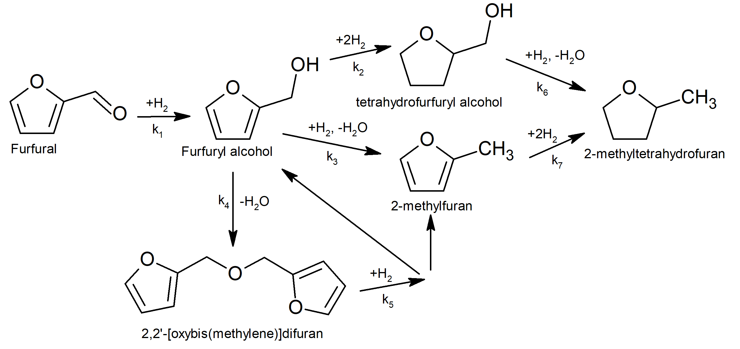
100% conversion of furfural was achieved during the reaction (Figure 2), leading to numerous intermediates and products, such as Furfuryl alcohol, 2-methylfuran, 2-methyltetrahydrofuran, Tetrahydrofurfuryl Alcohol, 2,2'-[oxybis(methylene)]difuran and others. According to the microkinetic model, furfural is firstly hydrogenated to furfuryl alcohol. Three parallel reactions occur afterwards: a) furfuryl alcohol hydrogenation to tetrahydrofurfuryl alcohol and subsequent hydrodeoxygenation to 2-methyltetrahydrofuran, b) furfuryl alcohol hydrodeoxygenation to 2-methylfuran and subsequent hydrogenation to 2-methyltetrahydrofuran and c) furfuryl alcohol oligomerization to 2,2'-[oxybis(methylene)]difuran with subsequent hydrogenation to furfuryl alcohol and 2-methylfuran, which are further converted as already mentioned.
Figure 1. Proposed reaction scheme.
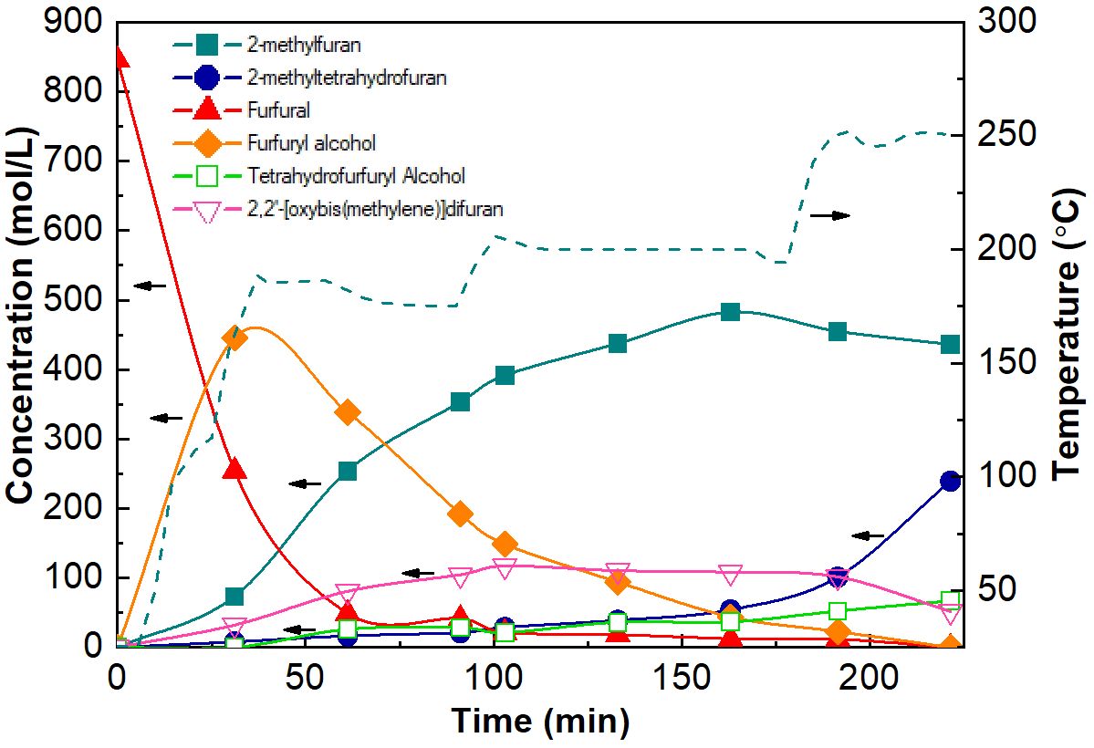
Figure 2. Experimental data of furfural conversion over Rh/C catalyst.
4. Conclusions
Experiments of furfural hydrodeoxygenation were carried out with the use of Ru/C and Rh/C catalyst. The results are promising for 2-methylfuran and 2-methyltetrahyfdrofuran production. The developed microkinetic model will be fitted to experimental data points and used to predict the reaction at different conditions.
References
- M. Dashtban, A. Gilbert, and P. Fetehi, J-FOR, 2(4) (2012) 44–53.
- R. Mariscal, P. Maireles-Torres, M. Ojeda, I. Sádaba, and M. López Granados, Energy Environ. Sci., 9(4) (2016) 1144–1189.

