Enhancing palladium promotion of indium oxide for CO₂-based methanol production through synthetic control.
Matthias S. Frei¹, Cecilia Mondelli¹, Klara S. Kley¹, Begoña Puértolas¹, Rodrigo García-Muelas², Núria López², Olga V. Safonova³, Joseph A. Stewart⁴, Daniel Curulla Ferré⁴ and Javier Pérez-Ramírez¹*
1 ETH Zürich, 8093 Zürich, Switzerland; 2 Institute of Chemical Research of Catalonia (ICIQ), 43007 Tarragona, Spain; 3 Paul Scherrer Institute, 5232 Villigen, Switzerland; 4 Total Research & Technology Feluy, 7181 Seneffe, Belgium
*Corresponding author: jpr@chem.ethz.ch
Highlights
- Controlled coprecipitation embeds Pd in the lattice leading to low-nuclearity clusters.
- The superiority of this Pd speciation is elucidated by theoretical and empirical methods.
- Record methanol productivity is sustained for 500 h.
- The benefits of nanoscale design for a sustainable large-scale process are demonstrated.

1. Introduction
Metal promotion is broadly applied to enhance the performance of heterogeneous catalysts to fulfil industrial requirements. Still, generating and quantifying the effect of the promoter speciation that exclusively introduces the desired property and ensures proximity to the active site and durability is very challenging. Recently, In₂O₃ was discovered as a highly selective and stable catalyst with the potential to realize green methanol production from CO₂ at a commercial scale [1]. Activity boosting with the H₂-splitter palladium led to partial success since Pd nanoparticles mediate the parasitic reverse water-gas shift (RWGS) reaction, reducing selectivity, and sinter or alloy with indium, limiting metal utilization and robustness. Herein we introduce a coprecipitation method leading to low-nuclearity Pd clusters anchored to the active site that curtail these limitations.
2. Methods
In₂O₃ and Pd(0.1-10 wt.%)-In₂O₃ catalysts were prepared by precipitation, and coprecipitation or dry impregnation, respectively, followed by calcination. They were characterized by inductively coupled plasma optical emission spectroscopy, N₂ sorption, X-ray diffraction, thermal techniques, electron microscopy, and X-ray photoelectron and absorption spectroscopy. CO₂ hydrogenation to methanol was conducted in a continuous-flow fixed-bed reactor setup at 473-653 K, 5 MPa, H₂/CO₂ = 1.8-5.7, and weight hourly space velocity = 24,000-48,000 cm³_{STP} h⁻¹ g_{cat}⁻¹. Pd speciation and reaction energetics were studied by Density Functional Theory (DFT).
3. Results and discussion
Pd-promoted In₂O₃ featuring palladium atomically dispersed in the oxide matrix was generated by coprecipitation and was benchmarked with dry impregnated systems comprising Pd clusters deposited onto the oxide. The first exhibited a stable activity enhancement compared to bulk In₂O₃ solely directed to methanol synthesis, while the second displayed a decaying improvement of both methanol and CO formation (Figure 1, left). Based on structural, spectroscopy, and microscopy (Figure 1, middle) analyses, Pd formed clusters of very low nuclearity attached to the lattice in the coprecipitated sample, whereas aggregated to form defined nanoparticles in the impregnated material. DFT calculations indicated that Pd atoms embedded into the oxide structure serve as effective anchoring sites for the noble metal atoms accommodated onto the surface hindering excessive agglomeration, which provides a molecular-level explanation to the profoundly diverse time-on-stream behaviors of the two catalysts. According to thermal characterization, theoretical simulations, and kinetic data, these Pd clusters do not significantly increase the number of active vacancies but impart an improved H₂-dissociation capability without enhancing the RWGS reaction (Figure 1, right), leading to a sustained record productivity (0.96 g_{MeOH}⁻¹ h⁻¹ g_{cat}⁻¹ after 500 h on stream). In contrast, Pd nanoparticles supply activated hydrogen that fosters vacancy and methanol formation on In₂O₃ but also convert CO₂ into CO on their own surface.
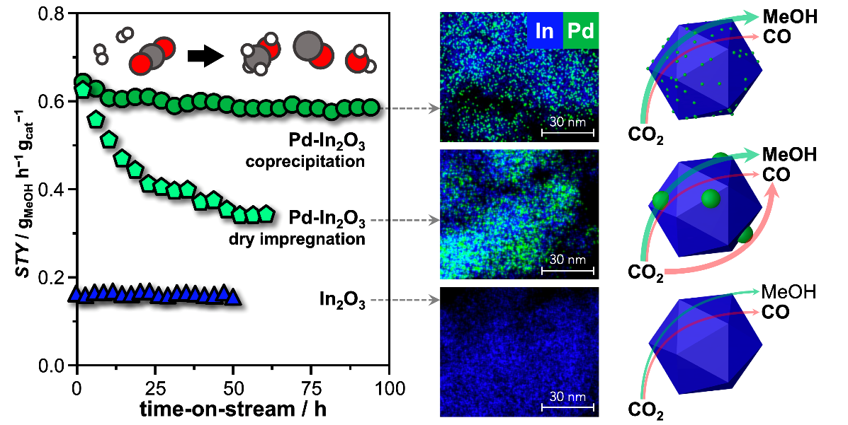
Figure 1. Methanol space time yield (STY) versus time-on stream over Pd(0.75 wt.%)-In₂O₃ catalysts and pure In₂O₃ during CO₂ hydrogenation at 553 K, 5 MPa, and H₂/CO₂ = 4 (left). EDX maps of In and Pd (middle) and representation of the distinct promotional effect of Pd (right) for the same catalysts after equilibration.
4. Conclusions
Controlled coprecipitation enables a fine tuning of the Pd speciation, generating small Pd clusters strongly bound to the oxide that offer a highly effective use of the noble metal and are robust, granting a sustained unparalleled methanol productivity. This permits to operate the catalyst at reduced temperature, with hydrogen-lean feeds, and in the presence of greater amounts of water, implying strong economic and ecologic benefits for a perspective CO₂-based methanol synthesis process.
Reference
- Martin, O., Martín, A.J., Mondelli, C., Mitchell, S., Segawa, T.F., Hauert, R., Drouilly, C., Curulla-Ferré, D., and Pérez-Ramírez, J. Angew. Chem., Int. Ed. 55 (2016) 6261–6265.

