Development of a Novel Atomization Process using Liquid Carbon Dioxide
Clara Lauscher*, Gerhard Schaldach, Markus Thommes
TU Dortmund, Laboratory of Solids Process Engineering, Emil-Figge-Str. 68, 44227 Dortmund, Germany
*Corresponding author: clara.lauscher@tu-dortmund.de
Highlights
- Fabrication of droplets in the small micrometer range.
- Dispersing a liquid in liquid carbon dioxide.
- Expansion of the CO₂ emulsion.

1. Introduction
Atomization is used in many industrial processes like in spray drying. Unfortunately, atomization is limited regarding small droplet sizes. A new approach to overcome this limitation is to disperse two liquid phases into each other rather spraying a liquid into a gas. Since the droplet size also depends on the continuous phase, using emulsification could be beneficial for achieving the desired size reduction. Indeed, in addition to spraying, there are various methods of emulsification and the milk industry has already proven that it is possible to produce droplets smaller than 1µm. The aim of this study is to investigate the potential to produce an aerosol using emulsification. Therefore, an emulsion of liquid carbon dioxide and a non-miscible liquid will be produced. Afterwards, due to the expansion of the emulsion a fine aerosol will have been prepared.
2. Methods
Based on the idea an aqueous system will be emulsified with liquid carbon dioxide using various emulsification processes. Therefore, a high-pressure emulsification system will be constructed utilizing HPLC equipment. Following, the high-pressure emulsion will be evaporated through a special nozzle.
3. Results and Discussion
As the emulsification system needs to be constructed, first experiments were conducted by using silicon oil (η = 1mPas) instead of liquid carbon dioxide as the continuous phase. Demineralized water is the disperse phase. The disperse phase (water) was pumped through a capillary (d = 0.3mm) with a volume flow rate of 50ml/min leading to a Reynolds number of 3500.
The Reynolds number of the continuous phase was calculated based on the physical properties of the continuous phase and drawn in Ohnesorge/Reynolds diagram (figure 1a). As shown in the diagram, the disintegration regime changes from the Rayleigh regime to second wind induced regime by changing the continuous phase from air to silicon oil. By spraying into air a droplet size of about 570μm can be expected [1]. In case of spraying the water into silicon oil the average droplet diameter (d_{50,3}) measured in the preliminary experiment is about 110μm as shown in figure 1b. The emulsion was analyzed using laser diffraction technique (Malvern Spraytec, Harrenberg, Germany).
Figure 1a. Ohnesorge/Reynolds diagram for dispersing water in silicon oil versus in air.  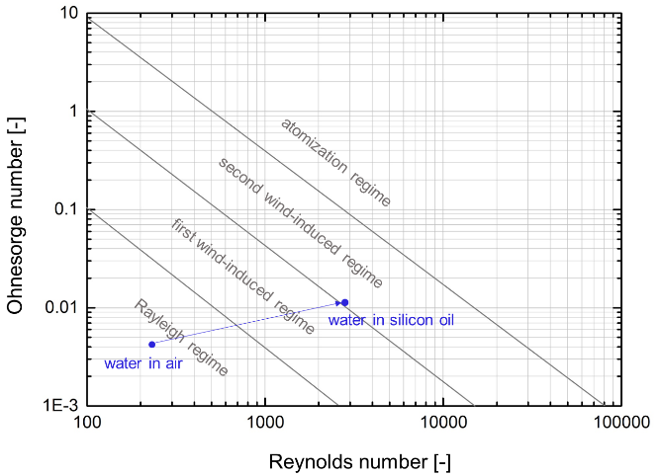 | 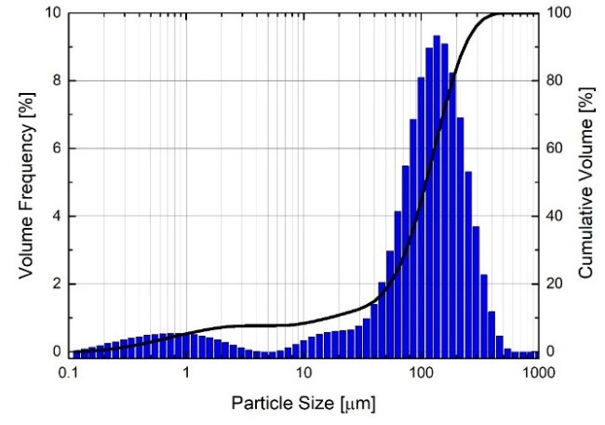  Figure 1b. Particle Size Distribution Dispersing water in silicon oil (η= 1mPas) through a capillary nozzle (d=3mm).
In general, the Reynolds number of the continuous phase increases with decreasing viscosity and increasing density. Consequently, dispersing in a liquid phase can cause higher Reynolds numbers and result in smaller droplet sizes.
4. Conclusions
The idea to emulsify liquid carbon dioxide seems to be a promising approach to produce fine droplets. The low viscosity will increase the Reynolds number significantly. In addition, liquid carbon dioxide facilitates spraying of the emulsion and is non-toxic. Liquid carbon dioxide vaporizes rapidly as soon as the pressure drops below the saturated vapour pressure and should support the production of even smaller droplets.
References
[1] Walzel, P., 2012, "Spraying and Atomizing of Liquids," Ullmann´s Encyclopedia of Industrial Chemistry, 34, pp. 79-98.

