Influence in the Mixing Energy and Volumetric O₂ Mass Transfer Coefficient of Exopolysaccharide Production by Gluconacetobacter Diazotrophicus.
Sebastián Pineda¹, Carlos Cardona², Juan Higuita³
¹ spinedap@unal.edu.co; ²ccardonaal@unal.edu.co; ³ jchiguitav@unal.edu.co
¹ ² ³ Universidad Nacional de Colombia sede Manizales
Research group in Chemical, Catalytic and Biotechnological processes.
*Corresponding author: jchiguitav@unal.edu.co
Highlights
- G. diazotrophicus is able to produce an exopolysaccharide.
- Exopolysaccharide produced by G. diazotrophicus changes the properties of medium.
- Power required for mixing is directly affected by exopolysaccharide production.
- Oxygen transfer decreases in function of exopolysaccharide accumulation.

1. Introduction
Gluconacetobacter diazotrophicus is an endophytic nitrogen fixing bacterium and was the first isolated from sugarcane [1]; genus Gluconacetobacter is able to produce large amounts of exopolysaccharides (EPS) and lipopolysaccharides (LPS) [2]. One of the proposed roles for EPS is the molecular communication between plants and microbes during plant-microbes association [3]. The aim of this article was to grow Gluconacetobacter diazotrophicus using sucrose as carbon source in order to obtain an exopolysaccharide. In addition, the investigation was focused in the production of EPS and its influence in the mixing energy and oxygen consumption.
2. Methods
The strain was grown in a Biorreactor with 14 L of liquid LGI-P fresh medium with sucrose 100gL⁻¹ at pH 8. Inoculum was 1.60 liters, which corresponds to 10.25% v/v. Culture was kept at 30°C under constant agitation of 150 rpm for 277 hours. Measurement of G. diazotrophicus growth were performed using the dry weight technique and the EPS was precipitated with cold ethanol (1:1 v/v, -20°C) and recovered by centrifugation at -20°C and 10000 rpm [4]. Quantification was made using a gravimetric analysis.
The Kendall-Monroe equation was used to calculate the blend viscosity as the cubic-root average of the component viscosities. Biomass viscosity can be predicted using the Vand equation and the rest of products have no significant influence on the viscosity. The required mixing power depends on the stirrer speed (N), the impeller shape and size${(D}_{i})$, the tank geometry, the density ($ρ$) and viscosity ${(μ}_{mix})$ of the fluid [5]. The relationship between these variables is usually expressed using the impeller Reynolds number. Finally, the statistical analysis was performed using descriptive analysis of Microsoft Excel®.
- Results and discussion
Results show that this microorganism is able to grow in LGI-P medium with sucrose 100gL-1, with a maximum cell concentration of 3.75 +/- 0.13 gL-1 (Figure 1). G. diazotrophicus is also able to produce an exopolysaccharide that was quantified by cold precipitation with ethanol with a maximum concentration of 9.20 +/- 0.23 gL-1 (Figure 2).
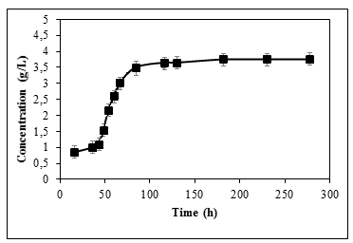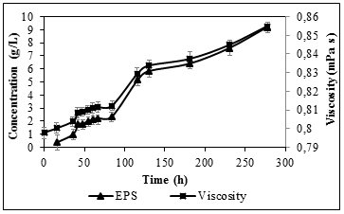
Figure 1. Biomass profile. Figure 2. Calculated viscosity in comparison with
EPS concentration.
It was also observed that both the mixing energy and the effort of the agitator (torque) were increased. This phenomenon may be due to the fact that exopolysaccharide production changes the rheological properties of the medium since it is a compound with a high viscosity (35 mPa-s). A reduction of 1.32% ${in k}_{L}a$ was noticed during fermentation.
- Conclusions
The results demonstrated that the EPS produced by G. diazotrophicus is a relevant factor in the rheological properties of the medium, which is then related with the increase in power requirement. In addition, this study aims to relate the volumetric oxygen mass transfer coefficient of the microorganism with changes in fluid properties.
References
[1] Cavalcante, V. A., Dobereiner, J., Plant and Soil. 108(1) (1988) 23–31.
[2] Ruka, D. R., Simon, G.P., Dean, K. M. Carbohydrate Polymers. 89 (2) (2012) 613-622.
[3] Braga, R. M., Dourado, M. N., Araújo, W. L. Brazilian Journal of Microbiology, 47 (2016), 86–98.
[4] Serrato, R. V. Frontiers in Cellular and Infection Microbiology. 4 (2014), 119-125.
[5] Doran, P. M. Bioprocess Engineering Principles. Technology (Vol. 9) (2012).

