Adhesion of sea-urchin living cells on nano-patterned anodic porous alumina

Carla Falugi¹, Chiara Gambardella², Marco Salerno³, Matteo Neviani⁴, Ombretta Paladino^{4*}

1 DISTAV, Università di Genova, Viale Benedetto XV, I-16132 Genova, Italy
2 CNR-IAS, Via de Marini 6, I-16149 Genova, Italy
3 Materials Characterization Facility, Istituto Italiano di Tecnologia, via Morego 30, I-16163 Genova, Italy
4 DICCA, Università di Genova, Via Opera Pia 15, I-16145 Genova, Italy
*Corresponding author: paladino@unige.it

Highlights
- Sea-urchin coelomocytes as biosensors for sea water contamination
- Anodic nanoporous alumina as adhesion substrate
- Long-term cultures in polylactic sampling chambers

1. Introduction
In this work we investigated the possibility of using living cells as stress sensing material in biosensors, in the light of the three Rs principle – Replacement, Reduction and Refinement [1]. This approach requires the necessity to cultivate them on biocompatible electrical conducting substrate and to insert the circuit into a culture chamber that must assure both the transport of oxygen and the diffusion of the medium containing the potential stressor to the cells, without modifying their response and the structure of the culture. To this aim we fabricated nano-patterned substrates of anodic porous alumina to be used for enhancing cell adhesion, and culture chambers made in polylactic acid. Sea-urchin cells (coelomocytes) were cultured on these substrates at different times of 1, 3 and 5 days in vitro. Since these cells are progenitors of immune cells in vertebrate systems (blood cells), they carry out similar functions. For this reason, although they can differ considerably from vertebrates, they have been proved to be very promising sentinels of environmental water quality [2], [3].
2. Methods
In order to assess the effect of pore size on the living cell adhesion, pores with different diameter in the range of 10 to 200 nm were prepared on the same substrates [4].
Figure 1. Anodization chamber
In the present version of the patterned substrates the living cell viability were assessed by examining both the presence and the nuclear status of the cells, via DAPI and IP staining, respectively.
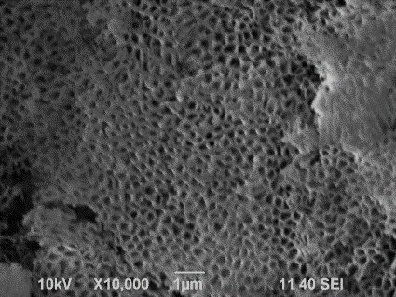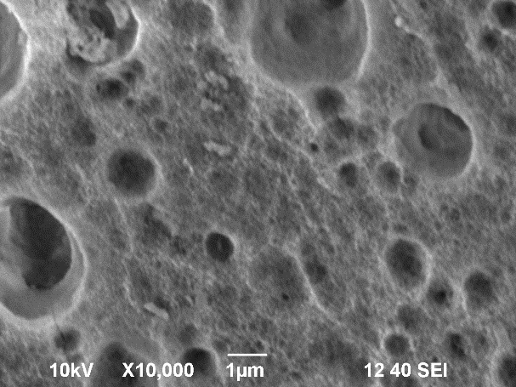
Figure 2. Different APA substrates
3. Results and discussion
All porous surfaces presented a higher number of adhering cells than different smooth controls of glass, polymer, and flat aluminum oxide without cell-adhesion promoting biomolecules. Coelomocytes readily adhered to the APA substrate up to 5 DIV: it can be observed that the nuclei are intact, and are all characterized by the same oval shape and size.

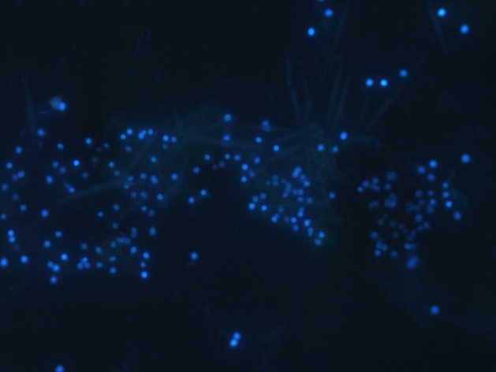
Figure 3. Culture cells on APA at DIV5, after staining with DAPI
4. Conclusions
The different pore size does not seem to have statistically significant effect on cell adhesion and this means that pore dimension can be optimized based on the need to realize an electrical read-out, to be carried out by impedance measurements.
References
- T. Hartung, Comparative analysis of the revised Directive 2010/63/EU for the protection of laboratory animals with its predecessor 86/609/EEC – a t4 report. ALTEX 27, 285-303, 2010.
- C. Falugi, M.G. Aluigi, M.C. Chiantore, D. Privitera, P. Ramoino, M.A. Gatti, A. Fabrizi, A. Pinsino, V. Matranga, Mar. Environ. Res, 76 (2012) 114-121.
- C. Gambardella, S. Ferrando, A. Gatti, E. Cataldi, P. Ramoino, M.G. Aluigi, M. Faimali, A. Diaspro, C. Falugi, Environ. Toxicol. 31 (2016) 1552-1562.
- M. Salerno, N. Patra, R. Losso, R. Cingolani, Materials Letters 63 (2009), 1826.

