Multi-scale characterization of precipitated silica in terms of vacuum insulation panels
Manuel Meier¹, Sebastian Sonnick², Ermek Asylbekov¹, Mira Klinge¹, Matthias Rädle², Hermann Nirschl¹
1 Karlsruhe Institute of Technology, Institute for Mechanical Process Engineering and Mechanics, Karlsruhe, Germany
2 Mannheim University of Applied Sciences, Institute of Process Control and Innovative Energy Conversion, Mannheim, Germany

Corresponding author: manuel.meier@kit.edu
Highlights
- Multi-scale characterization of precipitated silica using SAXS, AUC and REM
- Analysis of aggregate structure using pore size determination techniques
- Determination of fractal dimensions, sediment structure as well as porosity
- Correlation of the measurement data with mathematical models

1. Introduction
Ensuring the cold chain is a prerequisite for maintaining product quality in a global market. The requirements for insulation material are accordingly clearly defined: high insulation effect at low weight, high transport stability and low production costs. A material that meets all the requirements is foamed polystyrene. In terms of sustainability, oil free materials have been under investigation for their use as insulation material for some time now. However, in many cases, alternative materials are overpriced in production or delivery costs. Previous studies showed, that precipitated silica is an interesting alternative to conventional insulation materials. In addition to low production costs, precipitated silica has low bulk density, low flammability and good biodegradability. On market, there are a lot of materials available for a wide range of industrial applications. Nevertheless, most of these materials are developed in the respect of their effect on product but not in particle characteristics. This investigation takes into account both nanoscopic properties such as primary particle and aggregate size, their fractal dimension and the size distribution within the aggregate, as well as mesoscopic properties of the pellets.

2. Methods
This work deals with the metrological description of precipitated silica by a multi-scale characterization. Measurements by means of small angle X-ray scattering (SAXS) and electron microscopy allow a statement to be made about the basic structure levels of an aggregate: fractal dimension of surface, primary particle size, fractal dimension of mass and the aggregate size. To combine information about the aggregate with information about the sediment structure itself, porosimetry and centrifugation techniques were used.

3. Results and discussion
The obtained results allow a realistic aggregate computation and building of a sediment structure of precipitated silica by DEM simulations (see Figure 1). The computation based on a fundamental consideration of the structure of aggregates by diffusion-limited aggregation (DLA) made by Forrest and Witten [1] and Witten and Sander [2, 3]. Assumptions for the modelling of the compactness of the individual aggregates were examined under consideration of geometric and scatter-based approaches.

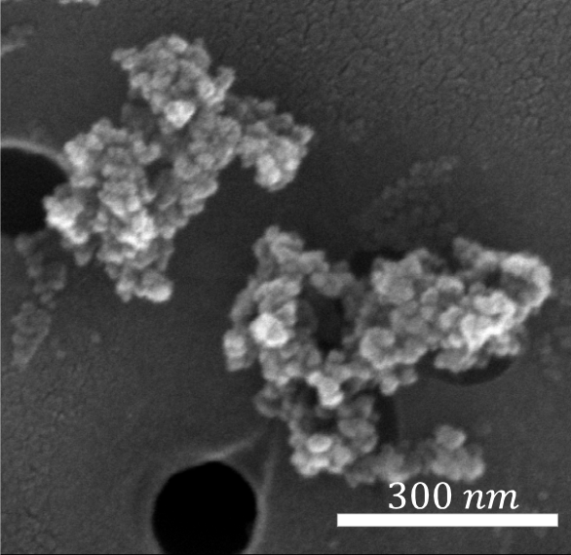
Figure 1. TEM image, aggregate computation and sediment structure of a precipitated silica.

4. Conclusions
In this study we performed a multi-scale characterization of several precipitated silica including small-angle X-ray scattering (SAXS), analytical (ultra-) centrifugation as well electron microscopy and pore size characterization techniques. The correlation of the obtained measurement data with mathematical models allow a statement to be made about the aggregate structure. Pore size characterization techniques using mercury and nitrogen provided information on the porous structure of the aggregates with respect to the pore inlet diameter and the pore diameter itself. The knowledge gained here allows us to gain a deeper understanding of the structure and description of fractal aggregates of precipitated silica.

References

[1] S.R. Forrest, J. T. A. Witten, Long-range correlations in smoke-particle aggregates, Journal of Physics A: Mathematical and General, 12 (1979) L109.
[2] T.A. Witten, L.M. Sander, Diffusion-Limited Aggregation, a Kinetic Critical Phenomenon, Physical Review Letters, 47 (1981) 1400-1403.
[3] T.A. Witten, L.M. Sander, Diffusion-limited aggregation, Physical Review B, 27 (1983) 5686-5697.

