Laccase-catalyzed degradation of micropollutants – Relation between the degradations of bisphenol A and diclofenac when in a mixture
Rosalie Pype¹, Frédéric Debaste¹
1 Department of Transfers, Interfaces and Processes, Université libre de Bruxelles, Av. F.D. Roosevelt 50, ULB CP165/67, 1050 Brussels, Belgium
*Corresponding author: rosapype@ulb.ac.be
Highlights
- Bisphenol A radicals enable the degradation of Diclofenac in mixes.
- A kinetic relation can be established between the degradations of BPA and DCF.
- That relation is independent of the initial concentrations and enzymatic activity.

1. Introduction
A micropollutant is a substance that has a negative impact on the organisms of the environment even at very low concentrations (ng/L to µg/L). An important source of micropollutants in surface waters is the release of wastewater treatment plants (WWTPs) effluents [1]. Enzymatic treatments have been studied as a mean to remove micropollutants. One of the most studied enzymes is laccase, an oxidase that oxidizes its substrate to form a reactive radical with the concomitant reduction of molecular oxygen to water. The formed radicals can then undergo non-enzymatic reactions [2]. Several papers highlighted that interactions took place between the compounds when several micropollutants were present in a mix [3,4]. In this study, the mechanisms underlying micropollutants removal were investigated in single-compound reactions and binary mixes, as well as the impacts of the interactions on the degradations kinetics including a relation between the degradations of the two compounds.
2. Methods
Laccase-catalyzed degradations of bisphenol A (BPA) and diclofenac (DCF) were performed at 20°C in phosphate buffer (pH7). The solution Novozym 51003, a commercial laccase preparation from Novozymes, was used as the enzyme source. The laccase activity was determined has described in [5]. The reactions were performed using BPA and DCF in single-compound medium (5 mg/L and 10 mg/L) and mixes (5 mg/L each, 5 mg/L BPA with 10 mg/L DCF and 10 mg/L BPA with 5 mg/L DCF) with either 3000 U/L or 1500 U/L of laccases. Samples were withdrawn at 0h00, 0h30, 1h00, 2h00, 3h00, 4h00, 5h00 and 6h00 of reaction. They were immediately mixed with 30 µL of sodium azide 1M to stop the enzymatic reaction and centrifuged before being analyzed through HPLC-UV. All experiments were performed in triplicate.
Chemical equations and reaction rates were used as a basis to determine the kinetic relation between the degradations of BPA and DCF.

3. Results and discussion
In single-compound reaction, the degradation of BPA at a given time was higher for a higher enzymatic activity (3000 U/L) and for a higher initial concentration (10 mg/L). The augmentation of the degradation when a higher enzymatic activity is used is expected as the laccase catalyze the reaction. The increase of the degradation when a higher concentration of BPA is used can be explained by the reaction of the radicals formed through the laccase-catalyzed oxidation of BPA with BPA molecules.
When in single-compound reaction, DCF was not degraded by laccase. That can be linked to the fact that the laccase contained in Novozym 51003 is a laccase with low redox-potential from Myceliophthera thermophila. So, as DCF is more recalcitrant than BPA, its degradation can be impossible for that laccase in the considered conditions.
However, DCF was degraded up to 47% after 6h in presence of BPA. That can be explained by the radicals formed through the laccase-catalyzed oxidation of BPA reacting with DCF. The degradation of DCF (X_{DCF}) was found to be directly linked to the degradation of BPA (X_{BPA}) no matter what the reaction conditions were (see Figure 1). By building a kinetic model, the relation between these two degradations was evaluated by $X_{DCF}=1-{\left(1-X_{BPA}\right)}^{k}$ where k is a constant.
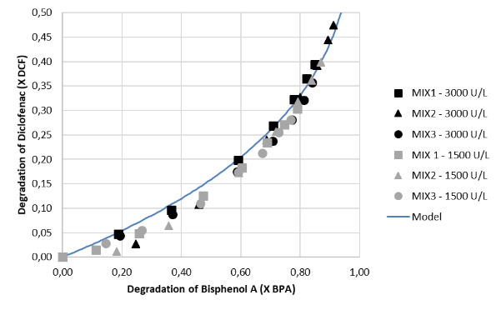
Figure 1. Degradation of DCF in function of the degradation of BPA obtained at the same reaction time. MIX1 = 5 mg/L BPA + 5 mg/L DCF, MIX2 = 10 mg/L BPA + 5 mg/L DCF, MIX3 = 5 mg/L BPA + 10 mg/L DCF. All reactions were performed at pH 7 and 20°C in triplicate (mean values of triplicates plotted). Model is the modelled relation between X_{DCF} and X_{BPA} where the constant k is 0.25.
4. Conclusions
The radicals formed through laccase-catalyzed degradation of BPA can react with other compounds present in the medium. Radicals participate to the degradation of BPA in single-compound medium and enable the degradation of DCF in mixes. A kinetic relation can be established between the degradations of BPA and DCF independently of the initial concentrations and enzymatic activity in the range of the tested conditions.
References
- Y. Luo, W. Guo, H. H. Ngo, L. D. Nghiem, F. I. Hai, J. Zhang, S. Liang, X. C. Wang, Sci. Total Environ. 473 (2014) 619-641.
- H. Claus, Micron 35 (2004) 93-96.
- J. Margot, J. Maillard, L. Rossi, D.A. Barry, C. Holliger, N. Biotechnol. 30 (2013) 803-813.
- R. R. Nair, P. Demarche, S. N. Agathos, N. Biotechnol. 30 (2013) 814-823.
- C. Hautphenne, F. Debaste, Chem. Eng. Technol. 38 (2015) 1223–1228.

