Are steady-state kinetics sufficient for the simulation of the transient CO₂ methanation?
Bjarne Kreitz¹, Jan Martin¹, Steffen Flaischlen¹, Gregor Wehinger¹, Thomas Turek¹
1 Institute of Chemical and Electrochemical Process Engineering, Clausthal University of Technology, Leibnizstr. 17, 38678 Clausthal-Zellerfeld
*Corresponding author: kreitz@icvt.tu-clausthal.de
Highlights
- Transient operation of the Sabatier reaction on Ni catalysts
- Dynamic simulation the methanation in a Berty reactor
- Storage effects on the catalyst are visible during concentration forcing
- Steady-state kinetics fail to describe the transient behavior

1. Introduction
Heterogeneously catalyzed processes are usually operated in steady state. The coupling of these processes to renewable energy sources, such as the methanation of CO₂ in the Power-to-Gas process, may require a dynamic operation of the reactor. Reaction kinetics resulting from steady-state measurements, mostly in the form of Langmuir-Hinshelwood-Hougen-Watson approaches, are typically used for the reactor design or the investigation of suitable operating conditions. The simulation of the periodic operation of a methanation reactor based on steady-state kinetics predicted dramatic effects of the inlet composition on temperature profile and outlet composition [1]. However, the underlying description of the reaction rate is a strong simplification of the actual processes on the catalyst surface. A detailed description of the transient and steady-state operation can be achieved by microkinetic models [2]. But microkinetics are rarely applicable for simulation and design on the reactor scale. Therefore, the aim of this study is dedicated to the detailed experimental investigation of the dynamic methanation on Ni catalysts in order to verify whether steady-state kinetics can describe the observed transient phenomena.
2. Methods
In order to develop a proper kinetic approach, measurements with a Ni catalyst in a Berty reactor are carried out. At temperatures of 200 - 400°C and pressures up to 30 bar, this reactor can be regarded as an ideally mixed continuous stirred tank reactor (CSTR). Through online analysis of the gas composition with a mass spectrometer, both stationary and dynamic measurements can be performed with high temporal resolution. For the investigation of the dynamic behavior of the methanation reaction, concentration pulses and steps are applied to the system. The high frequency of the step changes also allows for a periodic modulation of the system. During the dynamic catalyst operation, storage effects of adsorbed educts and intermediate products become visible. Additionally, the storage capacity is studied via the adsorption of CO₂ and H₂ at reaction temperatures by volumetric and dynamic adsorption methods, which allows the determination of adsorption isotherms and adsorption kinetics. Based on the experiments, approaches for the reaction kinetics (steady-state, dynamic) are developed. These are used in a model of the Berty reactor to explore the limits of steady-state kinetics and the applicability of simplified dynamic kinetics. The Berty reactor is modelled as a CSTR taking the catalyst as a separate solid phase into account.
3. Results and discussion
The bang-bang operation of a Ni/Al₂O₃ catalyst, where the reactor inlet composition is alternated between pure H₂ and CO₂, can be described with a relatively good accuracy by using a published steady-state reaction kinetics [3]. Figure 1 shows the transient operation of the same catalyst with a flush of He between the step changes in order to remove the remaining CO₂ from the gas phase. Switching to H₂ then leads to desorption of adsorbed CO₂ and methane formation sets in. This simple experiment nicely illustrates the failure of the steady-state reaction kinetics. Since H₂ and CO₂ do not simultaneously occur in the reactor, the calculated reaction rate is always zero. The observed methane formation reveals that significant quantities of CO₂ and/or carbon containing intermediates are adsorbed on the catalyst surface, which is also evidenced by the adsorption measurements.
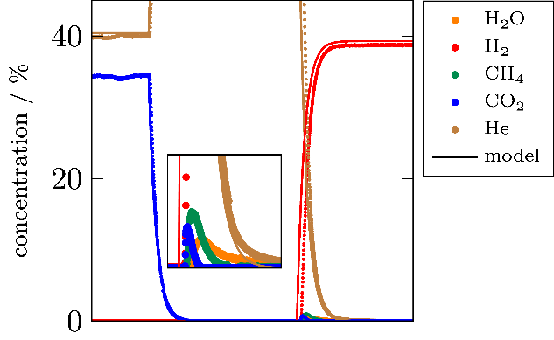
Figure 1. Experimental (dots) and simulation (solid) results when the Berty-reactor is flushed with He for 10 min between a change from CO₂ to H₂. The zoom is located at the step change of H₂. Conditions: 20 wt.-% Ni/Al₂O₃, 0.5 g, 250 °C, 2 bar, 200 mL_{N}/min.
4. Conclusions
The comparison of the reactor simulation and kinetic experiments shows, that steady-state kinetics are able to predict transient phenomena of the Berty reactor when both reactants are present in the gas phase. If, however, a component is missing, as shown in the experiment, the steady-state kinetics cannot correctly reproduce the behavior of the reactor. In order to be able to reproduce the transient results, it is necessary to develop dynamic kinetic approaches which can also be used on the reactor scale.

References
[1] B. Kreitz, G.D. Wehinger, T. Turek, Chem. Eng. Sci., 195 (2019) 541-552.
[2] C. Seidel, A. Jörke, B. Vollbrecht, A. Seidel-Morgenstern, A. Kienle, Chem. Eng. Sci., 175 (2018) 130–138.
[3] F. Koschany, D. Schlereth, O. Hinrichsen, Appl. Catal., B, 181 (2016) 504–516.

