Recovery of lipids from microalgae extracts by membrane processes: Comparison of cross-flow and shear-enhanced filtration performances.
Estelle Couallier¹, Shuli Liu¹, Erika Clavijo ¹, Liliana Villafaña Lopéz¹, Matthieu Frappart¹
¹ CNRS, GEPEA, CRTT, 37 boulevard de l’université, BP 406
44602 Saint Nazaire Cedex, France
*Corresponding author: Estelle.couallier@univ-nantes.fr
Highlights
- Membrane filtration allows the concentration of lipids from disrupted microalgae.
- The rotatin disk filtration with a PAN membrane offers the best performances.
- An optimized coupling between cell disruption and filtration will enhance the biorefining.

- Introduction
The biorefinery of renewable resources like microalgae offers great opportunities to substitute biomolecules to traditional raw materials in various industry sectors. Such strategies necessitate innovative choices of soft and energy-efficient processes to guarantee the integrity of fragile molecules and develop eco-friendly production. For large-scale production (food, energy or green chemistry), a wet processing of biomass has been proposed, that avoids expensive drying steps and reduces solvent use. However the energetically efficient extraction of biomolecules at low cost and industrial scale is not yet mature. Biomass wet treatment includes 1- the harvesting, 2- the cell disruption step to release the valuable biochemical compounds in the aqueous phase, 3- the fractionation step (extraction, concentration and purification). The integration of membrane processes into the microalgae downstream processing concerns the harvesting and the concentration of microalgae, but membrane filtration is also a promising clean separation process for the fractionation step.
In this work we focus on the recovery of lipids from Parachlorella kessleri, cultivated in starving conditions to enhance their lipid production. The lipid recovery from microalgae was mostly performed with supercritical CO₂ on dried matter or solvent extraction. In this study we will focus on the recovery of lipids from aqueous extracts by membrane processes. Clavijo et al. [1] demonstrated that the supernatant after bead milling and centrifugation of Parachlorella kessleri contains emulsified lipids in aqueous phase. The membrane separation of those valuable compounds is studied.

2. Methods
In this work a model solution was formulated, based on the analysis of ground Parachlorella kessleri [1].Then the performances (retention, flux, fouling, cleanability) of polyacrylonitrile (PAN), polyethersulfone (PES) and polyvinylidene fluoride (PVDF) membranes to concentrate lipids from Parachlorella kessleri aqueous extracts were evaluated, using the model solution. The most appropriate material and conditions (TMP) were then selected and validated on real microalgae fractions. Two modules were compared allowing the crossflow (CF) and the rotating disk (RD) filtration.
3. Results and discussion
The PAN 500kDa membrane presented the best performances (flux, lipid retention and cleanability) in crossflow and rotating disk filtrations. It was selected to test the filtration of real aqueous extracts from Parachlorella kessleri. The performances of the PAN membrane in CF module with the real products was similar to the one with the model solution despite the composition differences. The lipids are totally retained whereas some of the hydrophilic compounds (polysaccharides and proteins depending on the conditions) could permeate. The use of RD filtration allows reducing the membrane fouling, using a higher transmembrane pressure thus leads to higher fluxes. In the case of real aqueous extracts RD filtration, the water permeability is enhanced by the accumulation of hydrophilic compounds whereas the shear rate limits the membrane clogging by the lipids. The RD filtration using a PAN membrane presents the best performances.
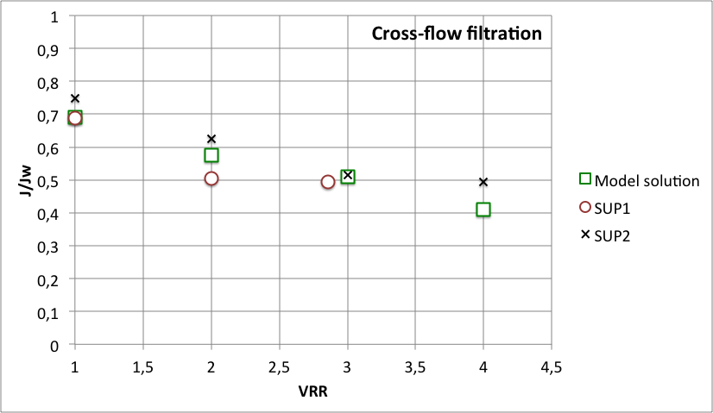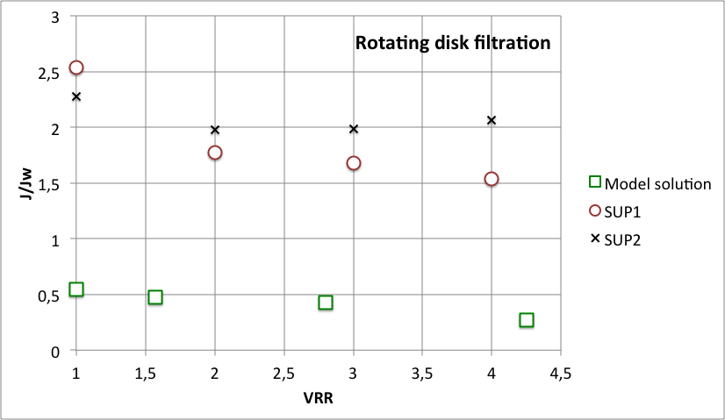
Figure 1. Crossflow and rotating-disk filtrations of an emulsion (model solution of concentrated microalgae aqueous extract) and two real aqueous extracts (SUP1 and SUP2) with a PAN membrane.
4. Conclusions
The membrane filtration is a relevant seperation process to concentrate the lipids, reduce the volume of water to treat for further purification steps and offers interesting opportunities for the fractionation of biomolecules from microalgae. An optimization of the coupling with the upstream operations (culture, cell disruption, clarification) would enhance the separation.
References
[1] E. Clavijo Rivera, V. Montalescot, M. Viau, D. Drouin, P. Bourseau, M. Frappart, C. Monteux, E. Couallier, Bioresource Technology, 256 (2018) 77 - 85

