Process development of a new green propellant: synthesis, isolation and performances
Valentine Passignat¹, Anne Dhenain¹, Anne-Julie Bougrine¹
1 Hydrazines and Polynitrogen Energetic Compounds Laboratory – UMR 5278 CNRS/UCBL/CNES/ARIANEGROUP University of Lyon, Claude Bernard Lyon 1 University, France.
*Corresponding author: anne-julie.bougrine@univ-lyon1.fr
Highlights
- Design of an innovative, efficient and scalable process of synthesis with yields of the useful product higher than those of literature
- Definition and optimization of the unitary operations of extraction by determination of the various solid-liquid-liquid ternary phase diagrams involved
- Characterization of the energetic properties of the propellant of interest
- Very promising substitute for the replacement of highly toxic hydrazines

1. Introduction
Propellants, which are part of the space hydrazines family, are mainly used in the aerospace and defense industries, in storable propellant engines for launchers, in satellite apogee motors as bipropellants, associated with nitrogen peroxide, and as mono-propellants in trajectory correction thrusters. In this paper, we describe the development of a new storable, reducing liquid propellant with prospective use in space launchers. Tetramethyl-2-tetrazene and its derivatives was identified by the French Space Agency (CNES) as interesting candidates^{[1]} to replace highly toxic hydrazines such as monomethylhydrazine (MMH), which is considered a substance of high concern (SHC) and is prone to be banned by the REACH European Union regulation. The molecule of interest in this study is the cyclic tetramethyl-2-tetrazene (1,4,5,6 tetrahydro-1,2,3,4 tetrazine C₄H₁₀N₄), which should provide optimum propulsive performances and should not have a significant impact on human health and the environment. The objective of the first stage will be to develop a green synthesis process that is competitive on the international level, in line with sustainable development and which can adapt to market fluctuations.
2. Methods
Cyclic tetramethyltetrazene (c-TMTZ) is obtained by two successive reactions: the first step is the synthesis of the bishydrazine by nitrosation of the amine followed by a reduction^{[2]}. The second reaction is the oxidation of this bishydrazine leading to the formation of c-TMTZ by intramolecular cyclization^{[3,4]}. Due to the low yields described in the literature, a study was carried out in the laboratory to optimize the oxidation conditions of bishydrazine and obtain the highest yields of c-TMTZ. The reaction kinetics were deduced from the in-situ concentrations of c-TMTZ obtained by RMN ¹H spectroscopy. The second part of the work focused on the design of the extraction and isolation process of c-TMTZ. In the actual process, the extraction of the bishydrazine (BH) from the complex reaction media is the key and tedious step of the global process, implying numerous unitary operations of distillation (at various pressures) and filtration, leading to a low yield of extraction. In our new concept, the basic idea would be to benefit from a gap of miscibility at the liquid state in the ternary system BH-H₂O-NaOH. Several isotherms of the solid-liquid-liquid ternary system BH-H₂O-NaOH were thus determined under atmospheric pressure. The demixing binodal curve and limits of each domain were obtained by combination of acidimetric titrations of phases in equilibria and conductimetric measurements. The final part of this work describes some energetic properties of c-TMTZ, essential for spatial applications: temperatures end enthalpies of melting and decomposition (DSC), impact sensitivity (BAM tester) and hypergolicity character.
3. Results and discussion
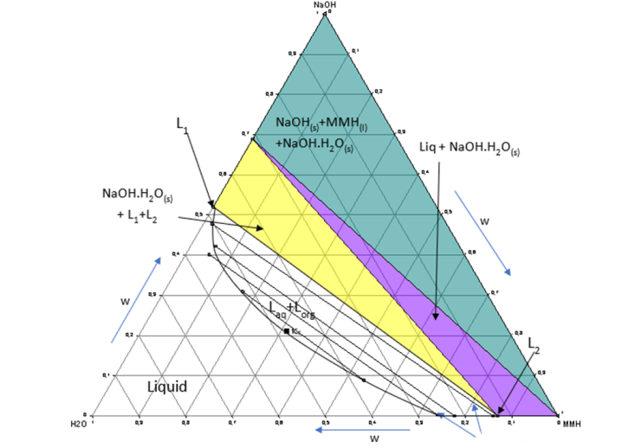
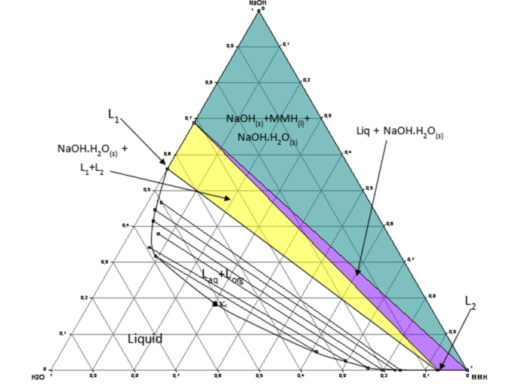
For the synthesis segment, influence of the nature of the oxidizer, concentration, temperature, solvent and pH was studied for the oxidation reaction of BH, allowing optimal conditions to be identified for c-TMTZ yields higher than 70 %. For the extraction segment, several isotherms of the solid-liquid-liquid ternary system BH-H₂O-NaOH were determined (Figures 1 and 2).

Tie-lines
Figure 1. Isothermal 293.15K of the BH-H₂O-NaOH S/L/L ternary system (P_{atm})
Figure 2. Isothermal 323.15K of the BH-H₂O-NaOH S/L/L ternary system (P_{atm})

These isotherms show the tendency of BH to demixing with NaOH and give the optimal quantities of NaOH to add in order to have the organic species concentrated in a single phase, separated from the salts and with a minimum of water. For the extraction of pure BH, 2 unitary operations are thus required instead of 4. Then, c-TMTZ is recovered by distillation. The characterization of the energetic properties of this propellant reveals a promising substitute: thermal stability on a large range of temperatures, no sensitivity to impact and hypergolic behavior with oxidants.
4. Conclusions
Cyclic tetramethyltetrazene holds great potential to be used as a propellant to replace hydrazines. The global process described in this work is “green” and suitable for large-scale synthesis. Moreover, c-TMTZ can be used to obtain compounds with higher propulsive performances.
References
[1] A. Dhenain, C. Darwich, C.M. Sabaté, D.M. Le, A.J. Bougrine, H. Delalu, E. Lacôte, L. Payen, J. Guitton, E. Labarthe, G. Jacob, Chem. Eur. J. 23 (41) (2017) 9897–9907.
[2] J.N. Hogset, V.E. Matthews, United States Patent: 3365338, January 23, 1968.
[3] S. F. Nelsen, R. Fibiger, J. Am. Chem. Soc. 94 (1972) 8497–8501.
[4] C.J. Michejda, R.S. Koepke, H.D. Campbell, J. Am. Chem. Soc. 100 (1978) 5978–5979.

