The Contribution Of CO₂ Utilisation to GHG Emission Reduction:
Some Results BasedoOn A European Supply Chain Optimisation.
Federico d’Amore, Victor Baldo, Fabrizio Bezzo*
CAPE-Lab - Computer-Aided Process Engineering Laboratory, Department of Industrial Engineering, University of Padova, via Marzolo 9, 35131 Padova PD (Italy).
*Corresponding author: fabrizio.bezzo@unipd.it
Highlights
- Optimisation of a carbon capture, transport, storage and utilisation network.
- <0.6% of European CO₂ from coal/gas plants can be removed through utilisation.
- 5.5% cost reduction achievable thanks to revenues deriving from utilisation.
1. Introduction
In the last 50 years, CO₂ constituted nearly the 80% of overall anthropogenic greenhouse gases (GHGs) emissions; global actions are therefore needed to tackle the increase of carbon concentration in the atmosphere [1]. Carbon capture and storage (CCS) has been highlighted as one of the most promising options. Recently, also carbon utilisation pathways have been highlighted as potential options to reduce the costs that derive from the installation and operation of a more general CCS and utilisation (CCUS) infrastructure. Nevertheless, there is debate on the actual effectiveness of the chemical conversion of CO₂, indicating that only minor environmental benefits could be obtained [2]. In this work, the aim is to evaluate the effects of CCUS from an economic perspective and to assess what contribution may derive from CO₂ utilisation for conversion into chemical products at a European level.
2. Methods
This contribution proposes a static mixed integer linear programming model for the economic optimisation of European CCUS supply chains (SCs). Building up from [3], the European territory is discretised by aim of set g of 124 squared cells and the SC takes into account the location of large stationary sources of CO₂, the techno-economic description of set k for carbon capture options, of set l of transport means, the location and size of storage basins, and the techno-economic features of the CO₂ utilisation stage via set c of chemical outputs. Given the numerous reaction mechanisms for CO₂ conversion [4], a restricted number of processes was selected according to the following principles: (i) minimum production threshold according to market demand (>1Mt/year of converted CO₂); (ii) techno-economic data availability (productivity and costs); (iii) environmentally promising (CO₂ emissions lower than consumption); (iv) current technology economically promising (the conversion process must generate a profit). As a result, set c = {PPP, MeOH}.
3. Results and discussion
The CCUS model was optimised using the GAMS CPLEX solver on a 16GB RAM pc in 27h (optimality gap <1%). As reference case, results from [3] of the optimal CCS network are reported (Scenario 0). The CCUS system (Scenario A) is optimised according to the selection of a reduction target of 43% of European CO₂ emissions from large stationary sources (consistent with [5]), and imposing to satisfy the current European production of PPP and MeOH. As a result, the SC entails a total cost TC for installing and operating the CCUS network that is reduced by 5.5% with respect to Scenario 0, because the introduction of chemical conversion brings in some revenues (with a profit equal to 1.57€/t). Conversely, the chemical conversion of CO₂ allows just a slight reduction of 0.7% of total capture costs TCC, which decrease from 30.93€/t (Scenario 0) down to 30.72€/t (Scenario A). The total transport cost TTC slightly varies from 1.96€/t (Scenario 0) to 1.90€/t (Scenario A). Despite a small decrease in the exploitation of geological storage (i.e., -1.44%), total sequestration costs TSC are unchanged between Scenario 0 and Scenario A (0.47€/t and 0.46€/t, respectively). In terms of CO₂ emission reduction, the net impact of utilisation amounts to 0.58% of the overall captured amount (comparable with [2]). It can be observed that the SC configuration is nearly identical between Scenario 0 and A (Figure 1). Including utilisation, capture points do not change and the main driver to establish the transport system is still the location of the sequestration sites.
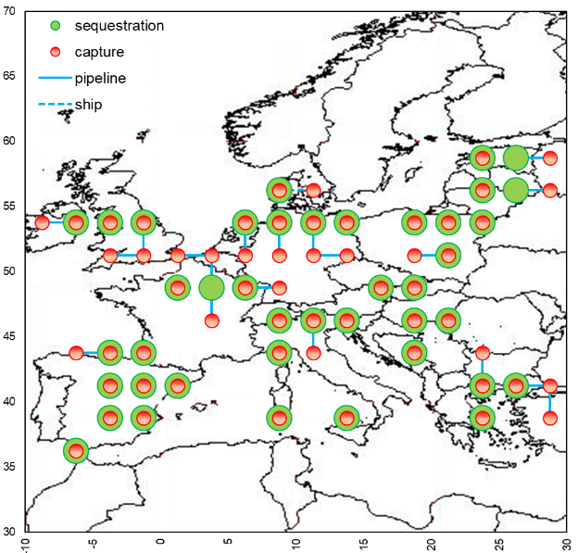 | 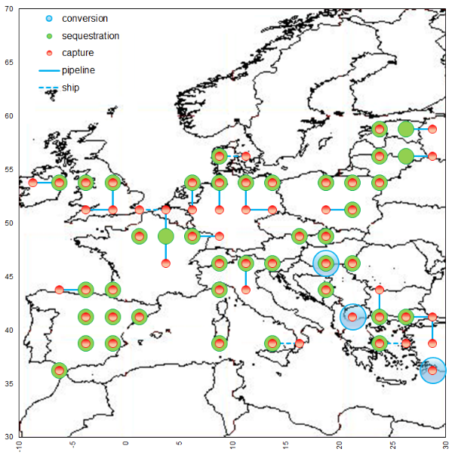
(a) | (b)
Figure 1. Final SC configurations for (a) Scenario 0 and (b) Scenario A.
4. Conclusions
This work has assessed the potential impact of a European CCUS SC. Results show that the environmental impact of CO₂ utilisation is likely to be a minor one (<0.6% reduction in GHG emissions for the chemicals considered in this study). The main benefit is the reduction of the overall costs (decreasing by 5.5%), since conversion would provide for new revenues (differently from sequestration).
References
- IPCC, Climate Change-Synthesis Report, Geneva, 2014.
- N. Mac Dowell, P.S. Fennell, N. Shah, G.C. Maitland, Nat. Clim. Chang. 7 (2017) 243-249.
- F. d’Amore, F. Bezzo, Int. J. Greenh. Gas Control 65 (2017) 99-116.
- M. Aresta, A. Di Benedetto, A. Angelini, J. CO₂ Util. 3-4 (2013) 65-73.
- EC, Implementation of Directive 2009/31/EC, Brussels, 2017

