Optimal Process Design for a Sustainable Methanol Production Using Renewable Energies by Applying the FluxMax Approach.
Dominik Schack¹, Kai Sundmacher^{1,2}
1 Max Planck Institute for Dynamics of Complex Technical Systems, Sandtorstr.1, D-39106 Magdeburg, Germany; 2 Otto-von-Guericke-University Magdeburg, Universitätsplatz 2, D-39106 Magdeburg, Germany
*Corresponding author: schack@mpi-magdeburg.mpg.de
Highlights
- Simultaneous flux optimization and heat integration.
- Decoupling of nonlinearities by discretization of thermodynamic state space.
- Versatility of FluxMax approach demonstrated at different levels of details.
- Powerful tool for identification of novel, non-intuitive, processes.

1. Introduction
In the context of energy transition, one of the major goals of the chemical industry is to replace fossil raw materials with renewable resources by using sustainable process technologies. However, even if in the main focus of interest, not only the substitution of feedstock, but also an increase in energy efficiency will be decisive for a successful transition towards a more sustainable production of chemicals. In order to enhance the overall process efficiency, challenges must be faced at different levels of detail. While at the plant level, more general questions and early stage decisions of chemical production networks are addressed, at the process level and process unit level the detailed optimization of chemical processes and process units is in the focus. We developed the FluxMax approach that enables the simultaneous flux optimization and heat integration by discretization of the thermodynamic state space. As a consequence, process-based nonlinearities are decoupled effectively from the flow optimization problem, which allows the optimization of chemical processes across different length. Heat integration is considered as integrated part of the optimization problem by introducing additional inequality constraints, which results in an outperformance compared to classical, sequential approaches.
2. Methods
The general idea of the FluxMax approach is an effective decoupling of process-based nonlinearities from the subsequent network flux optimization by discretization of the thermodynamic state space. The discretization allows the representation of chemical process across different length scales, which enables the transformation of a nonlinear process optimization problem into a convex flux optimization on a defined network graph. The chemical process is represented as directed graph, where the nodes correspond to thermodynamic substances, elementary processes and heat and work utilities. While each mixture is uniquely determined by thermodynamic coordinates, the elementary processes are uniformly described by stoichiometric equations. The edges, that connect the nodes, correspond to mass- and energy fluxes, and are decision variables of the optimization problem. As a result, the FluxMax approach can be divided into the three steps: i) discretization of the thermodynamic state space; ii) modeling of elementary processes; and iii) solution of the flux optimization problem.
3. Results and discussion
The methanol synthesis process was selected as example to apply the FluxMax approach to different levels of details. At the plant level [1,2] we systematically analyzed the influence of feedstock and energy sources on the specific methanol production cost and its specific CO₂ emissions. It could be shown that an economically competitive production process can be designed also under the usage of renewable energies (Figure 2 A). As a consequence of the simultaneous consideration of heat integration, the FluxMax approach identified energy-optimal process configurations [3], which outperform configurations identified in a sequential procedure (Figure 2 B). The proof-of-concept for the application at process unit level was provided for the reactor (Figure 2 C) and compressor cascade design of the methanol synthesis [4].
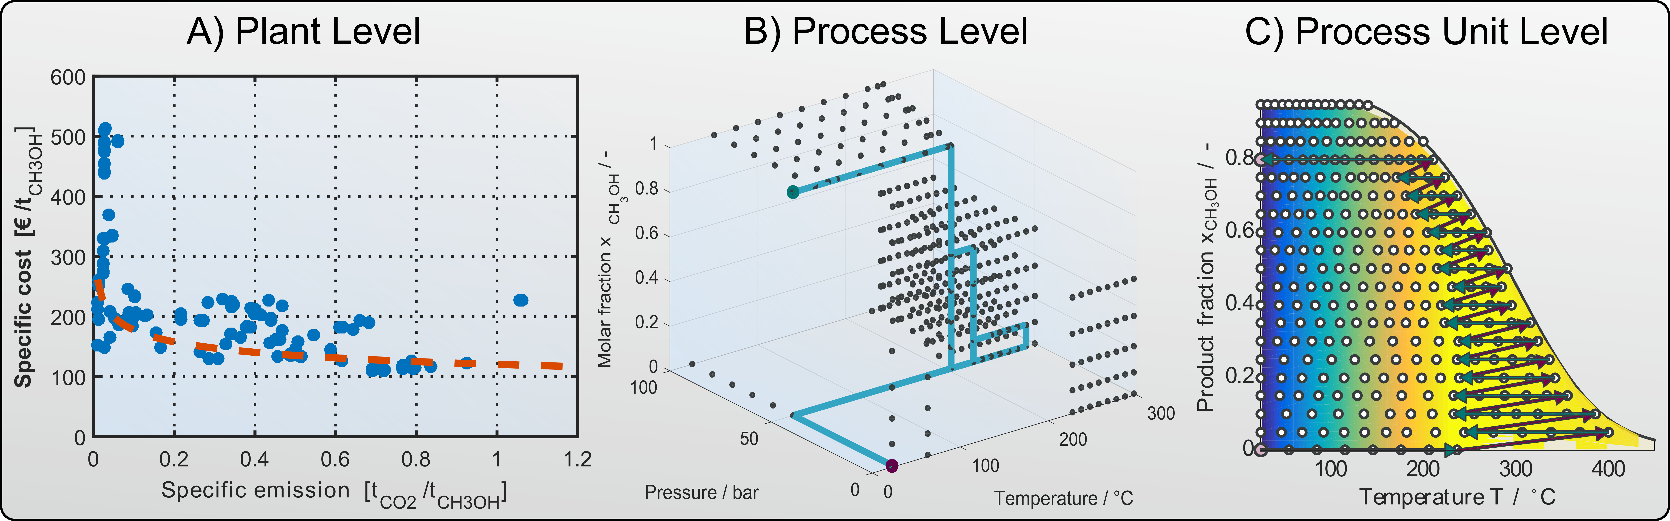
Figure 1. Pareto optimum of competing objectives, specific cost and CO₂ emissions (A), optimal trajectory of methanol synthesis process within discretized thermodynamic state space (B), and kinetic rate optimization of reactor part (C).
4. Conclusions
In this contribution, the FluxMax approach for the optimization of chemical processes across different length scales is presented, which enables the simultaneous flux optimization and heat integration. The introduction of nodes corresponding to mixtures, elementary processes and utilities allows the representation of any chemical process as a directed graph, with the edges corresponding to the mass and energy fluxes to be optimized. As a consequence, the FluxMax approach effectively decouples process based nonlinearities from the optimization problem. The heat integration is considered by additional constraints in the optimization. Using the methanol synthesis process as example, the FluxMax approach was applied to different levels of details. In particular the outperformance compared to classical approaches makes the FluxMax approach a powerful tool for designing chemical processes across different length scales.
References
- D. Schack, L. Rihko-Struckmann, K. Sundmacher, Comput.-Aided Chem. Eng. 38 (2016) 1551–1556.
- D. Schack, L. Rihko-Struckmann, K. Sundmacher, Ind. Eng. Chem. Res. 57 (2018) 9889–9902.
- D. Schack, G. Liesche, K. Sundmacher (submitted).
- G. Liesche, D. Schack, K.H.G. Rätze, K. Sundmacher, Comput.-Aided Chem. Eng. 43 (2018) 881–886.

