Numerical Modelling of Emulsion Preparation Through CFD.
Guido Lupieri^{1*}, Adam J. Kowalski¹ and Jo J.M. Janssen²
1 Unilever R&D, Port Sunlight Laboratory, Quarry Road East, Bebington, Wirral CH63 3JW, UK;
2 Unilever Research and Development, Olivier van Noortlaan 120, 1330 AC Vlaardingen, The Nederlands
*Corresponding author: Guido.Lupieri@unilever.com
Highlights
- High shear mixing and emulsification processes in high phase volume products
- Experimental models for numerical applications
- Population balance and instability

1. Introduction
Experiments and numerical modelling are considered crucial steps to control production in modern industrial processes since ensure the best quality of the product and the repeatability at the desired scale. These ideas apply also to the study of product preparation, when suited models of emulsification, viscosity, oil droplet distribution and size have been obtained in experimental sessions by one of the authors [1] or from existing computing libraries [2], [3]. This work concerns the modelling through Computational Fluid Dynamics instruments and scales of a step in the complex mixing process necessary to prepare the high phase volume emulsions in a standard [4] rotating geometry. The final goal is to control some of the most important properties of the emulsion like creaminess and taste.

2. Computing methods
The problem considers and simplifies the geometry of Figure 1 (a) in a computing domain discretized with polyhedral cells as in Figure 1 (b) where a multiphase segregated flow reproduces product and oil droplet. Finite Volume approach is assumed to resolve a set of differential equations for mass transport, momentum (and eventually energy) of each phase. All the phases share a common pressure field while for each one is defined a volume fraction according to VOF (Volume of Fluid) approach [3]. Interaction between phases is also assumed with models for drag force and droplet length scale, S-gamma [2] particle breakage and coalescence is adopted, the flow is considered and modelled in turbulent regime. A constitutive equation for viscosity is obtained from a Cross model modified according to the results in [1].
3. Results and discussion
Among the results, the oil droplet size at the outlet of the mixer is compared with the measures. An interesting feature of this flow is the possible development of instabilities in the small gap between the rotor and the cone mill walls as shown in Figure 1 (c).
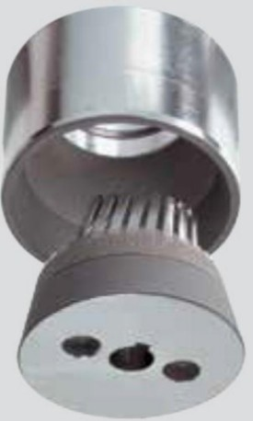(a)(b)
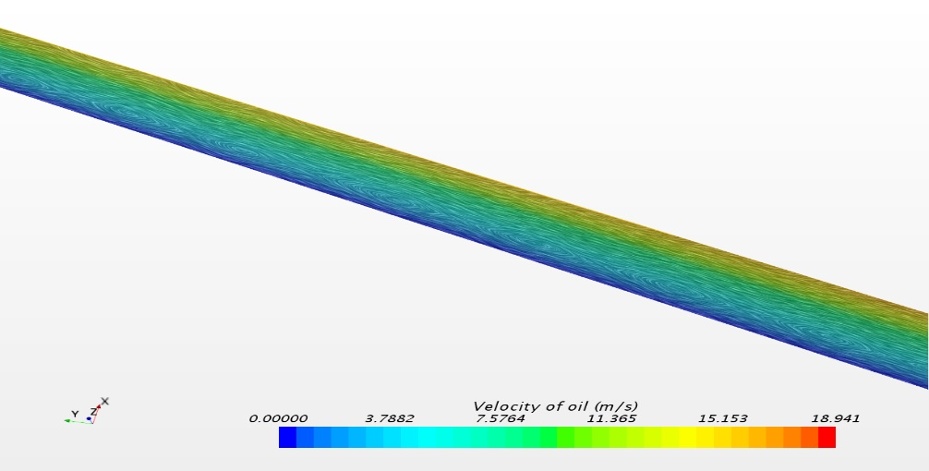 (c)
Figure 1. IKA cone mill from [4] on (a). A sketch of the computing domain on (b). Instability patterns of oil droplet patterns on (c).
4. Conclusions
By varying the rotation speed of the mixer, some numerical simulations have been conducted vs experiments in order to validate the approach and provide an affordable instrument for further analysis on in-house production processes.
References
- A. Dubbelboer, Jo J.M. Janssen, H. Hoogland, E. Zondervan, J. Meuldijk (2016). Chemical Engineering Science, 148, pp. 32-43.
- S. Lo and D. Zhang (2009). Modelling of Break-up and Coalescence in Bubbly Two-Phase Flows. J. Comp. Multiphase Flows, 1, pp. 23-38.
- C.W. Hirt and B.D. Nichols (1981). Volume of Fluid (VOF) Method for the Dynamics of Free Boundaries. Journal of Computational Physics, 39, 201-225.
- IKA Group. IKA Process Technology Brochure. www.ikausa.com

