Enzymatic Recovery of Building Blocks from Textile Blends.
Felice Quartinello¹, Alessandro Pellis², Georg M. Gübitz¹
1 University of Natural Resources and Life Sciences BOKU Vienna, Department of Agrobiotechnology IFA-Tulln,;
2 University of York, Department of Chemistry, Green Chemistry Centre of Excellence,
*felice.quartinello@boku.ac.at
Highlights
- Circular economy concept
- Textile waste recycling
- Enzymatic separation and degradation of fibres.
- Secondary value-added products

1. Introduction
In the last decades the production of textiles, especially for clothing, is exponentially increasing mostly due to the globalization phenomena [1].In Europe, 80.000 tons of textile waste are generated per year and their end-life is primarily landfilling. Together with soil pollution, this represents also a global warming challenge due the production of greenhouse-gases [2]. For example only 18% of this kind of waste in the last years was used for energy recovery. Furthermore, considering the material composition, the discarded textiles still contains valuable polymers/polymer building blocks that could be reused. In this study we present an enzyme-based strategy for the recovery of valuable building blocks from mixed textile waste and blends as a circular economy concept [3,4].
2. Methods
Textile, waste was sequentially incubated with 1) protease for the extraction of amino-acids from wool components) and 2) cellulases for the recovery of glucose from cotton and rayon constituents. The purity of the remaining poly(ethylene terephthalate) (PET) unaltered by the enzymatic treatments was assessed via Fourier-transformed infrared spectroscopy. Amino acids recovered from wool were characterized via elementary and molecular size analysis, while the glucose resulting from the cotton hydrolysis was successfully converted into ethanol by fermentation with Saccharomyces cerevisiae.

3. Results and discussion
The enzymatic hydrolysis of wool- and cellulose- based fibers led to yields of approximately 95% and 85%, respectively. The purity of the resulting poly(ethylene terephthalate) was comparable to the pure PET as demonstrated by FT-IR measurements, allowing recycling. Furthermore, in line with circular economy concepts, the recovered building blocks from wool and cellulose fiber components in blended textiles can be reused. The amino acids and oligopeptides (with molecular weight lower than 10 KDa) obtained from wool degradation can be used as a replacement for carbon and nitrogen sources for germination or phenolic-related compounds for resins according to previous reports. On the other hand, in this paper recovered glucose (around 0.62 g•L⁻¹) was successfully used as carbon source for yeast fermentation to produce ethanol (0.3 g•L⁻¹).

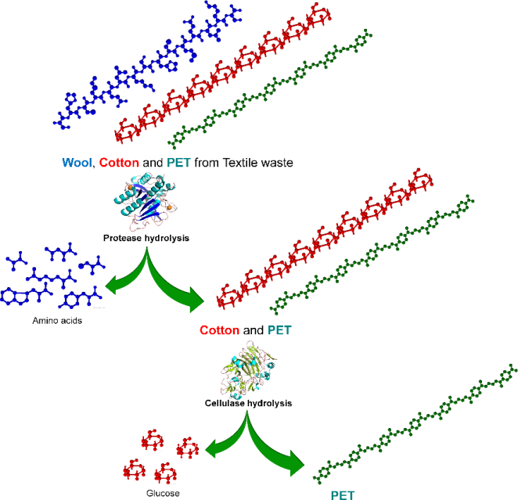
Figure 1. Scheme of enzymatic separation of textile fibers
4. Conclusions
In summary, such step-wise enzymatic process is especially attractive for the recycling of blended materials which are otherwise rather difficult to recycle with other technologies. Furthermore, this work demonstrated that the step-wise application of enzymes can be used for the recovery of pure building blocks and their further reuse, example for fermentative processes (glucose).
References
[1] Zamani, B., Peters, G. & Svasntröm, M. Towards Understanding Sustainable Textile Waste Management: Environmental impacts and social indicators. Chem. Biol. Eng. 52 (2014).
[2] European technology Platform. Towards a 4 th Industrial Revolution of Textiles and Clothing.
[3]Pellis, A., Cantone, S., Ebert, C. & Gardossi, L. Evolving biocatalysis to meet bioeconomy challenges and opportunities. N. Biotechnol. 40, 154–169 (2018).
[4]Guebitz, G. M. & Cavaco-Paulo, A. Enzymes go big: surface hydrolysis and functionalisation of synthetic polymers. Trends Biotechnol. 26, 32–38 (2008).

