A Simulation-based Support System for the Planning and Design of Modular Logistics in Chemical Production Processes.
Christian Sonntag^{1,*}, Dominik Wolff¹, Markus Zajac²
1 INOSIM Consulting GmbH, Joseph-von-Fraunhofer-Str. 20, 44227 Dortmund, Germany
2 Fraunhofer-Institut für Materialfluss und Logistik, Joseph-von-Fr.-Str. 2-4, 44227 Dortmund, Germany
*Corresponding author: christian.sonntag@inosim.com
Highlights
- Modular plant logistics are essential to realize the full potential of modularization.
- A new planning support tool enables efficient design of modular logistic systems.
- Material flow simulation quickly provides quantitative KPIs for decision support.
1. Introduction
In process industries, there is a constantly growing trend towards increasing product differentiation, shorter product life cycles, and increasing market volatility [1]. The reason for that lies in increasing market uncertainty: While in the past, usually only a few products were demanded constantly over long periods, nowadays markets require permanent innovation. This enforces raised industrial standards in production planning and logistics. To address these uncertainties, modular production concepts are receiving wide-spread attention since they allow industry to adjust their production processes quickly to changing market environments and enable a reduction in reconfiguration and adjustment times [2]. To realize the full potential of modularization, it must be extended beyond production itself to include the process logistics, including e.g. the plant supply chain, packaging, and shipping.
The increased flexibility that is provided by modular logistics systems requires new approaches for planning, engineering, and validation. In the scope of the research and innovation project LEGOLAS [3], we are developing a new planning support system for the simulation-based design of such modular logistics systems. This talk provides an overview of this system and illustrates its features on a challenging case study, the filling/packaging section of an herbicide/fungicide production plant.
2. The Planning Support System for Modular Production Logistics
The planning support system provides an environment to quickly design and validate modular logistics systems, covering scenarios such as from-scratch design, re-configuration, disturbance and fault analysis, and turnaround management.
Fig. 1 provides an overview of the iterative workflow that is supported by the planning support system. First, the user creates a set of system alternatives in a graphical drag-and-drop environment. These alternatives are then transformed into material flow models and analyzed using the INOSIM process simulation software to generate quantitative KPIs that the user then uses to choose a process alternative that fulfills all requirements or, if all alternatives are discarded, to return to the system design step to create more alternatives.
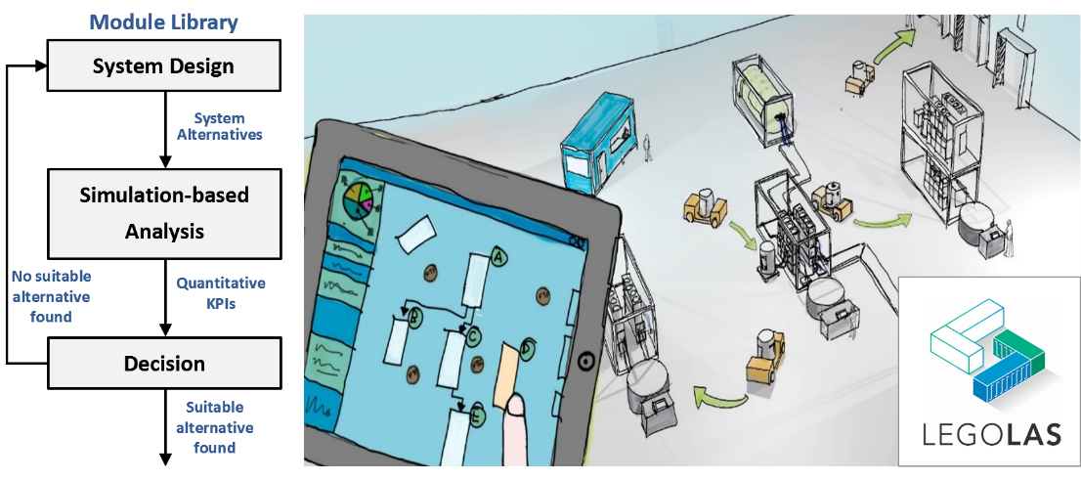
Figure 1. Conceptual workflow supported by the LEGOLAS planning support system.
3. Decision Support based on Material Flow Simulation
To illustrate the features of the planning support system, it has been applied to a challenging case study, the modular filling/packaging section of an herbicide/fungicide plant (see Fig. 2) by the German logistics provider Imperial Logistics. In this talk, the demonstration focuses on the simulation-based decision support step which is based on the dynamic simulation of modular logistics systems using the INOSIM process simulator and its new packaged-goods simulation engine, enabling the user to model complex batch and mixed processing plants and their logistical elements seamlessly within the same environment.
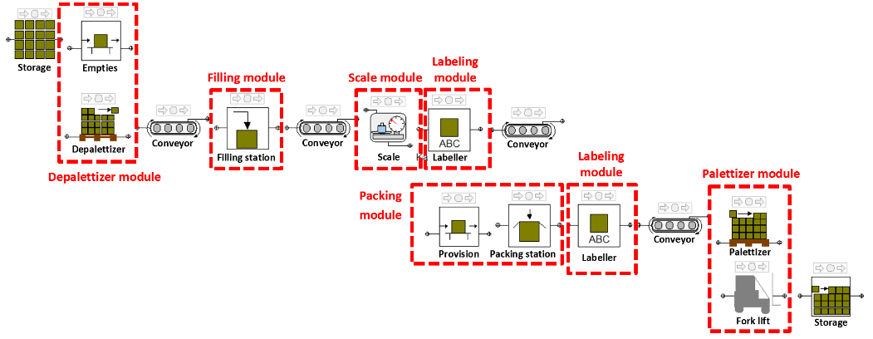
Figure 2. Flowsheet of a modular filling/packaging section of an herbicide/fungicide plant in the INOSIM process simulator.
4. Conclusions
The LEGOLAS planning support tool enables the efficient engineering of modular logistics systems based on material flow simulation for quantitative decision support. The next step is to validate it and illustrate its potential on a number of other challenging case studies.
References
- DECHEMA / VDI ProcessNet Work Group on Modular Plants: Flexible Chemical Production by Modularization and Standardization – Status Quo and Future Trends. White Paper, 2016, ISBN: 978-3-89746-191-2, available at: http://processnet.org/dechema_media/ModularPlants_2016-p-20002425.pdf
- F3 Factory: Flexible, Fast, and Future Production Processes. EU FP7 Project, 2009-2013, GA No. 228867.
- LEGOLAS: Planning Support System For Modular Industry 4.0 Plants in the Process Industries. R&I Project funded by the European Regional Development Fund (EFRE.NRW), 2017-2020.
- INOSIM Software GmbH: The INOSIM Process Simulation Suite. www.inosim.com.

