Dynamic Adsorptive Chromatographic Reactor Model.
Vincenzo Russo¹, Riccardo Tesser¹, Tapio Salmi², Martino Di Serio¹
1 Università di Napoli Federico II, Complesso Universitario M.S. Angelo, via Cintia 4, IT-80126 Napoli.; 2 Åbo Akademi, Piispankatu 8, FI-20500 Turku/Åbo
*Corresponding author: v.russo@unina.it
Highlights
- A new chromatographic reactor model was developed.
- Methyl acetate hydrolysis was simulated.
- Full conversion and product separation were predicted.
1. Introduction
The esterification of carboxylic acid with alcohols is a hot topic of the modern bio-refinery, to produce, for example, solvents, plasticizers [1]. Nowadays, a lot of effort is in progress to optimize the synthesis of several esters. The right reactor should optimize the physical characteristics of the system that is, as before mentioned, a liquid-solid reaction: i.e. Mazzotti et al. [2], used the simulated moving bed reactor (SMBR) packed with Amberlyst-15 catalyst to perform acetic acid esterification to ethylacetate, demonstrating that the resin can be used both to catalyze the reaction and separate the stream. It is important to underline that to design such apparatus, accurate and reliable models are needed, involving profiles along different coordinates (time, reactor radius, reactor axis and catalyst radius) [3], the knowledge of physical and chemical properties, and powerful tools to reach a reliable solution. In the present work, the development of a reactor model, that can be used to interpret experimental data collected in chromatographic reactors will be presented. Methyl acetate hydrolysis catalyzed by DOWEX 50W-X8 catalyst was chosen as case study [4].
2. Methods
The developed model can be considered an advancement respect to the recent efforts published in the literature [4]. The breakthrough idea is to develop a model where no rate-determining-step is considered, writing the opportune mass balance equations on both the liquid bulk and intraparticle phases. All the physical parameters were calculated from existing correlations. The liquid bulk and intraparticle mass balance equations are respectively reported in Eqs. 1-2.
(1)
(2)
The model was implemented in gPROMS ModelBuilder v.4 software, solving the axial and particle radial partial derivatives with a centered finite difference method with respectively 150 and 25 discretization points.
3. Results and discussion
Methyl acetate (MA) hydrolysis kinetic rate laws with related parameters are fixed and directly taken from literature [4]: the authors carried out different experiments by fixing the flow-rate at 0.75 mL/min and injecting pulses of 100 μL of a 0.5 mol/L solution of methyl acetate in water, at different temperatures (from 298 to 328 K). The results are reported in Fig. 1-left, together with the model predictions. As revealed, a temperature increase corresponds to an increase of the reaction conversion (the MA area decreases) with the related formation of the two products (M and A). Parameter estimation was carried out to obtain the surface diffusivity for each component, obtaining that the surface diffusivity values follow the order MA>M>A. The trend is due to the different acidity of each component, interacting with the acid solid phase. A parametric investigation was conducted evaluating the effect of different operation conditions on both the acid conversion and product separation (Fig. 1-right). It was possible to achieve complete MA conversion and product separation fixing the reactor length to L=2.50 m and T=323K, demonstrating high performances of the chromatographic reactor.
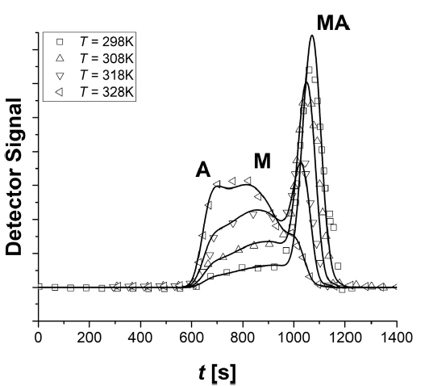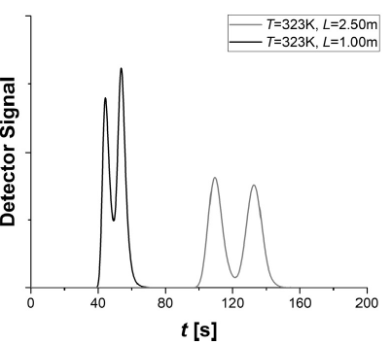
Figure 1. (Left) Description of experimental data taken from literature [4]: symbols are experimental data, lines the model description. (Right) Simulation of full conversion and total product separation.
4. Conclusions
A novel chromatographic reactor model was developed to interpret experimental data dealing both with the esterification of carboxylic acids and with the hydrolysis of organic esters. The model is advanced respect to the state of the art because no rate-determining steps are considered. All the physical and chemical phenomena are considered. In perspective, the model can be applied in optimizing the esterification/hydrolysis processes.
References
- D.R. Fernandes, A.S. Rocha, E.F. Mai, C.J.A. Mota, V.T. da Silva, Appl. Catal. A-Gen. 425 (2012) 199-204.
- M. Mazzotti, A. Kruglov, B. Neri, D. Gelosa, M. Morbidelli, Chem. Eng. Sci. 51 (1996) 1827-1836.
- V. Russo, R. Tesser, C. Rossano, R. Vitiello, R. Turco, T. Salmi, M. Di Serio, Chem. Eng. J. (2018). DOI: 10.1016/j.cej.2018.08.078
- T.D. Vu, A. Seidel-Morgenstern, J. Chromatogr. A 1218 (2011) 8097-8109.

