Ceramic Filter Candle Filled With Catalyst Pellets Inserted in the Freeboard of a Fluidized Bed Gasifier for In-Situ Syngas Conditioning.
Elisa Savuto^{1,*}, Andrea Di Carlo², Katia Gallucci², Pier Ugo Foscolo², Sergio Rapagnà¹
1 University of Teramo, Via R. Balzarini 1, 64100 Teramo, Italy; 2 University of L'Aquila, Via Campo di Pile, L'Aquila, Italy
*Corresponding author: elisa.savuto@gmail.com
Highlights
- A ceramic candle filled with catalyst was inserted in the freeboard of a gasifier
- Two different catalysts (A, B) were tested for tar reforming inside the gasifier
- Catalyst B showed very good performance, reaching 89% of tar conversion
- Catalyst B was more active than catalyst A, even though used at higher GHSV
1. Introduction
Gasification is a very promising conversion process to produce a fuel gas (syngas) from biomass, usable for direct power production or for the synthesis of high quality bio-fuels [1]. However, syngas has to be cleaned before its use, in order to remove main pollutants that may compromise its exploitability: particulate and tar [2]. Fluidized bed gasifiers have several advantages, including the presence of a free space above the bed (freeboard) in which devices for in-situ gas conditioning can be integrated. In this work, a segment of a commercial ceramic filter candle is inserted in the freeboard of a bench scale fluidized bed gasifier for particulate removal, and its internal hollow space is filled with catalyst pellets, in order to perform catalytic reforming of tar in the raw gas. Two different commercial catalysts are tested inside the filter candle and their performance is studied and compared.
2. Methods
Experimental tests were carried out in a bench scale biomass gasification system composed of a cylindrical fluidized bed reactor (ID 0.1 m) heated with an external electric furnace. The bed material is composed by olivine sand and the biomass used is ground almond shells. In the upper part of the reactor a ceramic candle is hosted (L 440 mm, 60 mm OD and 40 mm ID). At the outlet of the gasifier the gas composition (H₂, CO, CO₂, CH₄) is analyzed online and its volume flow is measured; tars are sampled according to the standard CEN/TS 15439 and then analyzed with HPLC. Temperatures and pressures are measured in different points of the reactor. More details on the experimental rig can be found in [3].Tests were carried out with the empty ceramic candle and with the candle filled with two types of Ni based commercial catalysts for steam reforming of methane and naphtha, referred to as A and B, respectively. Catalyst A has the shape of perforated pellets with a high void fraction; catalyst B instead, having the shape of small cylinders, could cause excessive pressure drop. For the tests with catalyst B the cavity of the candle was filled only partially, with an annular bed of catalyst pellets, leaving a cylindrical internal hollow space to reduce the whole pressure drop (see Figure 1).
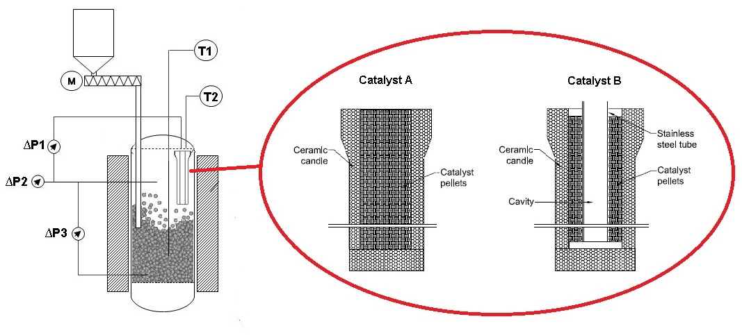
Figure 1. Scheme of gasification reactor and configurations of catalyst filled candle
3. Results and discussion
Table 1. Input conditions and test results
Test | 1 | 2 | 3
Filter candle | Empty | Catalyst A | Catalyst B
Temperature (°C) | 789 | 770 | 775
Gas yield (Nm³ dryN₂free/kg_{bio}) | 1.13 | 1.45 | 1.66
Water conversion (%) | 24.25 | 36.13 | 53.65
Tar (g/Nm³ dryN₂free) | 3.28 | 2.75 | 0.36
GHSV (h⁻¹) | - | 4211 | 5729
H₂ (%vol dryN₂free) | 40.65 | 55.34 | 54.04
CH₄ (%vol dryN₂free) | 9.03 | 2.13 | 1.20
Results reported in Table 1 show that both catalysts lead to an upgrading of the gas quality compared to that of the raw syngas. However, catalyst B (even though filling only partially the candle cavity, thus confined in a smaller volume) performed much better than catalyst A, with higher gas yield and water conversion. In fact, with catalyst A, tar is only slightly reduced (16%), while catalyst B brought to almost complete tar conversion (89%) with a final concentration in the gas lower than 0.5 g/Nm³ dry and N₂ free.
4. Conclusions
The integration of catalyst pellets in the cavity of a ceramic candle placed in the freeboard of a fluidized bed gasifier can be an effective solution for syngas upgrading. In particular catalyst B showed excellent performance in tar reforming, increasing H₂O conversion, gas yield and H₂ content. Even though catalyst B was filling only partially the candle cavity (thus under higher GHSV), better results were obtained compared to those exhibited by catalyst A.
References
[1] Sikarwar VS, Zhao M, Fennell PS, Shah N, Anthony EJ. Progress in biofuel production from gasification. Prog Energy Combust Sci 2017;61:189–248. doi:10.1016/j.pecs.2017.04.001.
[2] Devi L, Ptasinski KJ, Janssen FJJG. A review of the primary measures for tar elimination in biomass gasification processes. Biomass and Bioenergy 2002;24:125–40. doi:10.1016/S0961-9534(02)00102-2.
[3] Rapagnà S, Gallucci K, Foscolo PU. Olivine, dolomite and ceramic filters in one vessel to produce clean gas from biomass. Waste Manag 2017. doi:10.1016/j.wasman.2017.07.038.

