The Similarity of Power and Flow In Batch and Inline Rotor-Stator Mixers.
Thomas John¹, Adam J Kowalski², Tom L Rodgers¹, Claudio P Fonte¹.
1 University of Manchester, Manchester, M19 2FT, UK; 2 Unilever R&D, Wirral, CH63 3JW, UK.
*Corresponding author: thomas.john@manchester.ac.uk
Highlights
- Inline and batch rotor-stators modelled using CFD.
- Power and flow numbers investigated for various screen hole sizes.
- Inline and batch rotor-stators can be characterized using the same model
- A correlation is developed to predict the recirculating flow in inline mixers.

1. Introduction
Rotor-stator mixers are mixing widely used across many industries for emulsification and de-agglomeration which can be operated in batch or inline mode. Often, the scaling of rotor-stators involves a change from batch to continuous mode, so it is highly desirable to understand how the power and flow characteristics differ between the two modes of operation. Power number in inline mixers can be characterized using the following equation^{[1]}.
 | $$Po= Po_{Z}+k_{1}N_{Q}$$ | (1)
However, no such model has been developed or tested for batch mixers. The primary aim of this study was to investigate how this characterization differs between the two modes of operation.
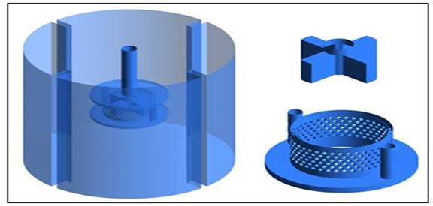
(b)
(a)
Figure 1. Surfaces across which flow was measured. | Figure 2. CFD geometries for (a) inline and (b) batch
2. Methods
The mixer studied was the Silverson L5M with standard emulsor head (Figure 1 and 2). Fluent v18.1 was the software used in this study. The standard k-ε turbulence model was utilized along with third order MUSCL discretization schemes for special discretization of momentum and turbulence. Rotation of the rotor was modelled using the multiple reference frame technique. Flow rate was measured across the red and purple surfaces shown in Figure 1. Power was measured from the bending moments on the rotor. In this study, using CFD, we were able to change the flow number in the batch configuration by constricting the base hole of the stator in small increments.
3. Results and discussion
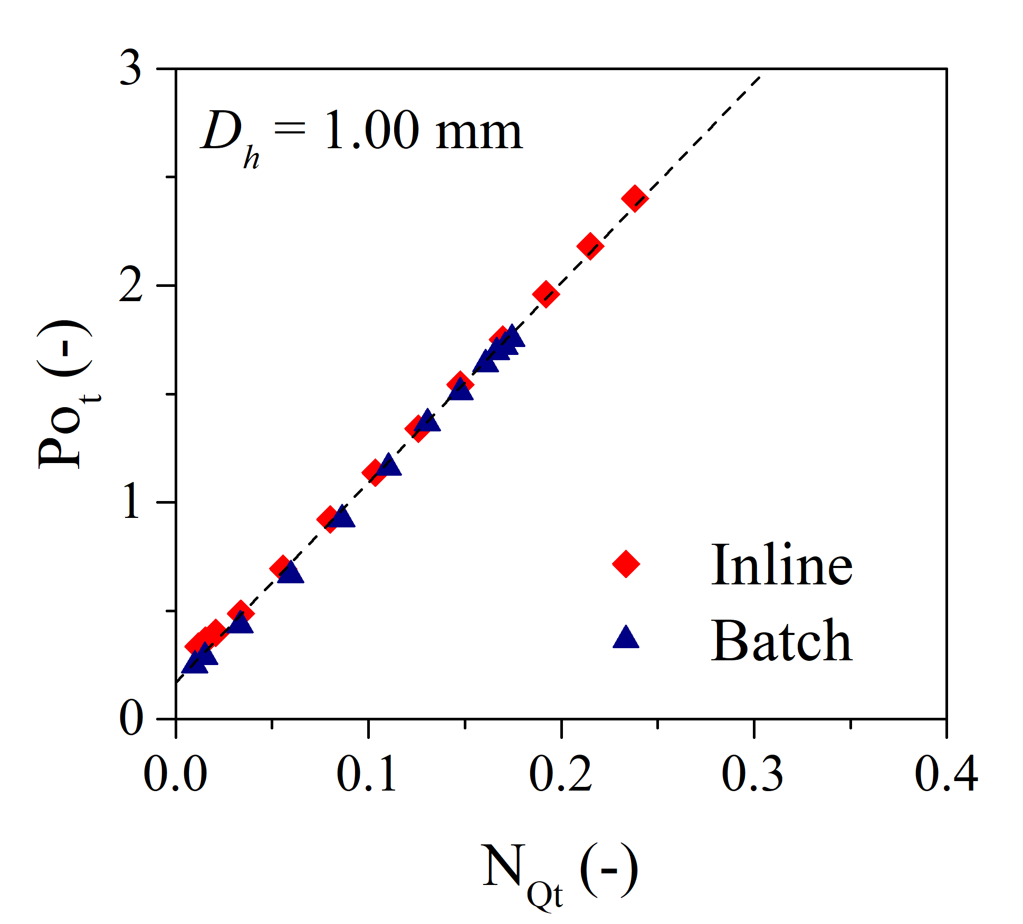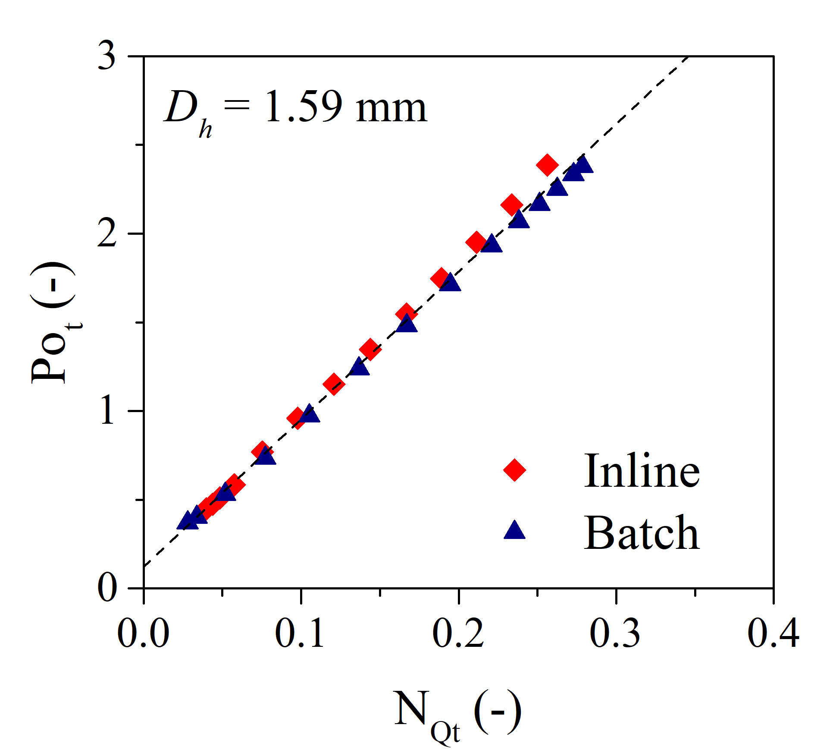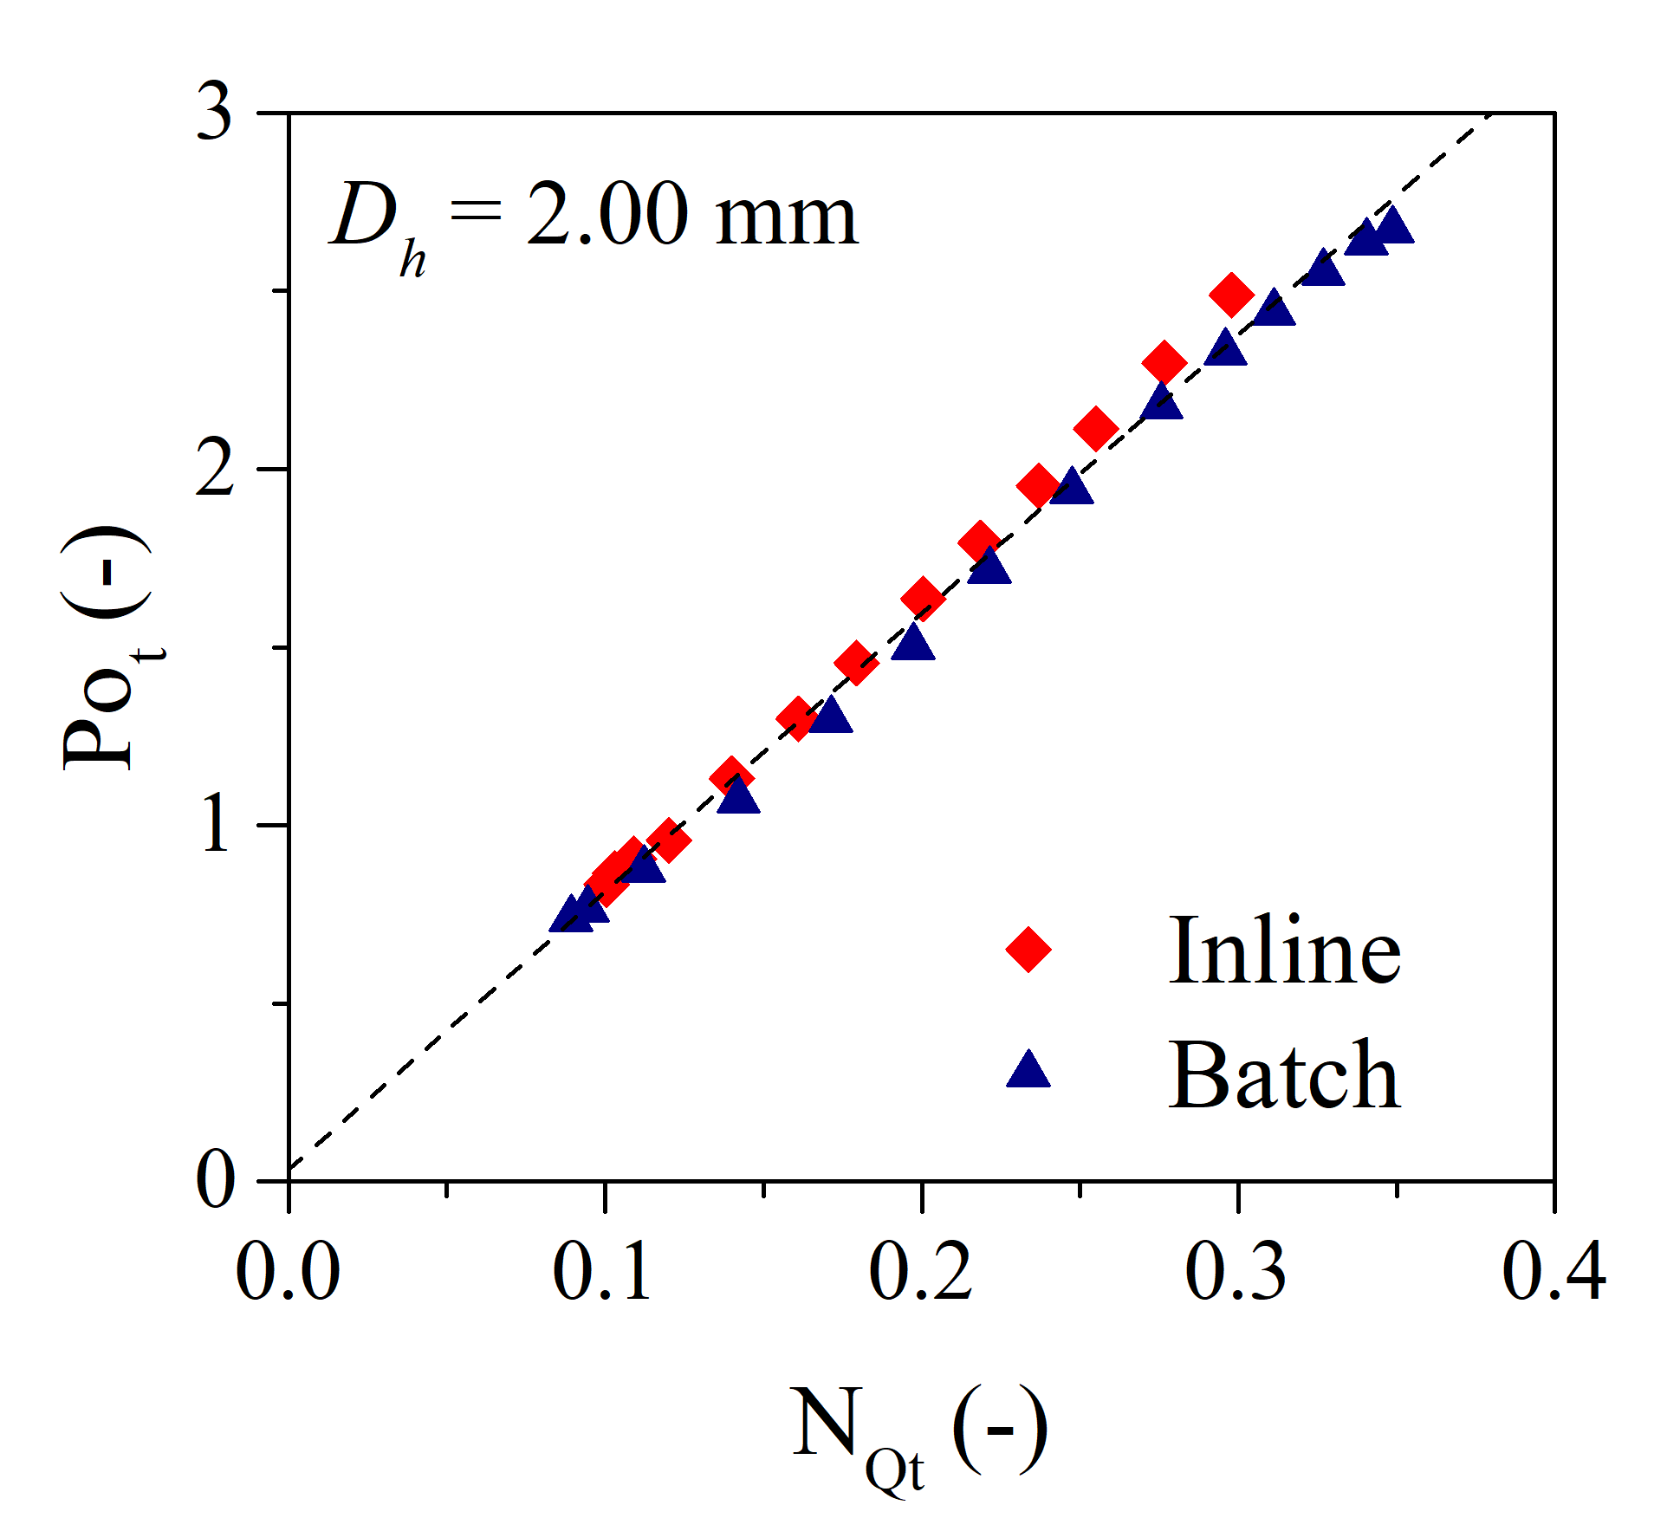
(c)
(b)
(a)
Figure 3. Power number vs flow number for both modes and hole sizes of (a) 1.00 mm, (b) 1.59 mm, and (c) 2.00 mm.
Figure 3 shows the power number as a function of the total flow number for the batch and inline simulations with various screen hole sizes. It can be seen that there is no difference between batch and inline RSMs in terms of power characterization. These results could suggest that with the same flow number, there will be no difference in the droplet size of an emulsified product, something which has also been suggested by Carillo De Hert^{[2]}.
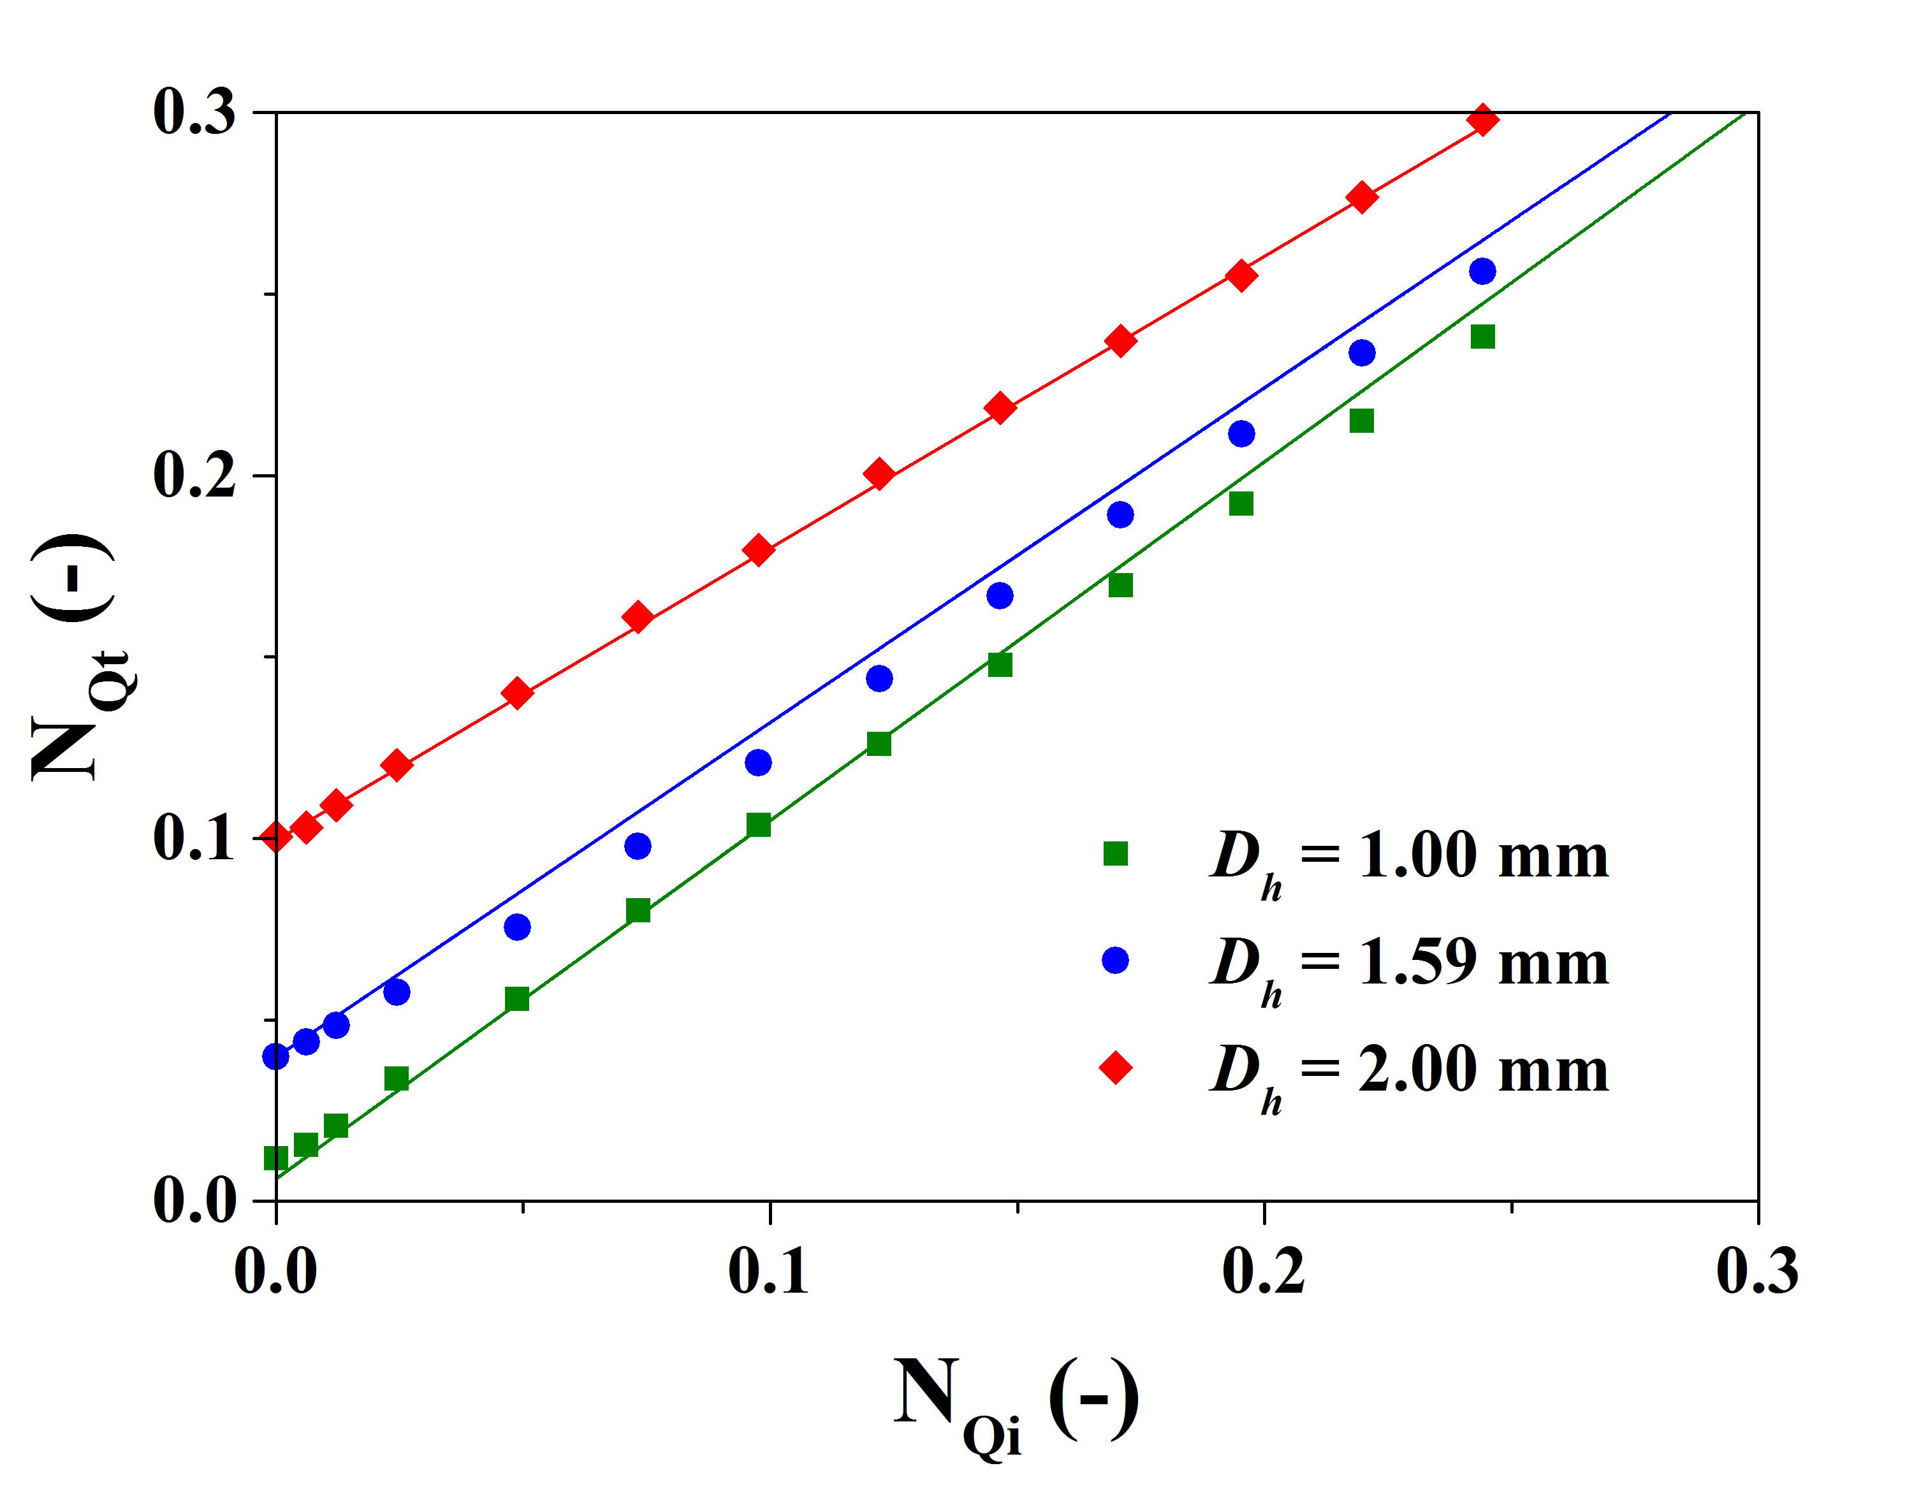
Figure 4. Total flow number vs imposed flow number for inline. Symbols - CFD data, lines - prediction by Equation 2.
Figure 4 shows the total flow number as a function of the imposed inlet flow number in the inline mixer. Since obtaining the total flow number would usually require CFD or PIV, a correlation was developed in order to predict the total flow number from imposed flow number and the geometry of the mixer using the following equation. The predicted results are shown in Figure 4.
 | $$N_{Qt}=N_{Qi}+0.33{\left(\frac{Area holes}{Rotor diameter^{2}}\right)}^{2}[0.51-N_{Qi}]$$ | (2)
4. Conclusions
Batch and inline rotor stators share the same characterization of agitation power. We have developed a correlation which enables the prediction of the total flow number from the imposed inlet flow number for inline rotor stators. This predicts how much flow recirculates back into the holes of the screen, and provides us with the true flow number that matches the batch data.
References
[1] A.J. Kowalski, Chem. Eng. Process: Process Intensif. 48 (2009) 581–585.
[2] S. Carrillo De Hert, Drop Size Distribution Analysis of Mechanically Agitated Liquid-Liquid Dispersions, University of Manchester, UK., 2017.

