A Population Balance Model for the Dynamic Simulation of Enzymatic Hydrolysis of Lignocellulosic Biomass in Batch or Fed-Batch Bioreactors.
Vasileios Margaritopoulos¹, Christos Chatzidoukas^{1,*}
¹ Chemical Engineering Department, Aristotle University of Thessaloniki (AUTH), 54142, Thessaloniki, Greece
*Corresponding author: chatzido@auth.gr
Highlights
- Endo- and exoglucanases synergy-the role of cellulose chain length distribution.
- Continuous varying substrate accessibility to the enzymes.
- Hydrolysis yield improvement from batch to fed-batch operation of bioreactors.
1. Introduction
Biomass hydrolysis is a critical step in biochemical processes where cellulose is degraded to glucose for the production of biofuels and useful chemical products. Enzymatic hydrolysis is a promising method for glucose production due to its low energy demand and mild operating conditions [1]. However, the multiple phenomena that occur make the hydrolysis process complex, impeding the comprehension of the exact mechanism. Thus, the commercialization of the process is still considered a challenge. Detailed mathematical models provide the means for further elucidating the dominant mechanisms and process optimization. Various semi-empirical models have been developed, however they usually suffer an over-parameterization or their predicting capability is confined within certain experimental conditions due to a simplified and macro-scale approach of the problem. In this work a mechanistic model is developed deepening further on meso- and micro-scale phenomena involved in the hydrolysis of lignocellulosic biomass, while accounting for critical substrate characteristics such as particle size, cellulose chain length distribution and lignin content. The dynamic evolution of the substrate accessibility to the enzymes is efficiently captured by the model in order to prove the hydrolysis yield reduction [5], experimentally observed in bioreactors of high solids loading compared to those of lower solids loading, demonstrating the model handiness for the operational design of fed-batch bioreactors.

2. Methods
Biomass hydrolysis refers to the degradation of cellulose to its oligomers, meaning glucose and cellobiose. The enzymatic hydrolysis is catalyzed by two types of cellulases named endo- and exo-glucanases. Endoglucanase attacks β-1,4-glycosidic bonds within the cellulose chain with random chain scission, while exoglucanase removes single units of cellobiose with chain end scission [3,4]. A population balance technique is applied [2,3,4] to describe the dynamic evolution of cellulose chain length distribution, from the distinct action of each enzyme as is described below:
$$x_{mer}\underset{→}{endoglucanase} y_{mer}+({x-y)}_{mer} x_{mer}\underset{→}{exoglucanase} {(x-2)}_{mer}+cellobiose$$
The model emphasizes on the fractional accessibility of the substrate to the surrounding enzymes adopting a layer-by-layer exposure of the cellulose chains and a binding mechanism of the enzyme on these chains. The Langmuir isotherm is employed to describe the adsorption of soluble enzymes on both surficial cellulose and lignin of the insoluble biomass particles to account for the heterogeneity of the hydrolysis mechanism. The entire dynamic model is developed and solved with the gPROMS® simulation platform.
3. Results and discussion
Endoglucanase is responsible for generating quickly cellulose chains of shorter length and providing to exoglucanase additional chain ends. Exoglucanase, hydrolyzes the substrate by generating soluble oligomers. Cellulose hydrolysis would be practically unaccomplished in the case where only endoglucanase was used, however, its role is not negligible since the generation of shorter chains increases the exoglucanase efficiency. The derived model uncovers these phenomena, the synergy between the two types of enzymes and the way endogenous traits of the substrate, such as particle radius, cellulose chain length distribution and lignin content are involved in the hydrolysis reaction rate. Precisely, as the hydrolysis proceeds new substrate layers of non-degraded cellulose chains, tangled with lignin, are exposed. The hydrolysis rate takes its maximum value at the beginning of the process since the quantity of enzymes that can bind effectively on the biomass is the maximum possible. Progressively, the particle radius is reduced and less amount of enzyme is adsorbed on the particle’s surface. Moreover, the lignin fraction in the particle increases, leading to the reduction of the effectively bound enzymes and finally the total rate of hydrolysis, without any product inhibition effect being necessary for such a response.
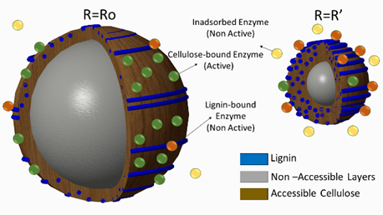  Figure 1: Graphical representation of particle hydrolysis. | 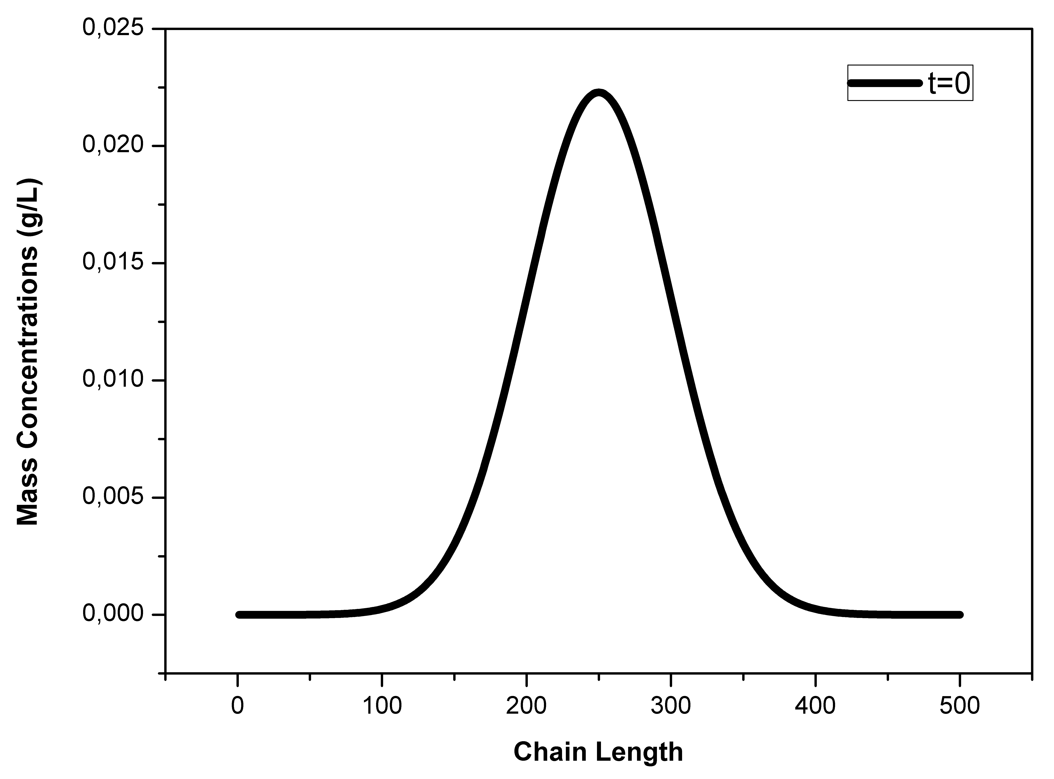  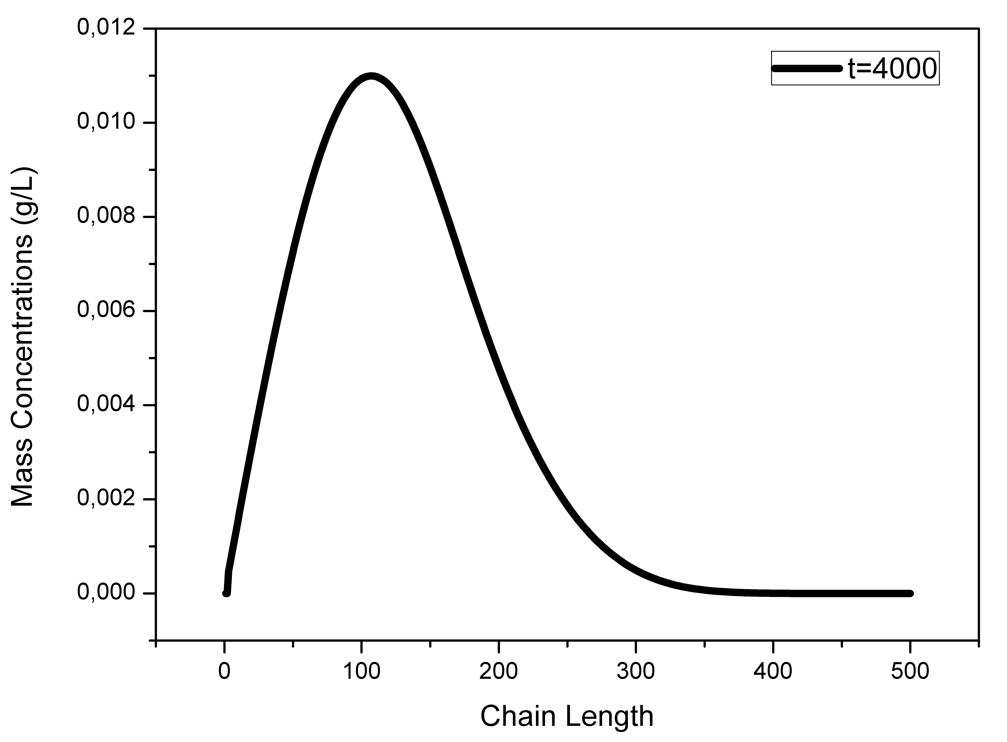  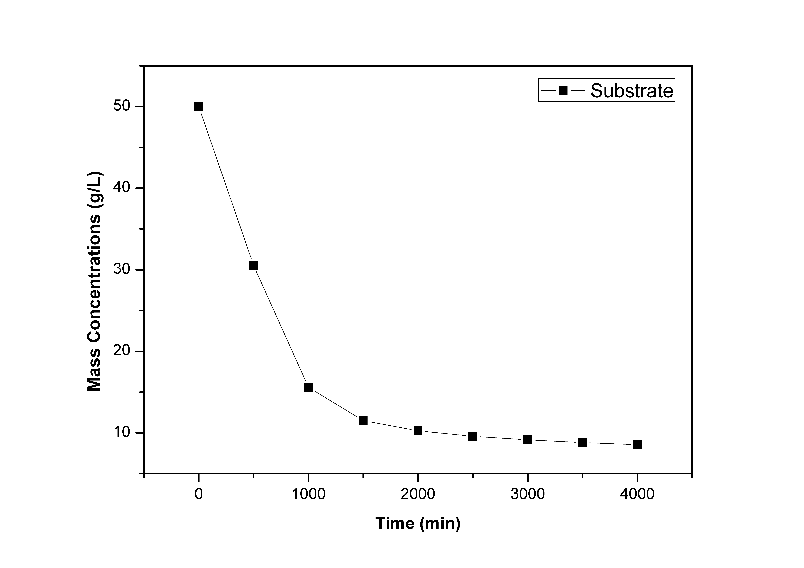  Figure 2: Time profile of cellulose hydrolysis.
4. Conclusions
A generic mechanistic model, which takes into consideration factors like chain length distribution, lignin content, particle size and specific surface area, has been built up. The influence of substrate characteristics on the catalytic efficiency of the enzyme highlights the importance of the pre-treatment the lignocellulosic biomass is subjected to. A model-based investigation of the optimal dynamic operation of fed-batch hydrolysis bioreactors can be essentially supported by the proposed mathematical model.
References
- Bansal, P., Hall, M., Realff, M., Lee, J. and Bommarius, A. (2009). Biotechnol. Adv., 27(6), pp.833-848.
- Griggs, A., Stickel, J. and Lischeske, J. (2011). Biotechnol. Bioeng. 109(3), pp.665-675.
- Hosseini, S. and Shah, N. (2011). Biomass and Bioenergy, 35(9), pp.3830-3840.
- Hosseini, S. and Shah, N. (2011). Biomass and Bioenergy, 35(9), pp.3841-3848.
- Kristensen, J., Felby, C. and Jørgensen, H. (2009). Biotechnol Biofuels, 2(1), p.11

