Design and Experimental Study of a Milli-Channel Vaporizer.
G. Henry^{1,} *, A. Pere-Gigante¹, J-M. Commenge¹, J. Seiwert², S. Valentin², M. Wagner²
1 Université de Lorraine, CNRS, Laboratoire Réactions et Génie des Procédés, UMR 7274, Nancy, F-54000 France; 2 , Air Liquide, Centre de Recherche Paris-Saclay, 1 chemin de la Porte des Loges, Les Loges-en-Josas, BP 126, 78354 Jouy-en-Josas, France
*Corresponding author: guillaume.henry@univ-lorraine.fr
Highlights
- High-quality vaporization of liquid water in millichannels is studied experimentally
- Dedicated test bench is used to study influence of flow rates, temperatures and pressure
- Flow regimes, vapor quality and heat-transfer coefficients are estimated
- High-quality vaporization is reached at low flow rate and large temperature difference
1. Introduction and context
Steam is largely used in industry as an energy vector and is currently generated in large tubular heat exchangers coupled to a vessel in a thermosiphon system. Process intensification mainly aims at increasing the process efficiency by reducing the size of the equipment: the smaller the size, the better the control of the operating conditions, for instance the heat transfer. The case of the water vaporizer in hydrogen production is the focus of the present study. However, the results of this study could be used in other applications as long as heat has to be valorized, such as in the case of hot gases outgoing from the reactor of the Steam Methane Reforming (SMR) process.
The intensification of this process could enable to reach total vaporization of the water flow and a significant simplification of the installation. A plate milli-channel heat exchanger is studied in this work, although some other technologies could have been used in this application such as brazed plates-and-fins exchangers.
The main goal of this work is to develop a sizing tool for intensified vaporizers in order to meet the expectations of the steam production needs on SMR plants. It is developed thanks to an experimental study of the hydraulic and thermal phenomena occurring during phase change in the milli-structured device.
2. Test Bench and Methods
A test bench has been set up for this study. Convection of hot oil was chosen as the heating mode for the water vaporization to avoid the risks induced by a hot gas convection loop at lab scale. The test bench presents three different loops of fluids: one for the process water, another one for the hot oil and the last one for the condensation of the produced vapor. Several parameters are measured, namely, the flowrates, the temperatures of fluids and the absolute and differential pressure inside the vaporizer for the water. A particular attention is given to the wall temperature between the oil and the water, measured at six positions along the millimeter-size channels. The semi-circular cross section of the channels was chosen to enable the visualization of the boiling fluid, through a 1 cm thick borosilicate window. Unfortunately, the vapor quality cannot be directly measured; nevertheless, it can be estimated using a heat balance on the vaporizer. A specific study on the heat losses was performed to minimize the uncertainty related to this heat balance.
3. Results and discussion
The vaporizer has been operated under various operating conditions: the water flowrate varied between 0 and 6 L/h, the oil flowrate between 0.5 and 4.5 L/min, the inlet temperature of oil between 100 and 190°C and the pressure on the water side between 1 and 5 bars. The resulting vapor quality (Figure 1.b), the pressure drop and the hydraulic regime, highlighted by image analysis of high frequency movies, are studied for all operating conditions. This work presents an analysis of this experimental campaign, completed with high-speed visualization, to characterize properly the “two-phase” thermal transfer coefficient in milli-structures (Figure 1.a), which is one of the keystones to design a vaporizer.
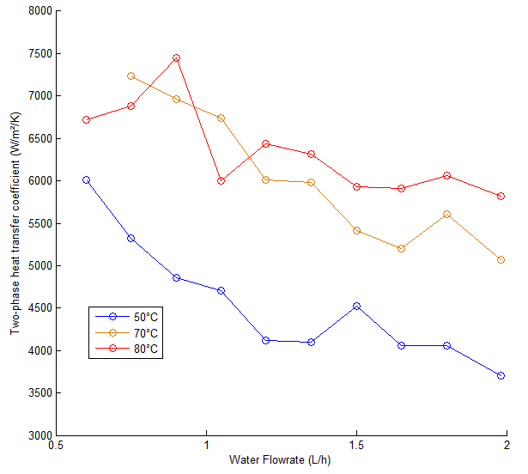
(b)
(a)
Figure 1. Influence of the pre-heating temperature on the two-phase heat transfer coefficient (a), Influence of the oil flowrate on the vapour quality (b)
The magnitude of the “two-phase” heat transfer coefficient is similar to what can be found in the literature [1]. Since the boiling in the vaporizer creates a high frequency oscillating flow, further investigations are needed to validate the evolution of these coefficients. Concerning the vapor quality, the geometry of straight milli-channels is not able to produce high quality at “high” water flowrates. However, it has been shown that the thermal gradient between the oil and the boiling water is the main way to step up the vapor quality.
4. Conclusions
The vaporizer studied enables the production of steam by heat recovery from a hot flow. The vapor quality produced is improved by low water flowrates and high differences of temperature between the hot and water flows.
References
- S. G. Kandlikar, Fundamental issues related to flow boiling in minichannels and microchannels, Experimental Thermal and Fluid Science, 26, 2002, pp 389-407

