Catalytic Oxidation Kinetics of Arabinose on Supported Gold Nanoparticles.
Leolincoln Correia¹, Johan Wärnå¹, Henrik Grénman¹, Tapio Salmi¹, Dmitry Murzin^{1*}
1 Laboratory of Industrial Chemistry and Reaction Engineering, Johan Gadolin Process Chemistry Centre (PCC), Åbo Akademi University, 20500 Turku, Finland
*Corresponding author: dmurzin@abo.fi
Highlights
- A novel kinetic model for aqueous-phase arabinose oxidation on Au catalysts is proposed.
- Influence of oxygen flowrates, pH values and temperature was adequately described.
- The model shows adequate results for both D- and L-arabinose oxidation.

1. Introduction
In order to decrease the high dependency on fossil feedstock, lignocellulosic biomass has been considered as a renewable resource alternative. Representing 15-30% of the total lignocellulosic biomass, hemicelluloses are the second most abundant carbohydrate polymers [1-2]. Selective oxidation of sugars, such as arabinose, to their corresponding aldonic acids is one of the most important lignocellulosic biomass valorization processes. Several articles have demonstrated that supported gold nanoparticles as a sugar oxidation catalyst under alkaline conditions result in high selectivity towards aldonic acids [3,4,5,6]. In the previous work [3], kinetic data for oxidation of arabinose were generated and a kinetic model was developed. However, there were some systematic deviations in the description of the experimental data and the role of hydroxyl groups in the reaction kinetics was not explained and molecular adsorption of oxygen and contribution of different forms of sugar were not considered. The objective of this work is to revisit the data reported in ref. [3], evaluate the reaction kinetics and to propose a new kinetic model based on the plausible reaction mechanism for arabinose oxidation over gold supported on alumina.
2. Methods
All the experimental results, setup and catalyst characterization data concerning L-arabinose oxidation over supported gold catalyst used for modelling were obtained from the work of Kusema et al. [3,6]. In order to bring the reaction to a more practical level, an experiment in a standard batch reactor with D-arabinose was carried out. The novel model was developed taking into account the different forms of sugar in aqueous solutions, molecular adsorption of oxygen and production of H₂O₂. The set of differential equations representing concentrations of the reagents and products was solved numerically during the parameter estimation using the Levenberg-Marquardt or Simplex methods incorporated in the ModEst software [7].

3. Results and discussion
The fit of the proposed kinetic model to the experimental concentration profiles is presented in Figure 1, clearly illustrating a good correspondence between experimental and calculated data (R² = 99.35 %). There were no systematic deviations in the description of experimental data compared to the work of Kusema et al. (R² = 98.70 %). Moreover, simulation of D-arabinose oxidation in a conventional batch described very well the experimental data (Fig 2).
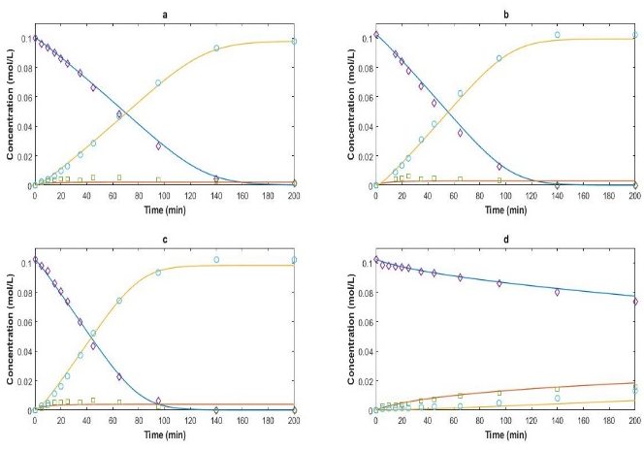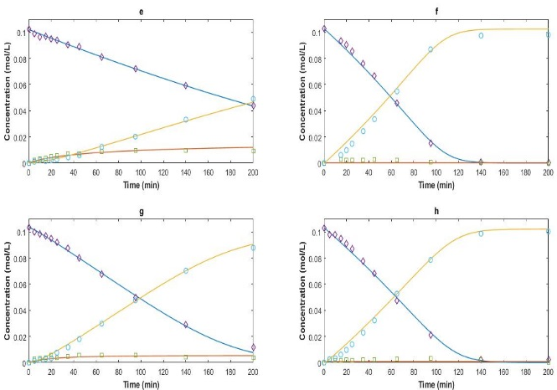
Figure 1. Experimental (dots) [3] and calculated (lines) concentrations profiles (◊→ L-arabinose, □ → arabinolactone, ○ → arabinonate) in arabinose oxidation over 1 wt% Au/Al₂O₃, m=0.25g. (a) 60°C, 2.5mL/min O₂, pH 8; (b) 60°C, 3.5mL/min O₂, pH 8; (c) 60°C, 5.0mL/min O₂, pH 8; (d) 60°C, 2.5mL/min O₂, pH 6; (e) 60°C, 2.5mL/min O₂, pH 7; (f) 60°C, 2.5mL/min O₂, pH 9; (g) 50°C, 2.5mL/min O₂, pH 8; (h) 70°C, 2.5mL/min O₂, pH 8.
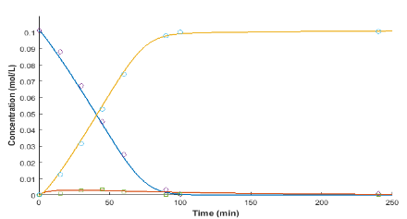
Figure 2. Experimental (dots) and calculated (lines) concentrations profiles (◊→ D-arabinose, □ → arabinolactone, ○ → arabinonate) in arabinose oxidation in a batch reactor over 2 wt% Au/Al₂O₃, m= 0.5g, T= 60°C, P_{O2} = 0.125 bar and pH=8.
4. Conclusions
A novel kinetic model for the aqueous-phase selective oxidation of L-arabinose over gold catalysts was proposed considering different forms of sugar in the solution. The parameter estimation was successfully carried out revealing that the calculated values are in good correspondence with the experimental behaviour. In general, oxidation kinetics for both D- and L-arabinose was successfully represented by the proposed elementary reaction mechanism.
References
- A. C. Canos, S. Iborra, A. Velty, Chem. Rev. 107 (2007) 2411–2502.
- M.N. Belgacem, A. Gandini, Monomers, Polymers and Composites from Renewable Resources, Elsevier, 2008.
- B.T. Kusema, J.-P. Mikkola, D.Y. Murzin, Catal. Sci. Technol. 2 (2012) 423–431
- O.A. Simakova, B.T. Kusema, B.C. Campo, A.-R. Leino, K. Kordás, V. Pitchon, P. Mäki-Arvela, D.Y. Murzin, J. Phys. Chem. C 115 (2011) 1036–1043.
- B.T. Kusema, B.C. Campo, O.A. Simakova, A.R. Leino, K. Kordás, P. Mäki-Arvela, T. Salmi, D.Y. Murzin, ChemCatChem 3 (2011) 1789–1798.
- B.T. Kusema, B.C. Campo, P. Mäki-Arvela, T. Salmi, D.Y. Murzin, Appl. Catal. A Gen. 386 (2010) 101–108.
- H. Haario, ModEst User's Guide, Prof. Math Oy. Helsinki (2001).

