Reactive Separation Concept for Valorizing Low Molecular Weight Carboxylic Acids from Aqueous Media.
Andreas Toth¹, Susanne Lux¹, Daniela Painer¹, Matthäus Siebenhofer¹
1 Institute of Chemical Engineering and Environmental Technology, Graz University of Technology, Inffeldgasse 25C/III, 8010 Graz
*Corresponding author: andreas.toth@tugraz.at
Highlights
- Valorization of dilute, biobased carboxylic acids is possible.
- Solvent regeneration rates above 75 % are feasible.
- Concept insensitive to residual acid in the regenerated solvent.

1. Introduction
Valorization of low molecular weight carboxylic acids (e.g., acetic acid, formic acid) of biogenic origin is associated with various problems. Originating mostly within biorefinery processes, the carboxylic acids show up at low concentration in aqueous broths. The main problems to be dealt with are (quasi-)azeotropic behavior, high water content and unfavorable combinations of substance properties (e.g., boiling points). While conventional separation technologies struggle with these problems, reactive separation technologies are promising alternatives. [1] For dilute acetic acid in particular and low molecular weight carboxylic acids in general, the concept of chemical conversion in emulsions with in-situ extraction of the products was developed. [2] Homogeneously catalyzed esterification with a higher aliphatic alcohol in the solvent phase (e.g., 1-octanol) addresses the liquid-liquid equilibrium partition by separation of the hydrophobized derivatives of the carboxylic acids. Reactive distillation with transesterification (octyl ester to methyl ester) was investigated for solvent regeneration and product isolation. The surfactant type catalyst 4-dodecylbenzenesulfonic acid accelerates esterification. 4-dodecylbenzenesulfonic acid is also reported to be a potent catalyst for transesterification by Hagen et al. [3]. A proof of concept was performed in batch operation mode.
2. Methods
The laden solvent after esterification was mixed with methanol in a batch reactive distillation column in lab-scale. Laden solvent with and without residual acetic acid from the esterification step was used. The setup consisted of a 500 ml three-neck flask, a 30 cm Vigreux column with a condenser and a reflux splitter. Total reflux ratio was applied until reflux from the condenser was fully developed, then the reflux ratio was set to 10. Distillate was withdrawn from the product funnel every 30 min and analyzed by gaschromatography. The experiments were performed until distillate formation stopped.
For the proof of concept, the molar ratio of methanol as well as the performance of the catalyst were investigated.
3. Results and discussion
Regeneration performance was evaluated via methyl ester yield and amount of volatile residues in the regenerated solvent phase. Figure 1 displays a comparison of methyl acetate yield for different stoichiometric ratios of methanol to octyl acetate. 3-fold excess of methanol allows a methyl acetate yield of 75.6 % and about 1.5 wt.% residual volatile components in the regenerated solvent. While increased excess of methanol is beneficial for yield and regeneration rate, energy demand for excess methanol removal multiplies.
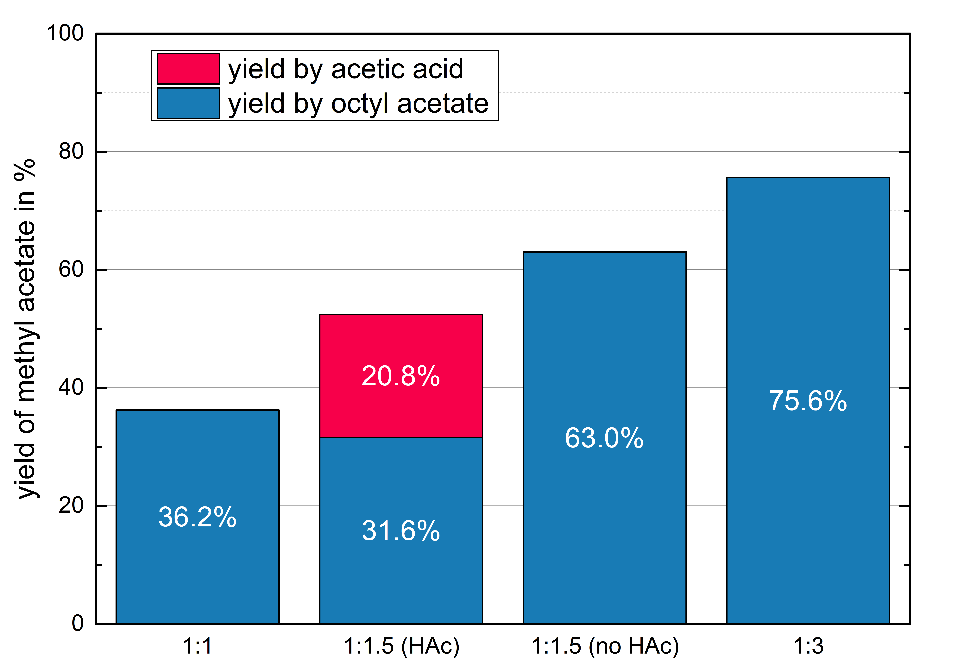
Figure 1. Methyl acetate yield of transesterification in batch reactive distillation
For 1.5-fold excess of methanol the impact of 2 wt.% residual acetic acid in the laden solvent was investigated. As shown in figure 1, less octyl acetate is converted, but more than 99 % of the acetic acid is esterified. Direct esterification (acetic acid to methyl acetate) is preferred over transesterification (octyl acetate to methyl acetate) as a consequence of a lower Gibbs free enthalpy for the esterification. In order to increase the performance a higher excess of methanol is needed, if residual acetic acid is present in the laden solvent.
4. Conclusions
The combination of reactive extraction (esterification in emulsion) and reactive distillation (transesterification) has proven feasible for valorizing low molecular weight carboxylic acids in lab-scale. Solvent regeneration with transesterification in reactive distillation allows regeneration rates in the order of 75 %. The favorable vapor-liquid equilibria between high and low boiling components enable reducing the amount of low boiling residues in the regenerated solvent to below 0.5 wt.%.
References
- V. D. Talnikar and Y. S. Mahajan, Korean J. Chem. Eng. (2014), 31, 1720–1731.
- A. Toth, S. Lux, D. Painer, M. Siebenhofer, React. Chem. Eng. (2018), 3, 905-911.
- J. Hagen, D. Henke, Chemie Ing. Tech. (2009), 81 (9), 1429–1438.

