Optimization of Heat Exchanger Network in the Dehydration Process by Using the Utility Pinch Analysis.
Choon-Hyoung Kang¹*, Moon Jeong², Seon Gyun Rho³, In-Ju Hwang⁴
1 School of Applied Chemical Engineering, Chonnam National University, 77 Yongbong-ro, Buk-gu, Gwangju 500-757, Korea; 2.CES Co. Ltd. 166, Gosan-ro, Gunpo-si, Gyeonggi-do,15850, Kore; 3 Department of Fire Service Administration, Honam University, 417, Eodeung-daero, Gwasan-gu Gwangju, 62399, Korea; 4 Environment Engineering Research Division, Korea Institute of Construction Technology, 283 Goyangdae-ro, Ilsanseo-gu, Goyang-si, Gyeonggi- do 10223, Korea
*Corresponding author: chkang@jnu.ac.kr
Highlights
- Perform modeling and pinch analysis for water removal process of natural gas.
- Process improvement in consideration of energy and economy in the water removal process of natural gas

1. Introduction
Many energy plants using processing system are trying to improve its efficiency and lessen the production of greenhouse gasses. In this study, the pinch analysis of the water removal process using triethylene glycol (TEG-C₆H₁₄O₄) was performed for the water removal process of the LNG plant. From the results of this study, the improvement factors of the heat flow were identified, and the applicability was evaluated by optimizing the pinch point on the composite diagram.
2. Methods
The economic feasibility was examined using the results of energy targeting using the pinch analysis. Energy costs were evaluated by using the following equation.

$E∙C=\sum{\left(C_{h}×Q_{h,min} \right)+\sum{\left(C_{c}×Q_{c,min}\right)}}$ (1)

$C_{h}$ and $C_{c}$ are utility costs of hot and cold temperatures, respectively. Also $Q_{h,min}$ and $Q_{c,min}$ are target energy values (kW) of hot and cold temperatures, respectively. Equation 2 was used to calculate the initial installation cost (C.C) of optimized heat exchanger network that can supply the minimum heat and cold utility values corresponding to energy target temperature (${∆T}_{min}$).

$C∙C=a+b×{\left(\frac{Area}{Shells}\right)}^{c}×Shells$ (2)

Finally, the total annual cost(TAC) is calculated from Eq(3) [1].

$A∙C=A×\left(\sum{C∙C}\right)+E∙C$ (3)
$A=\frac{{\left(1+{ROR}/{100}\right)}^{PL}}{PL}$ (4)

Rate of return (ROR) is fixed at 10% as investment-return rate. In addition, the heat exchanger network plant life was assumed to be 15 years.

3. Results and discussion
The static process model for the water removal process and utility system is shown in Fig. 1.
Furthermore, an attempt was made to see whether it is viable to replace high-pressure steam to either mid (175 ℃, 1,500 kPa) or low (125 ℃, 500 kPa) pressure steam. We set 8.5 ℃ as the lowest allowable temperature and applied various steam pressures to create balance composite curve and utility composite curve as seen in Figs. 2 and 3. As a result, it was possible to replace with 102.9 MJ/h (61%) of low pressure steam and 21 MJ/h (13%) of mid pressure steam, which account for 74% of overall heat supply in the plant.

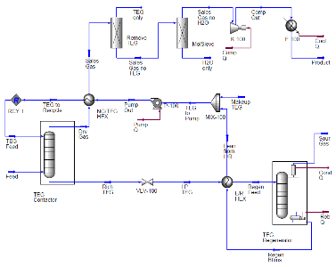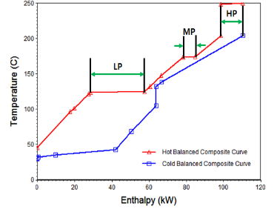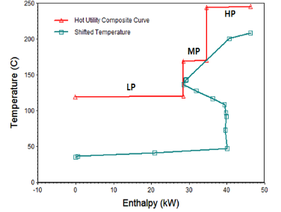
Fig. 1. The process flow diagram of the hydration process. | Fig. 2 Balanced composite curve with 3 utility. | Fig. 3 Utility composite curve with 3 utility.

4. Conclusions
Defining hot and cold stream utilities during the dehydration process was in order, followed by carrying out static process modeling in the utility system. The data resulted from these steps allowed producing composite curves of various utility usage levels, which can be helpful in planning a reduction strategy of the heat exchange temperature in the dehydration process.
References
- S. G. Yoon, Applied Thermal Engineering, 27(2007) 886-893.

