Catalytic Performance Investigations of the Direct DME Synthesis with Variable CO/CO₂/H₂ Feeds.
Stefan Wild¹, David Guse², Karla Herrera Delgado¹, Matthias Kind², Stephan Pitter¹, Sabrina Polierer¹ and Jörg Sauer¹
1 Institute for Catalysis Research and Technology (IKFT); 2 Institute of Thermal Process Engineering (TVT) Karlsruhe Institute of Technology (KIT) D-76131 Karlsruhe/Germany
*Corresponding author: Stefan.wild@kit.edu
Highlights
- Highly active CZZ/zeolite catalyst system with high CO₂ tolerance
- Good long-term stability under variable operating conditions

1. Introduction
Synthesis gas, a mixture of H₂, CO and CO₂ with variable composition, is the preliminary stage for many basic chemicals. Synthesis gas can be produced from a variety of feedstocks, resulting in a wide range of CO/CO₂/H₂ ratios^{[1]}. Methanol (MeOH) and Dimethylether (DME) formed from synthesis gas are promising energy carriers in the “Power to Fuels” (PtF) concept^{[2]}. Using CO₂ as a COx source would lead to a CO₂ recycle system and to CO₂-neutral fuels.

2. Methods
Within this study, the direct DME synthesis is investigated in a fixed-bed reactor aiming at dynamic processing with variable feed compositions. For initial methanol formation Cu/ZnO/ZrO₂ (CZZ) catalysts prepared at KIT-IKFT/TVT are used. Different solid-acid components such as γ-Al₂O₃, H-FER and H-MFI realize the dehydration of MeOH to DME. Experiments have been carried out under following reaction conditions: 483-523 K; 50 bar; gas hourly space velocity (GHSV) between 18.000 and 42.000 ml_{N}/(g*h); initial CO₂/(CO₂+CO) inlet-ratio between 0 and 1.
3. Results and discussion
Figure 1 (left) shows that CZZ catalyst enables up to 76 % higher DME productivity compared to a commercial Cu/ZnO/Al₂O₃ (CZA) sample material. DME productivity can be even increased at 503 K by raising the CO₂ content in the feed. At higher reaction temperature, the thermodynamic equilibrium becomes more noticeable, reflected by lower DME productivity for CO₂-rich feed compositions. More CO₂ in the feed generally favors water formation by reverse water-gas shift reaction, what also leads to a reduction of DME productivity^{[3]}. In a long-time experiment over nearly 600 h time on stream (ToS) using a CZZ/H-FER catalyst system a total decrease of 29 % in DME yield is observed. Figure 1 (right) shows the deactivation during the first 100 h under constant reaction conditions, followed by periods of variable dynamic changes subjected to varying temperatures, residence times and feed compositions.
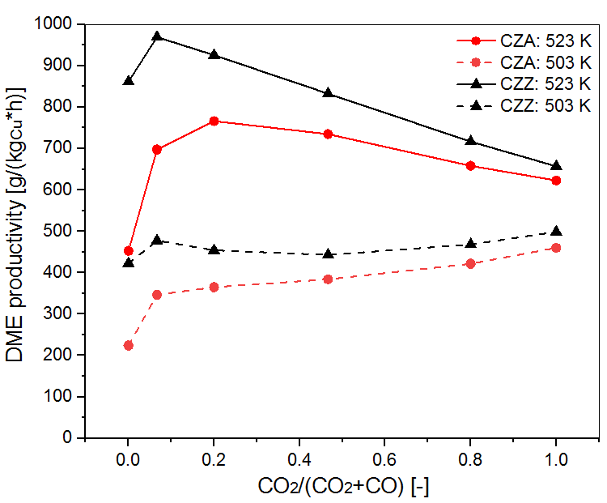 | 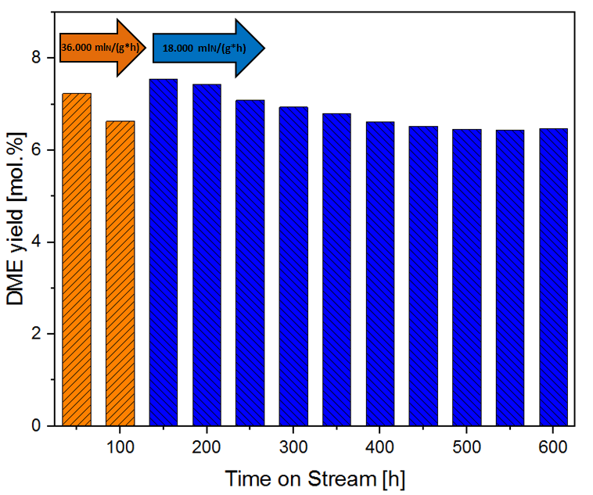
Figure 1. DME productivity of CZZ/H-FER and a commercial CZA/H-FER catalyst system (left). DME yield in a long time test of the CZZ/H-FER system (right).
4. Conclusions
The CZZ/H-FER system prepared at IKFT shows an enhanced performance compared to a commercial CZA/H-FER system and is a promising material for the conversion of syngas to DME with variable composition of CO/CO₂/H₂. With the appropriate choice of reaction conditions it is possible to make the DME productivity almost independent of the CO₂/(CO₂+CO) inlet-ratio.
References
- Ahmad, A.A., et al., Renewable and Sustainable Energy Reviews, 2016, 53: p. 1333-1347
- Niethammer, B., et al., Chemie Ingenieur Technik, 2018, 90(1-2), p. 99-112
- Ateka, A., et al., Reaction Kinetics, Mechanisms and Catalysis, 2018, 124(1): p. 401-418.

