Improvement of Enzymatic Hydrolysis of Cassava Starch to Produce Fermentative 2,3-Butanediol by Klebsiella Oxytoca KMS006.

Panwana Khunnonkwao¹, Sirima Suvarnakuta Jantama², Kaemwich Jantama^{1,*},
Claire Joannis-Cassan³ and Patricia Taillandier^{3,*}

¹School of Biotechnology, Suranaree University of Technology, Nakhon Ratchasima, Thailand
² Division of Biopharmacy, Faculty of Pharmaceutical Sciences, Ubon Ratchathani University, Warinchamrap, UbonRatchathani, Thailand, ³Laboratoire de Génie Chimique, Université de Toulouse, CNRS, INPT, UPS, Toulouse, France

*Corresponding author:Patricia.taillandier@ensiacet.fr, kaemwich@sut.ac.th
Highlights
- Klebsiella oxytoca KMS006 produced 2,3-BD from cassava starch with impressive yields.
- 1% (v/v) α-amylase was only used for releasing reducing sugars from cassava starch.
- Cassava starch is a promising feedstock for the economical production of 2,3-BD.
- The fermentation of 2,3-BD was performed in low salt medium to lower production cost.

1. Introduction
2,3-Butanediol (2,3-BD) is one of the building block chemicals which can be used in a variety of industrial applications [1]. Currently, the feasibility of 2,3-BD fermentation on a large scale depends on the use of cheaper renewable resource. The utilization of an inexpensive carbon source such as cassava starch has attracted attentions for the biotechnological production of 2,3-BD from an economic point of view. A metabolically engineered K. oxytoca KMS006 was engineered to enhance 2,3-BD production yield by gene deletion and metabolic evolution [2]. However, this strain does not efficiently ferment cassava starch due to low expression of malS encoding for α-amylase [3]. Thus, an external α-amylase enzyme was utilized to release fermentable sugars from cassava starch. The aim of this study was to investigate the optimal condition for enzymatic hydrolysis of cassava starch with α-amylase to obtain fermentable sugars for the production of 2,3-BD by K. oxytoca KMS006 in a simple batch fermentation.

2. Methods
Cassava starch (140 g/L or 130 g/L) was gelatinized in 2.5 L bioreactor with 1 L AM1 buffer (pH 6.0) (4) by autoclave at 121 °C for 20 min. A commercial α-amylase was added at concentration of 1% (v/v) into the bioreactor in order to covert cassava starch into sugars with two different conditions: before or after autoclaving. In this last case, the enzymatic hydrolysis step was carried out at 400 rpm during 3h. In both cases, the fermentation was then initiated by inoculation with K. oxytoca KMS006 at an initial OD₅₅₀ of 0.1 and carried out at 37 °C, 400 rpm and 0.8 vvm [5,6]. The pH of fermentation broth was maintained at 6.0 by automatic addition of 3 M KOH.
3. Results and discussion
To achieve a high 2,3-BD concentration from cassava starch, α-amylase was utilized to convert cassava starch to fermentable sugars. When the enzyme was added before autoclaving (Fig. 1A), the hydrolysis was not completed, probably due to the inactivation of α-amylase at high temperature. When α-amylase was added after autoclaving, the hydrolysis reaction was carried out for 3 h during temperature dropped from 85 to 45 °C. In this case, a maximum efficiency of starch hydrolysis was obtained as cassava starch concentration (130 g/L) was completely converted to reducing sugar (Fig. 1B). It resulted after fermentation of a final 2,3-BD concentration of 64.8 g/L with a yield of 0.46 g/g and productivity of 1.25 g/L/h at 52 h 8 with few by-product formed (about 3.8 g/L of succinate and acetate).
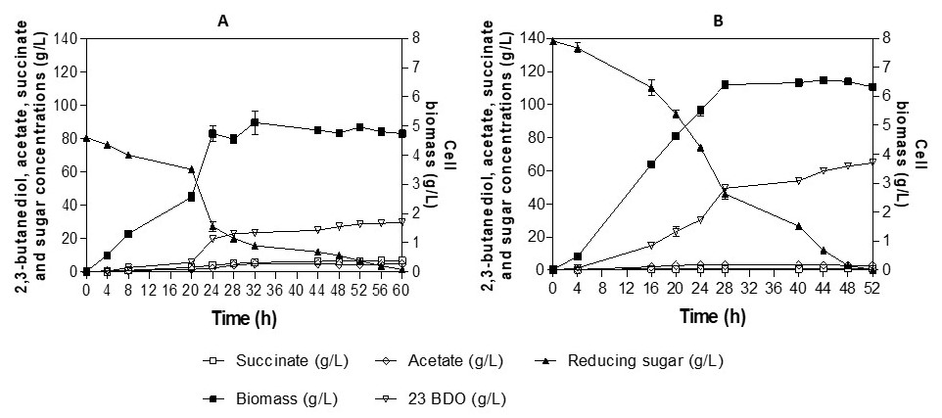
Figure 1. 2,3-BD fermentation from cassava starch using K. oxytoca KMS006. A) α-amylase was added into bioreactor before autoclave B) α-amylase was added into bioreactor after autoclave at ≈85 °C and hydrolysis for 3 h.
4. Conclusions
These results indicated that the fermentable sugars from cassava starch can be obtained by combined heat treatment with autoclave and solely α-amylase. In addition, cassava starch can be considered to be one of the most promising feedstock for cost-effective 2,3-BD production by K. oxytoca KMS006.
References
- M.J. Syu, Appl Microbiol Biotechnol. 55 (2001) 10-18.
- K. Jantama, P. Polyiam, P. Khunnonkwao, S. Chan, M. Sangproo, K. Khor, S.S. Jantama, S. Kanchanatawee, Met Eng. 30 (2015) 16-26.
- F. Tsvetanova, P. Petrova, K. Petrov, Appl Microbiol Biotechnol. 98 (2014) 2441-2451.
- A. Martinez, T.B. Grabar, K.T. Shanmugam, L.P. Yomano, S.W. York, L.O. Ingram, Biotechnol Lett 29 (2007) 397-404.
- S. Chan, S.S. Jantama, S. Kanchanatawee, K. Jantama, Plos one. (2016) 11:e0161503.Doi:10.1371/journal.pone.0161503.
- S. Chan, S. Kanchanatawee, S.S. Jantama, K. Jantama, C. Joannis-Cassan, P. Taillandier, J Chem Technol Biotechnol. 93 (2018) 600-608.

