Intensification of Fatty Acid Epoxidation in a Loop Reactor in the Presence of Microwave Radiation and Heterogeneous Catalysts.
Adriana Freites Aguilera^{1*}, Pasi Tolvanen¹, Kari Eränen¹, Johan Wärnå¹, Sébastien Leveneur^{1,2}, Tapio Salmi¹.

1 Laboratory of Industrial Chemistry & Reaction Engineering, Department of Chemical Engineering, Johan Gadolin Process Chemistry Centre, Åbo Akademi University, FI-20500 Åbo-Turku, Finland
2 Laboratoire de Sécurité des Procédés Chimiques, Institut National des Sciences Appliquées de Rouen, FR-76800 Saint-Étienne-du-Rouvray, France. Email: sebastien.leveneur@insa-rouen.fr

*Corresponding author: adriana.freites@abo.fi
Highlights
- Epoxidized vegetable oils are environmentally friendly chemical intermediates
- An extensive study of the epoxidation kinetics of vegetable oils was conducted in a loop reactor
- Microwave irradiation and heterogeneous catalysts enhanced the process considerably
- A detailed mathematical model for the multiphase system was developed
- Introduction
Epoxidized vegetable oils are chemical intermediates to valuable products, such as lubricants, plasticizers or non-isocyanate polyurethanes [1]. Tall oil obtained from forest biomass is a good source for vegetable oils, because it does not compete with the food chain. Epoxidation by the Prileschajew method implies the substitution of a double bond by an oxirane ring caused by a percarboxylic acid that is formed in situ from a carboxylic acid and hydrogen peroxide. Two liquid phases are present (oil and aqueous phases) and four reactions proceed simultaneously: formation of percarboxylic acid (perhydrolysis in aqueous phase), decomposition of the percarboxylic acid (aqueous phase), epoxidation of fatty acid (oil phase) and opening of the oxirane ring (oil phase) [2]. The principal method for vegetable oil epoxidation is well known but most of the studies published hitherto are qualitative in their character. Only few modelling studies have been published e.g. [3-4]. For process design, a detailed mathematical model for the complex multiphase system is necessary. The principles of the model and the essential modelling results are reported here.
2. Methods
A tailored recycle reactor system consisting of a vigorously stirred tank reactor, a circulation loop and a microwave source was constructed (Figure 1). The glass reactor was connected to a loop including a microwave cavity (Sairem) and a heat exchanger. Experiments were carried out both in the absence and presence of heterogeneous catalysts to reveal the potential intensifying effect of the catalysts. The cation exchanger Amberlite IR-120 was used as the main heterogeneous catalyst. The reaction temperatures were 40–70°C and the oil-H₂O₂- acetic acid ratio was varied in the experiments. The organic phase content was 32–45 %v/v.
3. Results and discussion
The main observations from the experiments were: epoxidation of vegetable oils (e.g. model component oleic acid) occurs spontaneously in the absence of the catalyst, but the reaction rate can be considerably enhanced by exposing the system to microwave irradiation and incorporating a catalyst. The benefit of the use of a heterogeneous catalyst (ion-exchange resin) is obvious compared to a homogeneous catalyst (e.g. mineral acid), because the catalyst separation problem is completely avoided when the heterogeneous catalyst is used. An example of an epoxidation experiment is given in Figure 1. A detailed mathematical model was developed for the system, consisting of mass balances of all the reacting components in both aqueous and oil phases. The set of differential equations in the model was solved numerically during parameter estimation. The accuracy of the parameters was checked by standard mathematical analysis and a Markov Chain Monte Carlo (MCMC) method. An example of experimental data and model fit is provided in Figure 2. In general, the model fit was good and the estimated parameters had a good accuracy. The model can be used for prediction of the progress of epoxidation in the absence and presence of microwave irradiation and catalysts.
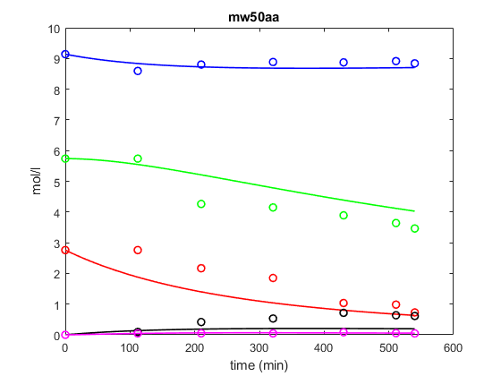
Figure 1. Tailored loop reactor system (left), model fit to experimental data (right); microwaves, 50ºC. In black: epoxidized oleic acid, pink: peracetic acid, red: oleic acid, green: hydrogen peroxide and blue: acetic acid.
4. Conclusions
An extensive set of kinetic experiments were carried out for the epoxidation of vegetable oils in a tailored reactor system. Microwaves and heterogeneous catalysts were successfully used to enhance the epoxidation process of a model compound, oleic acid and real tall oil mixtures. A multiphase reactor model was developed and applied to the experimental data. The model gave a good description of the experimental data and thus provides a perspective for process scale-up.
References
[1] S.G. Tan, W.S. Chow, Polymer-Plastics Technology and Engineering. 49 (2010) 1581-90.
[2] A. Campanella, M.A.Baltanás, European Journal of Lipid Science and Technology 106 (2004) 524-30.
[3] E. Santacesaria, R. Tesser, M. Di Serio, R. Turco, V. Russo V, D. Verde, Chemical Engineering Journal 173 (2011) 198-209.
[4] Z Wu, J Fang, Q. Xie, T. Zheng, L. Wu, M. Lu, et al. Industrial Crops and Products 122 (2018) 266-76.

