Aqueous Oxidation of Xylose to Xylonic Acid and Xylaric Acid over Synergistic PtAu and PtCu Catalysts Using Molecular O₂.
Jie Ding¹, Mengyuan Liu¹, Tianqi Fang¹, Chaohe Yang¹, Jian Shen², Xin Jin^{1*}
1 College of Chemical Engineering, China University of Petroleum, Huangdao District, Qingdao, Shandong Province 266580; 2 College of Environment and Recourses, Xiangtan University, Xiangtan, Hunan Province 411105
*Corresponding author: jamesjinxin@upc.edu.cn
Highlights
- Selective oxidation of xylose using O₂ in base-free medium at 80 ºC.
- Bimetallic PtAu and PtCu catalysts display synergistic performances.
- Combined selectivity towards xylonic and xylaric acid is approximately 85%.

1. Introduction
Carboxylic acids are important industrial chemicals for a variety of different everyday products. Catalytic conversion of inexpensive sugars to value-added acids provides an alternative route to fossil-based products. Xylaric acid ($ 2,650/g), produced from xylose ($ 0.07/g), has been identified as one of the top ten value-added chemicals for biomass conversion, with wide applications in fine chemicals, agriculture, medicine, and architecture [1].
Xylaric acid is conventionally produced using nitric acid as the oxidant, generating significant amounts of toxic by-products such as N₂O and NO. While oxidation of xylose to xylaric acid using molecular O₂ is environmental-friendly compared with mineral acid method, very limited work has been published on catalyst design for xylaric acid synthesis. One of the most recent results reported by Saha and colleagues showed that oxidation of xylose with O₂ to xylaric acid can be realized over supported monometallic Pt, Pd, Au, Ru and Cu catalysts with 64% yield [2]. The correlation of catalyst structures, including particle size, surface composition and metal-support interaction, with catalytic activity and selectivity, however, has yet to be fully understood in this area. Therefore, in this work, we reported a series of Pt-based mono- and bimetallic catalysts for effective oxidation of xylose to xylonic and xylaric acids. Influence of catalyst morphologies on conversion and selectivity will be particularly discussed in this work, with the aim to provide further insights into effective catalyst design for xylaric acid synthesis from xylose.
2. Methods
The catalysts were prepared by traditional method involving use of NaBH₄ as the reducing agent [3]. Metal loading was approximately 2wt%. In a typical oxidation experiment, 20 mL of aqueous xylose solution (0.07 mol/L) was added to the reactor and mixed with 0.05 g of catalyst. Reaction was conducted at 80 ℃ and 1 MPa O₂. The product solutions were analyzed by HPLC equipped with both RID-10A and SPD-20A detectors.
3. Results and discussion
Several TiO₂ supported Pt based mono and bimetallic catalysts were screened to evaluate their performances for xylose oxidation. Among other candidates, bimetallic PtAu catalyst shows enhanced conversion of xylose (X ~ 85%) and selectivity of xylaric acid (S ~ 18%, Figure 1a). PtCu catalysts also display interesting behaviors during xylose conversion. It is found that, PtCu/ZrO₂ catalyst exhibits higher conversion compared with PtCu/TiO₂, CeO₂, and AC with good selectivity towards xylaric acid being 19.6% at 80 ºC. The preliminary results clearly suggest bimetallic catalysts show promising performances compared with monometallic ones.
We also observed other co-products such as tartaric, glyceric, glycolic and formic acids, suggesting that xylose and xylonic acid might undergo C₁-C₄ and C₂-C₃ cleavage during oxidation reactions. Therefore, in this presentation, the influence of particle size of bimetallic PtAu and PtCu catalysts, and metal-support interaction on catalytic activity and product distribution during xylose oxidation will be discussed in details. BET, XRD, TEM and XPS characterization data will be correlated with experimental results from batch studies to establish possible structure-performance relation.
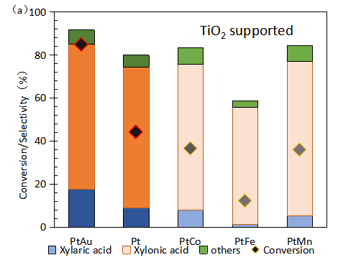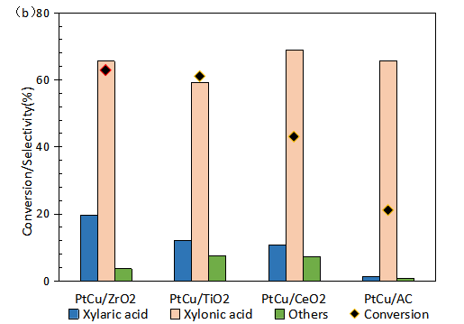
Figure 1. Activity and product distribution of Pt based mono and bimetallic catalysts (reaction conditions: 0.15 g xylose, 0.05g catalyst, 2wt.%, 2wt.%–2wt.% metal loading, 80 ℃, 10 h and 1 MPa O₂).
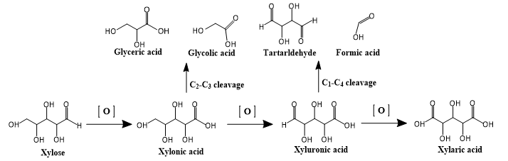
Scheme 1. Proposed reaction pathways of xylose Oxidation.
4. Conclusions
Bimetallic PtAu and PtCu catalysts exhibit synergistic catalytic performance in terms of activity and selectivity towards xylonic and xylaric acids during xylose oxidation.
References
- T. Werpy, G. Petersen, U.S. Department of Energy, 2004.
- S. Sadula, B. Saha, ChemSusChem, 2018.
- H. Shi, P. S. Thapa, B. Subramaniam, R. V. Chaudhari, Organic Process Research & Development, 2018.

