Molecular-Thermodynamic Correlation of Solubility Data for 20 Amino Acids in Water, in Ethanol and in Water-Ethanol Mixtures.
Nathan Bowden¹, Marieke E. Bruins², Johan Sanders³, John M. Prausnitz⁴
1 Institute for Sustainable Process Technology, Groen van Prinstererlaan 37 3818JN Amersfoort, the Netherlands; 2 Wageningen Food & Biobased Research, Bornse Weilanden 9, 6107WG Wageningen University and Research, The Netherlands; 3 Biobased Chemistry and Technology Group, AFSG, Bornse Weilanden 9, 6708WG Wageningen, Wageningen University and Research, The Netherlands; 4 Department of Chemical & Biomolecular Engineering, Gilman Hall, University of California, Berkeley, CA 94720-1462, USA
*Corresponding author: Nathan.bowden@ispt.eu
Highlights
- The solubilities of some amino acids show maxima in a water-ethanol mixed solution
- These calculated maxima, predicted by the model, are in agreement with experiments
- Solubility of amino acids depends its on $(f$^{s}/$f^{L})_{pure}$ ratio and its solvent interaction
- Amino acids with the lowest interaction parameters are not necessarily the most soluble

1. Introduction
Models have been proposed for amino acid solubility in aqueous solution [1] and for the solubility of amino acids in salt solutions [2]. A few empirical models with regressed parameters have been proposed to describe the solubility of α-amino acids in ethanol/water systems [3,4]. In this work, we apply the van Laar equation for the molar excess Gibbs energy to all 20 proteinogenic amino acids in ethanol, in water and in ethanol-water mixtures.
2. Methods
For each amino acid, $T_{m}$ and ${∆h}_{T_{m}}$ are estimated using the method proposed by Marrero and Gani [4]. To predict the solubility of an amino acid in mixtures of water and ethanol, we must determine the interaction parameters,$A_{ij}$, of an amino acid $(i)$ in water ($j$) or ethanol ($j$) and of water $(i)$ and ethanol ($j$) in a solute free solution, where $i$ and $j$ are all possible binary combinations of solute (1), water (2) and ethanol (3). To obtain the $A_{ij}$ parameters, we used the van Laar equation obtained from Wohl’s expansion for the molar excess Gibbs energy of a binary solution.
We then obtain the saturated mole fraction of the amino-acid solute, $x_{1}^{s}$ by simultaneously solving the model with the mass balance $x_{1}+x_{2}+x_{3}$= 1.00. The ratio $(f$^{s}/$f^{L})_{pure}$ at 25 °C is obtained.
$x_{1}^{s}=(f$^{s}/$f^{L})_{pure}{\left(exp\left[\frac{{{x_{2}}^{2}A}_{12}{\left(\frac{A_{21}}{A_{12}}\right)}^{2}+{{x_{3}}^{2}A}_{13}{\left(\frac{A_{31}}{A_{13}}\right)}^{2}+x_{2}x_{3}\frac{A_{21}}{A_{12}}\frac{A_{31}}{A_{13}}\left(A_{12}+A_{13}-A_{32}\right)\left(\frac{A_{13}}{A_{31}}\right)}{{\left(x_{1}+x_{2}\frac{A_{21}}{A_{12}}+x_{3}\frac{A_{31}}{A_{13}}\right)}^{2}}\right]\right)}^{-1}$ $.$
This calculation is not explicit in $x_{1}^{s}$. Solution of Equation is achieved by a simple iterative computer program.
3. Results and discussion
The Normalized Root Mean Square Variance for 16 of the 20 proteinogenic amino acids were lower than 0.100, indicating very good agreement with the solubility data. This group of amino acids includes L-tyrosine, whose maximum solubility occurs when the solute-free mixed solvent contains 91.1 mole% water and 8.90 mole% ethanol, higher than that at 100 mole% water. For L-isoleucine, L-tryptophan, L-phenylalanine and L-proline, NRMVs are lower than 0.220, indicating good agreement with the solubility data.

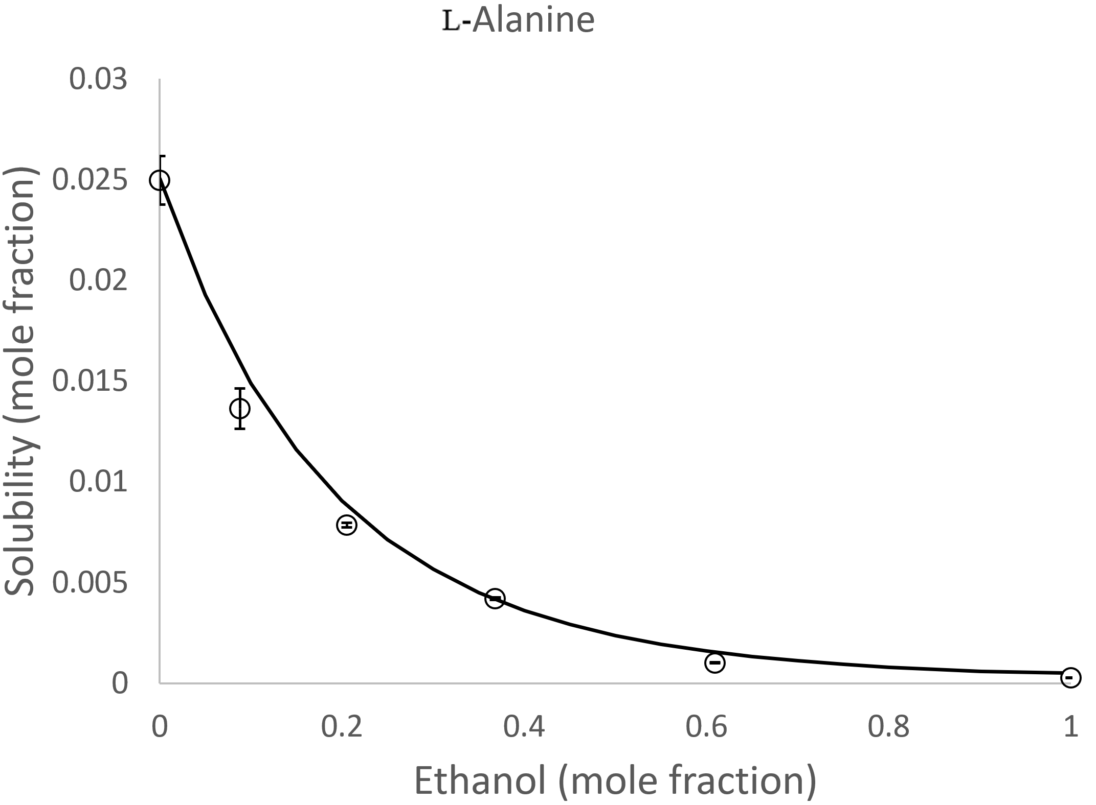
Figure 1: Predicted (solid line) and experimental (circles) solubilities of l-alanine in water-ethanol mixtures at 25 ˚C.

4. Conclusions
The ternary form of the van Laar equation for the molar excess Gibbs energy is useful for predicting the solubilities of amino acids in water-ethanol mixtures at 25 °C. The calculated solubilities of some amino acids show maxima in a water-ethanol mixed solution. These calculated maxima, predicted by the van Laar model, are in agreement with experiments.

The advantage of the thermodynamic technique used in this work is scale-up. A good solubility of a solute in a binary solvent (i.e. a ternary system) can be calculated based on only binary information.
References

[1] Gude, M. T.; Meuwissen, H. H. J.; van der Wielen, L. A. M.; Luyben, K. C. A. M., Partition Coefficients and Solubilities of α-Amino Acids in Aqueous 1-Butanol Solutions. Industrial & Engineering Chemistry Research 1996, 35 (12), 4700-4712;
[2] Held, C.; Prinz, A.; Wallmeyer, V.; Sadowski, G., Measuring and modeling alcohol/salt systems. Chemical Engineering Science 2012, 68 (1), 328-339;
[3] Gude, M. T.; van der Wielen, L. A. M.; Luyben, K. C. A. M., Phase behavior of α-amino acids in multicomponent aqueous alkanol solutions. Fluid Phase Equilibria 1996, 116 (1–2), 110-117.
[4] Bowden, N. A.; Mendez Sevillano, D.; Sanders, J. M. P.; Bruins, M. E. Modelling the effects of ethanol on the solubility of the proteinogenic amino acids with the NRTL, Gude and Jouyban-Acree models. Fluid Phase Equilibria 2017 459: 158-169
[5] Marrero, J.; Gani, R.; Group-contribution based estimation of pure component properties Fluid Phase Equilibria 2001, 183-208

