Population Balance Modelling in Bubble Columns Operated in Heterogeneous Regime: From 3D URANS QMOM Simulations to the Development of a Stable Sauter Diameter Model.
Frédéric Augier^{1,*}, Luca Gemello^{1,2}, Cécile Plais¹, Daniele Marchisio²
1 IFP Energies nouvelles, Rond-point de l’échangeur de Solaize, 69360 Solaize (69), France, 2 Dipartimento di Scienza Applicata e Tecnologia, Istituto di Ingegneria Chimica, Politecnico di Torino, Corso Duca degli Abruzzi 24, 10129 Torino, TO, Italy. *Corresponding author: frederic.augier@ifpen.fr
Highlights
- Efficient CFD modeling of Bubble Columns coupled with Population Balance
- Identification of a set of kernels validated over a wide range of cases
- Dimensionless analysis and proposal of a simple 0D approach to screen kernels

1. Introduction & Methods
This project aims at developing a bubble column model that couples CFD 3D Unsteady Reynolds Averaged Navier-Stokes equations (3D URANS) with a Population Balance (PB) approach. Experimental data obtained in a former work^{[1]} including gas holdup, liquid velocity and bubble size measurements have previously been used to validate a 3D URANS CFD model^{[2]} without PB, thanks to the use of a specific drag law^{[2]}. Now the Quadrature Method of Moments (QMOM) is applied^{[3]} to solve PB. This method allows to calculate, at low CPU cost, the k-first moments (m_{k}) of the Bubble Size Distribution (BSD), and thus the Sauter mean diameter d₃₂ (=m₃/m₂). We propose to present 1) the validation of breakage and coalescence kernels for this application, and 2) a model simplification and analysis that points out the link between physical models and the resulting Sauter mean diameter. The CFD and QMOM equations are solved with the commercial software ANSYS Fluent® 18.2.
Transport equations of the moments of the BSD are synthetized in Figure 1:

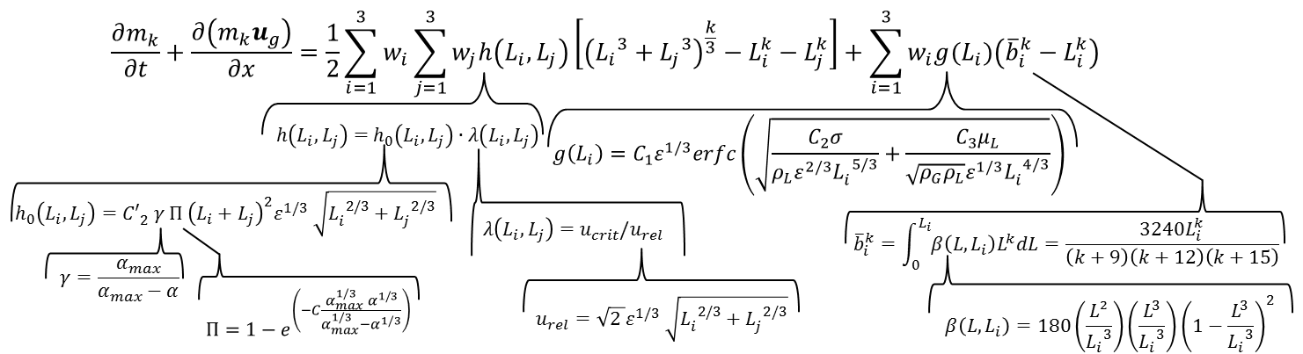
(1)
Figure 1. Scheme of the moment transport equations.
where L (m) is the bubble diameter, i and j are the indices of the 3 nodes of the quadrature method. w_{i} (m⁻³) is the bubble density of the node i. h (s⁻¹m³) is the coalescence kernel and g (s⁻¹) is the breakage kernel. h₀ (s⁻¹m³) is the collision frequency model, λ (-) is the coalescence efficiency, β (m⁻¹) is the distribution of the daughter bubbles after the breakage of a parent bubble and ε is the dissipation rate (W/kg). α is the gas volume fraction, u_{rel} (m/s) is the turbulent relative velocity and u_{crit} (m/s) is the critical approach velocity between bubbles above which coalescence is not possible. γ and Π are dimensionless correction factors to include the effect of gas volume fraction on collision frequency. α_{max} is the maximum gas volume fraction, taken equal to 0.8. C_{xx} are the constants of the different involved models. At each time step and in each spatial location, wi and Li are reconstructed from the m₀ to m₅ moments by a Product-Difference algorithm. Breakage and coalescence contributions to the moments are computed with the 3 nodes (w_{i}, L_{i}) in the source (right) term of Eq. (1) in Fig. 1.
3. Results and discussion
Comparing simulations and experimental data obtained in the breakage-dominated regime^{[2]}, it is possible to validate the breakage model of Laakonnen^{[4]}. Concerning the coalescence model, the best agreement is obtained by coupling the collision frequency model suggested by Wang^{[5]} and the coalescence efficiency of Lehr^{[5]}, based on the critical approach velocity model (Fig.1) . Sauter diameter radial profiles are well predicted over a wide range of operating conditions (not shown). Besides, as equation (1) is very complex, a drastic simplification is considered to analyse the consistency of the kernel with our phenomenology. In Eq. (1) the source term is computed by considering only a single bubble diameter (L=d₃₂) to calculate the right-hand term. Consequently i=j=1 in the transport equations, and the bubble density is equal to $w=6α/\left(πL^{3}\right)$. Note that m₃ is always equal to 6α/π whatever the BSD. The steady state of the equation (1) for k=2 is strongly simplified and becomes a dimensionless relation:

${τ_{b}}/{τ_{c}}={6α.h(L,L)}/{\left(g\left(L\right).π.L^{3}\right)}={\left(1-{{\overline{b}}^{2}}/{L^{2}}\right)}/{\left(2^{-\frac{1}{3}}-1\right)}$ (2)

where $τ_{b}=1/{g(L)}$ is the characteristic breakage time and $τ_{c}=1/{w.h\left(L,L\right)}$ ${=πL^{3}}/{(6α.h(L,L))}$ is the characteristic coalescence time. The term ${{\overline{b}}^{2}}/{L^{2}}$ depends only on the shape of the daughter-bubble distribution β and not on L². Using the β model of Laakonnen leads to ${τ_{b}}/{τ_{c}}$≈1.15. This equation only depends on L, α and ε and physical properties . It can be used to calculate directly the stable d₃₂ and to compare various models of breakage and coalescence. α and ε can be computed by using CFD simulations for instance. d₃₂ calculated from Eq. (2) is successfully compared both to the complete CFD+QMOM model and experimental results in Figure 2. This shows that the strong assumptions done to develop the Eq. 2 are acceptable if only the Sauter mean diameter of the BSD is required.
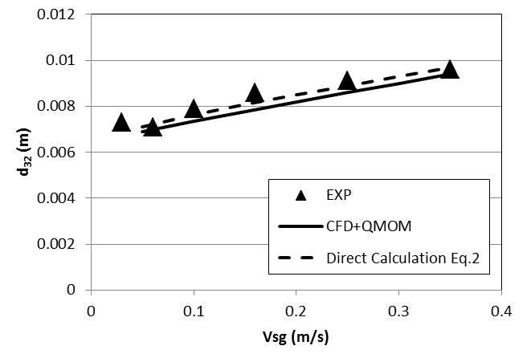
Figure 2. d₃₂ comparison between CFD, Eq. (2) and experiments^{[1]} (0.4 m column diameter, demineralized water)
References
- L. Gemello, C. Plais, F. Augier, A. Cloupet, D.L. Marchisio, Chem. Eng. Sci. 184 (2018) 93-102.
- L. Gemello, V. Cappello, F.Augier, D.L.Marchisio, C. Plais, Chem. Eng. Res. Des. 136 (2018) 846-858.
- D.L. Marchisio, R.D. Vigil, R.O. Fox, J. Coll. Interf. Sci. 258 (2003) 322-334.
- Y.Liao, Lucas, Chem. Eng. Sci. 64 (2009) 3389-3406.
- Y.Liao, Lucas, Chem. Eng. Sci. 64 (2010) 2851-2864.

