Intensifying the Re-carbonation Process of Water.
Gabi Altabash¹, Mahmoud Al-Hindi¹, Fouad Azizi¹*
1 Dept. of Chemical and Petroleum Eng. American University of Beirut, POBox: 1107 2020 Beirut, Lebanon
*Corresponding author: fouad.azizi@aub.edu.lb
Highlights
- An attempt to intensify CO₂ absorption in water was undertaken,
- Two different measurements techniques were employed,
- High k_{L}a values were obtained in short residence times at low energy consumption,

1. Introduction
Several reactor types are used for gas-liquid mass transfer operations; however, many of which remain improperly designed because of their complex hydrodynamics. A new type of static mixing element was recently introduced in which woven mesh screens or grids are used to repetitively superimpose an adjustable uniformly distributed turbulence field on the nearly plug flow conditions encountered in high velocity pipe flows. These mixers were found to be very effective at processing multiphase operations [1, 2]. These screens are typically used as a source or sink for turbulence and are characterized by their wire size, mesh opening, and fraction open area. This study therefore aims at employing them to intensify the absorption of CO₂ in RO water without chemical reactions. Its success would allow achieving smaller reactor volumes and introducing various economical and safety enhancements. Faster and more efficient re-carbonation processes can thus be conducted at lower energy consumption and space requirements. In addition, the intensification of these processes will also impact the design of photo-bioreactors by providing CO₂-rich waters for the cell cultures in very short residence times and influence various applications of biogas upgrading.
2. Methods
In order to meet the research objectives, a plug flow reactor design (length = 560 mm and inner diameter = 25 mm), equipped with screen type static mixers was employed to test and quantify the transfer rates of CO₂ into RO water. To analyze the data, the amount of absorbed CO₂ was quantified using two different measurement techniques, namely, pH measurements and another direct measurement technique using a CO₂ analyzer (Anton Paar®, model CarboQC). The method of analysis was that proposed by Kordač and Linek [3]. The experiments were conducted using 8 screen elements placed at 70 mm apart. The total superficial velocity was varied between 1 and 2 m/s while testing for three different gas volume fractions (φ = 10, 20, and 30%). Under these conditions, the residence time of the mixture in the mixing section varied between 0.28 and 0.56 s.
3. Results and discussion
The efficiency of the reactor was evaluated from the calculated volumetric mass transfer coefficients, k_{L}a, that were determined from the dissolved concentrations of CO₂ in water. The two measurement techniques differed by less than 10% when comparing pH measurements to pH values back-calculated from direct CO₂ measurements. Similarly, to many other studies, k_{L}a increased with an increasing U_{T} and φ (cf. Figure 1). It reached a maximum value of 1.01 s⁻¹. These values were obtained at low energy consumption rates. The latter was characterized using the specific energy consumption per unit mass of liquid treated, E_{spm} [1]. This parameter was found to vary between 0.002 and 0.019 kWh/tonne and always decreased with an increase in φ because of the subsequent reduction in the total pressure drop. For a detailed comparison with other gas-liquid contactors, the reader is referred to [1]. Furthermore, to better differentiate the effect of changing the screens, it was critical to choose the Reynolds number characteristic length with respect to the screen geometry and not rely on the empty pipe Re (cf. Figure 2).
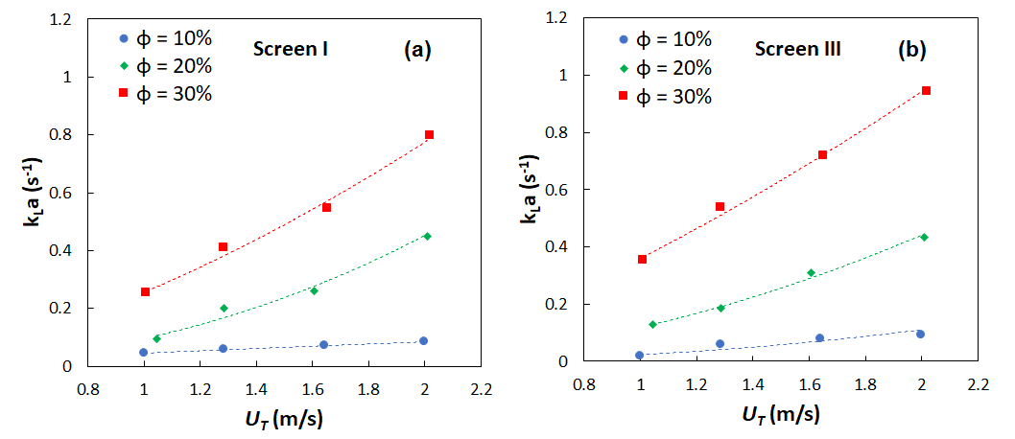
Figure 1. Effect of superficial velocity and gas holdup on the volumetric mass transfer coefficient.
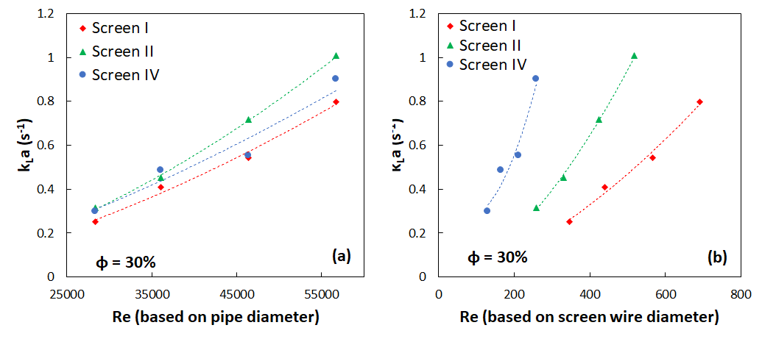
Figure 2. Effect of changing Re characteristic length on interpretation of results.
4. Conclusions
Intensifying CO₂ absorption in RO water was investigated using a tubular reactor equipped with screen-type static mixers. k_{L}a values were affected by screen geometry where higher values were recorded when using screens characterized by small open area, small wire diameter and mesh size. The values obtained in the present work were found to be one to two orders of magnitude higher than conventional gas-liquid contactors such as mechanically agitated tanks and bubble columns and were in the same order of static mixers and advanced flow reactors.
References
- F. Azizi, A.M. Al Taweel, Ind. Eng. Chem. Res., 54 (2015) 11635–11652.
- A.M. Al Taweel, F. Azizi, G. Sirijeerachai, Chem. Eng. Proc.: Proc. Intens. 72 (2013) 51–62.
- M. Kordac, V. Linek, Ind. Eng. Chem. Res., 47 (2008) 1310–1317.

