**A Novel Closure Method for Pbes Based on Gram-Charlier Densities.**

Grzegorz Tyl1*, Jerzy Bałdyga1, Mounir Bouaifi2

*1 Faculty of Chemical and Process Engineering, Warsaw University of Technology, ul. Waryńskiego 1, 00-645 Warsaw, Poland*

*2 Centre de Recherche et d’Innovation de Lyon, Solvay, 85 Avenue des Frères Perret, BP 62, 69192 Saint-Fons Cedex,France*

*\** *grzegorz.tyl.dokt@pw.edu.pl*

**Highlights**

* A novel closure method for the nonlinear moment-transformed Population Balance Equations has been proposed and applied.
* Gram-Charlier type A densities allow to access the full distribution during simulation.
* The introduced method has been employed to solve PBE for Ostwald ripening problems.

**1. Introduction**

Population balance equations (PBE) are widely used to predict evolution of the particulate systems. To decrease computation time and incorporate PBE into CFD software one can use methods of moments and represent distributions with averaged values. When, however, nonlinear terms are present in PBE, a closure procedure is required. This is often done by using quadrature methods, which precisely approximate polynomial terms. In other cases an error of approximation can be significant. There is also no simple way to calculate pointwise values.

In this work a new method of closure, based on Gram-Charlier type A expansion [1] with GNT transformation [2], is presented. It allows to robustly retrieve a full distribution in each time step of the simulation and close the nonlinear terms of PBE.

**2. Gram-Charlier densities**

One of the approaches to retrieve a full probability density function (PDF) from its statistical parameters is an expansion of the searched PDF about another PDF with common mean and variance. A type A Gram–Charlier expansion is made about normal distribution density:



where  stands for the normal probability density function with a mean value  and standard deviation ,  are the moment dependent parameters and  are Hermite polynomials of order s. The series in Eq. (1) have to be truncated depending on the number of moments available and required precision. To obtain , being a positive function that integrates to unity, a squared transformation and scaling are applied ([2], [3]). The function given below can be used to execute further integration in nonlinear terms of PB:





**3. Application to population balance**

As a test case for the introduced closure method a simulation of the Ostwald ripening (OR) process has been chosen. Modeling with PBE of the size dependent dissolution, requires calculation of the pointwise values of the PDF. The moment-transformed PBE for OR reads:



where *m­k* denotes k-th moment of the PDF, *G(x)* is a size dependent growth rate such that particles smaller than *x­min* disappear and larger grow ([4], [5]):



where *x* denotes the particle size, *x\** = *x­min* and α is proportional to the diffusion coefficient.

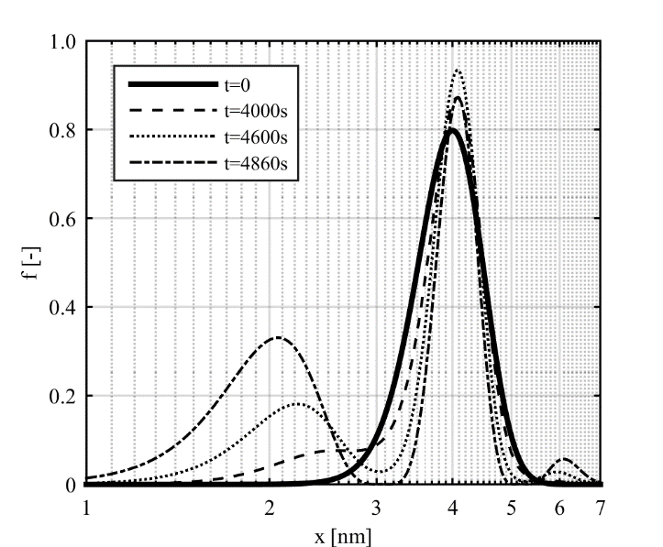

**Figure 1.** Time evolution of the particle size distribution (*n0=1023*, *μ0=4nm, σ0=0.5nm, xmin=0.5nm, α=10-30, x*=4nm*)

**4. Discussion and conclusions**

A time evolution of the normalized particle size distribution is presented in Figure 1. As one can see dissolution of particles smaller than 4nm results in creation of transient multimodal distributions. Results of simulations agree, at least qualitatively, with experimenal data.

A closure method is robust and can be used ragardless of the type of system simulated, including non-polynomial source terms and application of pointwise values of PDF if necessary.

*The authors gratefully acknowledge the financial support from Solvay, France.*

**References**

[1] E.B. Del Brio, J. Perote, Insur Math Econ. 51 (2012) 531-537.

[2] A.R. Gallant, D.W. Nychka, Econometrica. 55 (1987) 363–390.

[3] A.R. Gallant, G. Tauchen, Econometrica. 57 (1989) 1091–1120.

[4] I.M. Lifshitz, V.V. Slyozov, J. Phys. Chem. Solids. 19 (1961) 35-50.

[5] C. Wagner, Zeitschrift für Elektrochemie. 65 (1961) 581-591.