Process Analytical Tools for Monitoring, Design and Model-free Control of Crystallization Systems
Zoltan K Nagy^{1, 2, *}
¹ Department of Chemical Engineering, Loughborough University, Loughborough, LE11 3TU, United Kingdom;
² Davidson School of Chemical Engineering, Purdue University, West Lafayette, IN, 47907, United States
*Corresponding author: z.k.nagy@lboro.ac.uk
Highlights
- Process analytical tools for crystallization will be reviewed
- Application of model-free feedback control will be presented
- Monitoring and control of batch and continuous crystallization systems

1. Introduction
In the absence of a dedicated monitoring and control system, industrial crystallizers often perform sub-optimally, which is mostly reflected in a low-quality product with a wide or multimodal size distribution, undesirable mean crystal size, a sub optimal crystal shape or an unwanted crystal structure. Recent developments in in situ monitoring, modeling as well as in both model-free and model-based control strategies, however enable new opportunities in the design and application of control strategies for practical applications (Nagy and Braatz, 2012; Nagy et al., 2013). 2.
2. Results and discussion
This lecture provides an overview of the state-of-the-art in the monitoring and model-free control of industrial crystallization processes and through a series of case studies illustrates how these recent developments can contribute to better product quality and improved performance of industrial crystallization systems. The advantages of using integrated in situ and in line monitoring systems as a composite sensor array in conjunction with a crystallization process informatics system will be illustrated, which enables robust data reconciliation, automated calibration and sensor fault detection as well as an intelligent, rapid design and of robust crystallization processes with precise control of critical quality attributes (Fig. 1). The key process analytical tools (PATs) that can be used for in situ monitoring of crystal size, shape, polymorphic form and purity will be described. Model-free control approaches, such as supersaturation control (SSC) and direct nucleation control (DNC) will be described and illustrated with industrial case studies. The control of batch, continuous stirred tank and tubular crystallization systems will be corroborated. The final part of the lecture will introduce the application of monitoring and control systems for novel integrated systems to achieve high degree of control of various crystal properties, including integrated crystallization and wet mill process and continuous plug flow crystallization platforms with spatially distributed control strategy and controlled spherical crystallization that enable the simultaneous control of the trade-off between bioavailability and manufacturability of the final product.
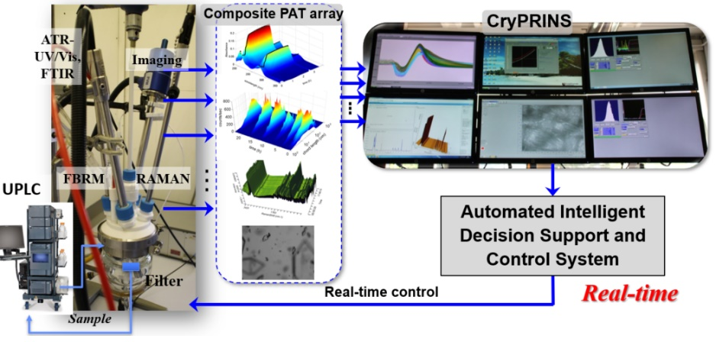
Figure 1. Fully automated batch/continuous reactor/crystallization platform with array of in situ and in line PAT.
References
[1] Nagy, Z. K., Braatz, R. D. (2012). Advances and new directions in crystallization control, Annu. Rev. Chem. Biomol. Eng., 3, 55-75.
[2] Nagy, Z.K., Fevotte, G., H., Kramer, Simon, L.L. (2013). Recent advances in the monitoring, modelling and control of crystallization systems, Chem. Eng. Res. Des., 91 (10), 1903-1922.

