Understanding freeze drying of sucrose solutions
Mercedeh Sadat Hosseinalipour, Luca Bosetti, Viktoria Wiedmeyer, Marco Mazzotti*
Institute of Process Engineering, ETH Zurich, 8092 Zurich, Switzerland
mhossein@ipe.mavt.ethz.ch
Highlights
- Freeze drying, a pharmaceutical unit operation to ensure prolonged product stability during storage
- Model study of sucrose, as one of the main excipients used in pharmaceuticals
- Importance of ice nucleation for freeze drying and final product structure

1. Introduction
Freeze-drying is a process, where a solvent, e.g. water, is removed from a frozen product under vacuum. Such a process, also called lyophilisation, is widely used in pharmaceutical industry to improve stability and long term storage of labile drugs [1]. Freezing and drying are the main two steps of the process, among which the latter can be further divided into primary and secondary drying. Controlling ice nucleation temperature during the freezing step is one of the most challenging aspects of the development of a lyophilisation cycle and it affects drying time, product morphology, protein preservation, intra-vial and vial-to-vial heterogeneity and process performance [2]. In order to overcome this challenge, understanding thermodynamics and kinetics of the product is of great importance.
In addition to being bulking agents, disaccharides, like sucrose, have proven to be most effective in stabilizing products such as liposomes and proteins during lyophilisation [3]. Since in many pharmaceutical preparations the bioactive content amounts to no more than a few percent, the freeze-drying characteristics of such formulations are often governed mainly by the physical and thermomechanical behaviour of the excipient mixture [4]. In the present work, sucrose-water solution has been chosen as a model solution to be freeze-dried regarding its wide usage in pharmaceutical formulations.

2. Methods
The basis to investigate thermodynamics and kinetics is the state diagram of sucrose-water solution with experimentally driven equations of solubility, solidification and glass transition temperature [5], which is shown in Figure 1.
Experiments were performed to investigate the effects of different thermal treatments, drying conditions and solution volume on the final freeze-dried product. XRD and TGA were used to study crystallinity and water content of different experiments.

3. Observations and discussion
Freeze-dried sucrose of all experiments were amorphous, as expected [5]. Samples with the same freezing treatment but different drying conditions resulted in very different specifications of the final product related to cake appearance, colour and stickiness. Regarding their characteristics, some of the products were classified as totally or partially collapsed cakes. These observations further clarified that sucrose, as an important component in pharmaceutical formulations, can present various states.
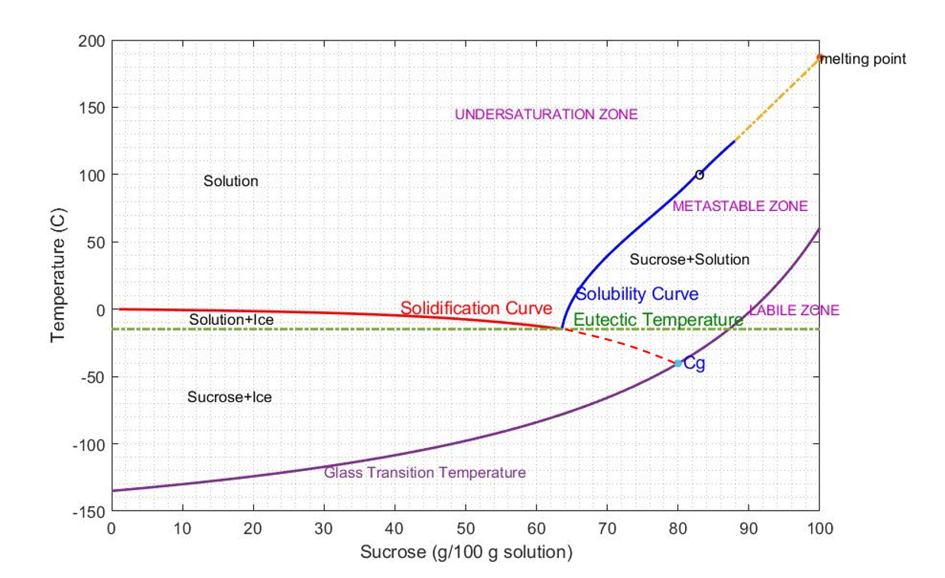
Figure 1. State diagram of sucrose-water [5]
4. Conclusions
In this work, it has been discussed how better understanding of the state diagram for a formulation to be freeze-dried can lead to a successful process. The importance of thermodynamics and kinetics is crucial to improve the design of a lyophilisation cycle of a formulation in a more predictable way.

References

[1] | S. Nail, G. Gatlin, “Freeze drying: principles and practice,” in Pharmaceutical Dosage Forms - Parenteral Medications, 2010, pp. 353-381.
[2] | R. Pisano, “Alternative methods of controlling nucleation in freeze drying,” in Lyophilization of Pharmaceuticals and Biologicals, New York, NY, Humana Press, 2019, pp. 79-111.
[3] | S. Leslie, E. Israeli, B. Lighthart, J. Crowe and L. Crowe, “Trehalose and sucrose protect both membranes and proteins in intact bacteria during drying,” Applied and Environmental Microbiology, vol. 61, no. 10, pp. 3592-3597, 1995.
[4] | F. Franks, “Freeze-drying of bioproducts: putting principles into practice,” European Journal of Pharmaceutics and Biopharmaceutics, vol. 45, pp. 221-229, 1998.
[5] | M. Mathlouthi and P.Reiser, Sucrose, properties and applications, Chapman & Hall, 1995.

This project has received funding from the European Research Council (ERC) under the European Union's Horizon 2020 research and innovation programme under grant agreement No 2-73959-18.

