Valorization of distillers dried grains with solubles for the production of enzymes
Jasper Driessen, Solange I. Mussatto
Biomass Conversion and Bioprocess Technology Group,
Novo Nordisk Foundation Center for Biosustainability, Technical University of Denmark
*Corresponding author: jasdri@biosustain.dtu.dk
Highlights
- Optimization of lignocellulosic biomass pretreatment
- Adaptive laboratory evolution for increased robustness to hydrolysate-associated inhibitors
- Optimization in small-scale fermenters to study scale-up and scale-down effects for increased industrial applicability

1. Introduction
The total production volume of bioethanol reached 96 billion liters in 2015 and economic projections estimating a steady increase until 2020 [1] [2]. A vital part (20%) of the total plant revenue is generated by selling of distillers dried grains with solubles (DDGS) as animal feed. However, since DDGS can only account for 30% of the wildstock feed (dry basis) due to palpability and excessive protein issues, a saturated animal feed market is expected lower DDGS market prices [2]. Bearing these developments in mind, the need of an innovative method to generate value to DDGS grows.
The global industrial enzymes market should reach $7.0 billion by 2023 from $5.5 billion in 2018 at a compound annual growth rate (CAGR) of 4.9% for the period 2018-2023 [3]. Although the industrial production of enzymes is well established, the growing market, high production costs and high level of competition in a changing market have pressed industry to seek new sustainable alternatives for their processes [4] [5]. Next to capital investment (50%), the highest cost factor of industrial enzyme production is associated to raw materials (33%) [6]. Last decades, researchers started to look into using agro-industrial lignocellulosic waste streams as raw material for enzyme production [6].
2. Methods
In this project, we propose an innovative bioprocess for the valorization of DDGS by using it as raw material for enzyme production (Fig.1). First, characterization of feedstock and optimization of biomass pretreatment are required to produce a suitable hydrolysate-based medium. Combining molecular biology tools for strain development and bioreactor design principles for optimized fermentation conditions will ensure that all aspects of enzyme production are covered. In the last phase, the optimized production strain is optimized for different process parameters in small-scale bioreactors. Final experiments in large-scale fermenters are used to validate strain productivity.
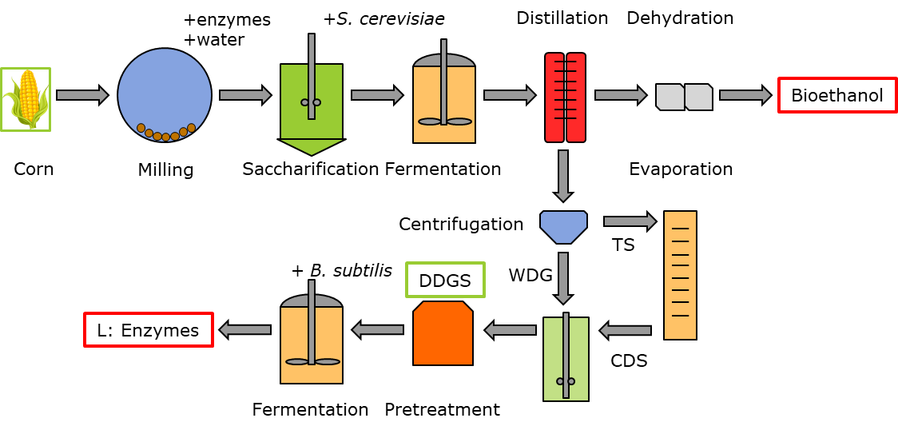
Fig. 1 Valorization of DDGS by enzyme production
3. Results and discussion
DDGS is a highly available material (32.3 kg DDGS /100 kg grains in a dry milling process), rich in nutrients and carbon sources (crude protein 24.9%, cellulose 16%, starch 5.2%, xylan and arabinan 13.5% w/w) [2] [8]. The high amount of sugars released after biomass conversion as well as the crude proteins serve as source of energy, carbon and nitrogen to sustain microbial growth during fermentation. Considering the price and composition of DDGS, valorization via biomass conversion for enzyme production seems to be a promising strategy.
4. Conclusions
The integration of DDGS to a multi-stream process could lead to the generation of different value added products, increasing economic viability and reducing DDGS market saturation associated to the growing bioethanol industry. Insights gained in this project should result in clear and applicable recommendations for the industry.
Acknowledgements: Novo Nordisk Foundation, Denmark, NNF10CC1016517; DuPont Industrial Biosciences.
References
[1] S. I. Mussatto and G. M. Dragone, Biomass Pretreatment, Biorefineries, and Potential Products for a Bioeconomy Development. Elsevier Inc., 2016.
[2] A. Chatzifragkou and D. Charalampopoulos, “Distiller’s dried grains with solubles (DDGS) and intermediate products as starting materials in biorefinery strategies,” in Sustainable Recovery and Reutilization of Cereal Processing By-Products, 2018.
[3] B. Research, “Global Markets for Enzymes in Industrial Applications,” 2018. https://www.bccresearch.com/market-research/biotechnology/global-markets-for-enzymes-in-industrial-applications.html.
[4] Ling Lin Fu, Zi Rong Xu, Wei Fen Li, Jiang Bing Shuai, Ping Lu, and Chun Xia Hu, “Protein secretion pathways in Bacillus subtilis: Implication for optimization of heterologous protein secretion,” Biotechnol. Adv., vol. 25, no. 1, pp. 1–12, 2007.
[5] A. Sonenshein and R. M. L. , Abraham L., James A Hoch, “Bacillus Subtilis and Other Gram-positive Bacteria : Biochemistry, Physiology, and Molecular Genetics.,” in Bacillus Subtilis and Other Gram-positive Bacteria : Biochemistry, Physiology, and Molecular Genetics., 1993.
[6] R. Ravindran, S. Hassan, G. Williams, and A. Jaiswal, “A Review on Bioconversion of Agro-Industrial Wastes to Industrially Important Enzymes,” Bioengineering, vol. 5, no. 4, p. 93, 2018.
[7] M. A. Martin, “First generation biofuels compete,” N. Biotechnol., vol. 27, no. 5, pp. 596–608, 2010.

