Combined Enzymatic Decarboxylation and Pd-catalyzed Heck Coupling in Continuous Flow
Bianca Grabner¹, Anna K. Schweiger², Kristian Gavric¹, Robert Kourist²,
Heidrun Gruber-Woelfler¹*
1 Institute of Process and Particle Engineering, Graz University of Technology, Graz, Austria
2 Institute of Molecular Biotechnology, Graz University of Technology, Graz, Austria
*Corresponding author: woelfler@tugraz.at
Highlights
- A fully integrated two-step flow process combining metal- and biocatalysis
- Use of deep eutectic solvent (DES) to overcome the problem of solvent compatibility
- Full conversion for both decarboxylation and subsequent Heck coupling
- The two-step process was successfully operated for more than 16 h

1. Introduction
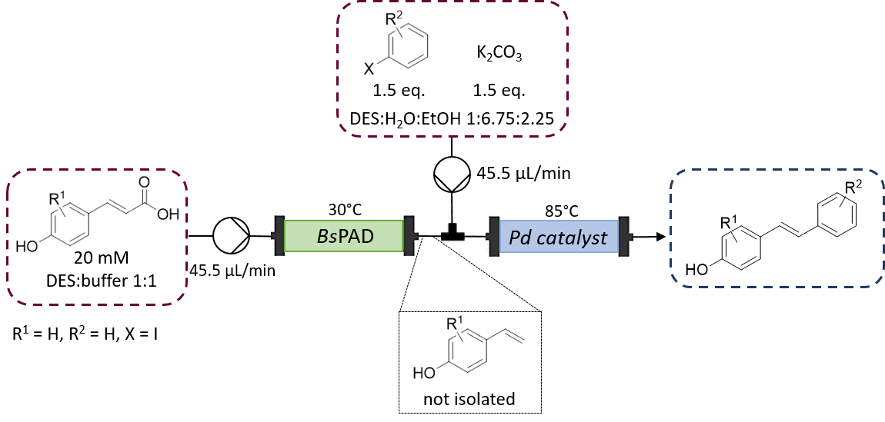
Tandem-catalytic reactions are promising routes for the synthesis of high-value products in fine-chemical, agrochemical and pharmaceutical industry. Therefore, they have attracted the attention of researchers in the past decade. [1] Based on recent findings [2], in this work we present a fully integrated two-step flow setup consisting of an enzymatic decarboxylation followed by a Heck reaction coupling the decarboxylation product to an aryl halide as shown in Figure 1 to synthesize asymmetric stilbene derivatives. The most prominent derivatives of stilbenes are resveratrol and its analogues. Their conjugated double bond system gives the molecule anti-oxidant, anti-inflammatory, antidiabetic, antiaging and anticancer properties. [3]
Figure 1. General reaction scheme for enzymatic decarboxylation with a phenolic acid decarboxylase from Bacillus subtilis (BsPAD) yielding a 4-hydroxystyrene derivative, which serves as substrate for a Pd-catalyzed cross-coupling reaction with an aryl halide, resulting in a 4-hydroxystilbene product.
2. Methods
A cell-free extract (CFE) of phenolic acid decarboxylase from Bacillus subtilis (BsPAD) was immobilized in 2 % alginate beads and employed in a 1:1 (v/v) mixture DES (Choline chloride:glycerol 1:2 (mol/mol)) with potassium phosphate buffer (50 mM, pH 6.0) to decarboxylate para-coumaric acid. [4] For the second step, the Heck coupling of the decarboxylation product to iodobenzene, an in-house developed heterogeneous Pd-catalyst (Pd-substituted cerium-tin-oxide with the composition Sn_{0.79}Ce_{0.29}Pd_{0.01}O_{2-δ)} was applied. [5] The reaction was conducted in a solvent mixture of DES (30 vol%), buffer (25 vol%), ethanol (34 vol%), and water (11 vol%) For the continuous mode, both catalysts were packed in stainless steel columns and heated to 30 °C (PAD) and 85 °C (Pd-catalyst) in a water bath, respectively.
3. Results and discussion
The residence time in the reactors was calculated to be 30 min for the decarboxylation and 45 minutes for the Heck coupling. The conversion of the first step could be followed visually as CO₂ bubbles left the reactor as soon a full conversion of the substrate was achieved. In continuous mode, full conversion was reached for both decarboxylation and Heck coupling. The two-step process was successfully operated for more than 16 h. While the continuous mode allowed to conduct both reaction at their optimal temperature, DES proved to be a solvent compatible with both reactions.
4. Conclusions
These results are important steps towards chemo-enzymatic reactions in continuous flow and should be further investigated in the near future. The results show the importance of DES to overcome obstacles like substrate solubility and solvent compatibility in chemo-enzymatic tandem reactions.
References

- a) F. Rudroff, M. D. Mihovilovic, H. Gröger, R. Snajdrova, H. Iding, U. T. Bornscheuer, Nat. Catal. 1 (2018) 12-22; b) J. Enoki, C. Mügge, D. Tischler, K. Miyamoto, R. Kourist, Chemistry 25 (2019) 5071-5076; c) S. Schmidt, K. Castiglione, R. Kourist, Chem. Eur. J. 24 (2018) 1755-1768; d) J. M. Sperl, J. M. Carsten, J.-K. Guterl, P. Lommes, V. Sieber, ACS Catal. 6 (2016) 6329-6334.
- Á. Gómez Baraibar, D. Reichert, C. Mügge, S. Seger, H. Gröger, R. Kourist, Angew. Chem. Int. Ed. 55 (2016) 14823-14827.
- a) H.-Y. Tsai, C.-T. Ho, Y.-K. Chen, J. Food. Drug. Anal. 25 (2017) 134-147; b) W. Nawaz, Z. Zhou, S. Deng, X. Ma, X. Ma, C. Li, X. Shu, Nutrients 9 (2017); c) M. Savio, D. Ferraro, C. Maccario, R. Vaccarone, L. D. Jensen, F. Corana, B. Mannucci, L. Bianchi, Y. Cao, L. A. Stivala, Sci. Rep. 6 (2016) 19973.
- a) Z. Maugeri, P. Domínguez de María, ChemCatChem 6 (2014) 1535-1537; b) J. Paris, N. Ríos‐Lombardía, F. Morís, H. Gröger, J. González‐Sabín, ChemCatChem 10 (2018) 4417-4423; c) L. Cicco, N. Ríos-Lombardía, M. J. Rodríguez-Álvarez, F. Morís, F. M. Perna, V. Capriati, J. García-Álvarez, J. González-Sabín, Green Chem. 20 (2018) 3468-3475
- a) G. J. Lichtenegger, M. Maier, J. G. Khinast, H. Gruber-Wölfler, J. Flow Chem. 6 (2016) 244-251; b) G. J. Lichtenegger, M. Maier, M. Hackl, J. G. Khinast, W. Gössler, T. Griesser, V.S.P. Kumar, H. Gruber-Woelfler, P. A. Deshpande, J. Mol. Catal. A-Chem 426 (2017) 39-51.

