Crosslinked Carboxymethyl Cellulose−Polyethylene Glycol Binder for the Improved Cycle Performance of Silicon Anodes in Li−Ion Batteries
Dongsoo Lee¹, Kangchun Lee¹, Seho Sun¹, Jeongheon Kim¹, Bonggu Kim², Junseong Kim², Yeongil Jung², and Ungyu Paik^{1*}
¹Department of Energy Engineering, Hanyang University, Seoul, Republic of Korea, 133-791
² School of Materials Science and Engineering, Changwon National University, Changwon, Gyeongnam 641-773, Korea
*Corresponding author: upaik@hanyang.ac.kr
Highlights
- A facile in situ crosslinked binder system is proposed by a convenient, environmental-friendly and low-cost methodology for the practical use.
- The silicon anode prepared with the CMC-PEG binder shows stable cycling performances as lithium-ion batteries.

1. Introduction
Silicon has been widely studied due to its relative abundance and high theoretical specific capacity (~3572 mAh g⁻¹) as an anode material for lithium ion batteries (LIBs). However, the drastic volume changes up to 300% associated with Li still hinder the practical implementation of Si. Herein, we report an in situ cross-linked carboxymethyl cellulose-polyethylene glycol (CMC-PEG) binder and its application to the silicon anode for the long-term cycle life of LIBs. potential to be used for Si and other active materials experiencing volume expansion for LIBs.
2. Methods
For slurry preparation of the reference electrode with CMC, silicon , conducting carbon, CMC, and SBR were placed into deionized water in a weight ratio of 85 : 5 : 8 : 2. For slurry preparation of the electrode prepared with the crosslinked CMC-PEG binder, silicon, conducting carbon, CMC, PEGDE, and SBR were placed into deionized water in a weight ratio of 85 : 5 : 6.4 : 1.6 : 2.
3. Results and discussion
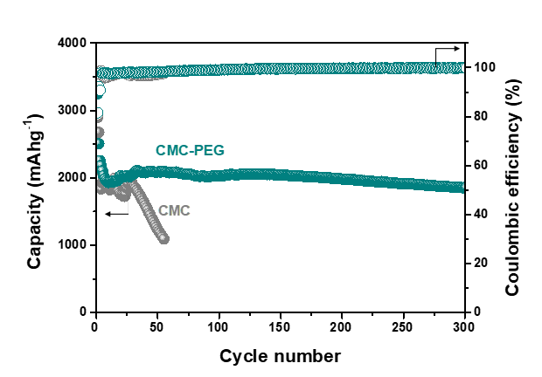
Figure 1. Cycling performance of the silicon electrodes prepared with CMC and crosslinked CMC-PEG binders at 0.5 C rate.
The crosslinked CMC-PEG binder is simply prepared during the electrode drying process without an additional process. In particular, the crosslinked CMC-PEG binder enables the improved and adhesion between active materials and a current collector, and cohesion between active materials. The silicon anode prepared with the crosslinked CMC-PEG binder exhibits stable cycling performance with a capacity of ∼2000 mAh g−1 over 300 cycles.
4. Conclusions
Crosslinked CMC-PEG binder was prepared by a facile and low-cost approach. The silicon electrode prepared with the CMC-PEG binder exhibited outstanding cycle performance over 300 cycles at 0.5 C. In terms of the simplicity, in situ crosslinked CMC-PEG binder has a potential to be applied to the silicon anodes for stable cycle performance of LIBs.

