Study of the correlation between the production of radicals OH and the radiative field in a photocatalytic reactor
Ana Gómez Llanos¹, Richard Ruiz Martínez¹, Ariadna Morales Pérez¹, Carlos Castillo Araiza¹
1 Laboratory of Reactor Engineering Applied to Chemical and Biological Systems. Chemical Engineering Area. Dept. of IPH. Autonomous Metropolitan University-Iztapalapa, Av. San Rafael Atlixco 186 Vicentina, C.P. 09340, Mexico City; 2 Affiliation and address
*Corresponding author: alexisgomez@xanum.uam.mx
Highlights
- Energy radiative balance.
- Production of hydroxyl radicals.
- photocatalytic efficiency.
- photocatalytic activity with different sources.

1. Introduction

It has been demonstrated that photocatalysis is efficient in the degradation of a wide range of organic pollutants present in water [1]. Although the potential advantages of using photocatalytic reactors in the degradation of refractory contaminants, there are still problems to face. One of the main problems is the lack of adequate radiation models, as well as kinetic models and design procedures to scale up photocatalytic reactors [2], [3]. The main deficiencies in heterogeneous photocatalysis are: i) that there are no studies describing kinetics and radiation adequately, ii) no in-depth study has been carried out on the production of hydroxyl radicals and their correlation with the radiative, iii) it is not known if the rate of formation of hydroxyl radicals depends on the wavelength with which the photocatalyst is activated, and d) there is no model that describes with certainty the process of production of hydroxyl radicals, and thus perform a scale up reactor. A lot of research still needs to be done about those topics, as the research that is done till now resulted in kinetics and optical parameters that included several phenomena such as hydrodynamics, mass transfer and radiation. In addition, no comparison between the use of different light sources and the obtained specific extinction coefficients has been made and no intrinsic kinetic study about the production rate of the •OH using titanium dioxide (TiO₂) as a catalyst was done.

2. Methods
A tubular photoreactor 10 cm length, 2.2 cm diameter where the suspended photocatalyst flows was used to get the experimental data
2.1 Radiative characterization
2.1.1 Calculation of the extinction coefficient
For the optical parameter, extinction coefficient of the catalyst, experiments were carried out irradiating with an external source (one LED in front of the reactor) to the reactor using the approximation of Beer-Lambert Law and the energy balance was calculated.
2.1.2 Isoactinic conditions
To achieve that the radiative energy was constant at different positions of the reactor, a strip of LEDs was placed around it, thus allowing to reach isoactinic conditions and avoid the change of the production of hydroxyl radicals at different positions inside the reactor.
2.2 Production of hydroxyl radicals
•OH radicals have a low stability and consequently a high reactivity. For this research, terephthalic acid was used to react with the formed •OH. This reactant reacts with •OH to form a highly fluorescent product 2-hydroxyterephtalic acid (2-HdA), fluorimetry is used to detect 2-HdA.
3. Results and discussion
the extinction coefficient can give an initial idea about the activation of photocatalysts, as the first result it was expected to be able to calculate the coefficient of intrinsic form (independent of the concentration of the catalyst) which was achieved when it is irradiated with wavelengths inside of the absorption spectrum of the material Figure 1a, on the other hand this parameter, since it does not depend on other phenomena.
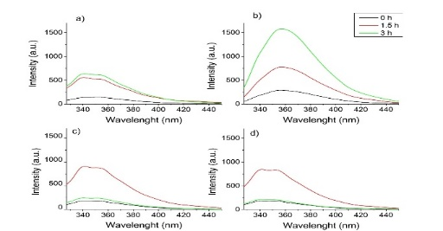
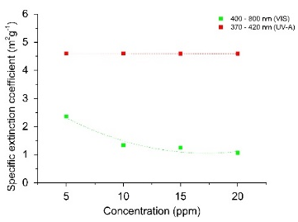
5 ppm
10 ppm
15 ppm
20 ppm
b)
a)

Figure 1. a) Specific extinction coefficients of 400-800 nm and 370-420 nm in front of the reactor, b) Production of 2-HdA after reaction (3 hours) between •OH and terephthalic acid with different TiO₂ concentrations.
The measured intensities of the 2-HdA are shown in function of the wavelength and corresponds to the formed amount of •OH. At 5 and 10 ppm of TiO2, the intensity of the formed 2-HdA increases over time and consequently also the produced •OH. when the solution passes for a longer time through the reactor, more catalyst particles are activated by the radiation source and the production increases Figure 1b.
4. Conclusions
Higher intrinsic specific extinction coefficient (4.6 m² g⁻¹) with purple LED, more absorption by TiO₂ whit the same LED, production of •OH is influenced by the catalyst concentration.
References
- M. Chong, B. J. (2010). Recent developments in photocatalytic water treatment technology: a review. Water research, 2997-3027.
- Li Puma, G. &. (2007). Dimenssionless analysis of slurry photocatalytic reactors using two flux and six flux radiation absorption scattering models. Catalysis Today, 78-90.
- Valades Pelayo P.J., J. M. (2014). Boundary conditions and phase functions in a photo-CREC Water-II reactor radiation field. Chemical Engineering Science, 123-136.

