Usage of Future Energy Market Scenarios for Assessing the Benefits of Residual Heat Recovery From a Chemical Cluster in Western Sweden.
Simon Harvey^{1,*}, Erik Axelsson², Thore Berntsson³, Johan Holm²
1 Energy Technology, Chalmers University of Technology, Göteborg, Sweden;
2 Profu AB, Göteborg, Sweden; 3 CIT Industriell Energi AB, Göteborg, Sweden;
*Corresponding author: simon.harvey@chalmers.se
Highlights
- 140 MW of residual heat are available at a chemical cluster in Western Sweden
- This heat could be delivered to the city of Göteborg, constituting the largest industrial residual heat recovery project in Sweden
- The costs and climate benefits are analyzed using energy market scenarios

1. Introduction
Over 50% of building heating requirements are covered by district heating in Sweden. Approximately 8% of the heat supply to district heating systems comes from residual heat from industrial processes. Many studies indicate that there is a potential to substantially increase this share, and a number of policies promoting energy efficiency and greenhouse gas emissions reduction are providing incentives to do this. Quantifying the medium and long term economic and climate benefits of such investments is difficult because the background energy system against which new investments should be assessed is also expected to undergo significant change as a result of the afore-mentioned policies. Furthermore, in many cases, the district heating system has already invested or is planning to invest in non-fossil heat sources such as biomass fueled boilers or CHP units. This paper illustrates usage of energy market scenarios for assessing the long term benefits of recovering residual heat from a chemical cluster located approximately 50 km from the city of Göteborg on the West Coast of Sweden and delivering the heat to the city’s district heating network which aims to be completely fossil-free by 2030.
2. Methods
Availability and costs for residual heat at the chemical cluster site were investigated in previous work [1] using pinch analysis tools. Piping costs for transporting the residual heat from the chemical cluster to the city’s district heating system were estimated from previous studies, as summarized in [2]. The impact of delivery of the residual heat on district heating system production costs and greenhouse gas emissions was performed using the method described in [3]. Energy carrier costs and carbon intensity factors were estimated for future energy market conditions using the ENPAC tool described in [4]. The energy market scenarios include energy prices for years 2030 and 2040 for two different scenarios based on the IEA’s World Energy Outlook 2017 [5]: New Policy (NewPol) and Sustainable Development (SustDev). The NewPol scenario reflects implementation of global policy announcements and plans, which is expected to lead to moderately increasing energy prices. The SustDev scenario reflects global commitment to sustainable development, resulting in high carbon dioxide prices, which we have extrapolated to also imply high biomass fuel prices.
3. Results and discussion
140 MW of residual heat are available at the chemical cluster. If recovered and transferred to the district heating in Göteborg, this would be the largest residual heat recovery project in Sweden. The total investment cost to collect 140 MW of residual heat and deliver it to the district heating system is approximately 3 billion SEK. Figure 1 shows the total costs for this investment compared with investment in a biomass-fired CHP plant with the same heat output. The direct climate consequences of using the residual heat are negligible for both the chemical cluster and for the district heating system. However, decreased use of biomass and decreased electricity production will affect the climate impact of the surrounding energy system. Assuming fossil-free grid electricity production in the future, the climate consequences of decreased electricity production in the CHP unit are also close to zero. Hence, decreased firing of biomass in the CHP unit is the main cause of climate consequences of residual heat recovery. Assuming that biomass will be a limited resource in the future, the released biomass can be used to further decrease the use of fossil fuels. In this case, the carbon dioxide decrease is approx. 200 ktonnes per year.
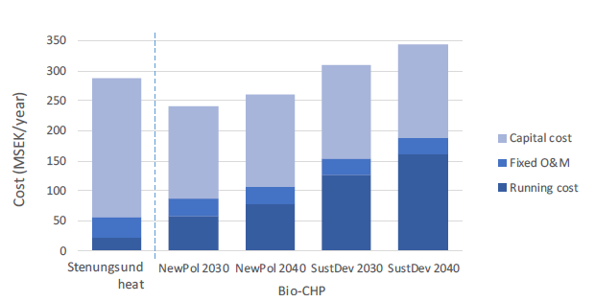
Figure 1. Total cost for residual heat from the Stenungsund chemical cluster and a bio-CHP plant, both delivering 140 MW heat and with about 5000 hours of yearly utilisation time.
4. Conclusions
There are many opportunities to substantially increase recovery of residual heat from industrial processes and clusters. Industry as well as the heating and power sectors are in a period of rapid transition due to ambitious energy efficiency and greenhouse gas emission reduction policy targets. As a result, new methods are necessary to understand the economic and climate consequences of recovering residual heat for use in the heating sector.
References
- L. Eriksson, M. Morandin & S. Harvey, Int J Energy Res. 2018;42:1580–1593
- E. Axelsson, T. Berntsson, S. Harvey & J. Holm, Nyttjande av industriell restvärme från Stenungsundsindustrierna som fjärrvärme, report, 2018, available at research.chalmers.se
- E. Ahlgren & E. Axelsson, The value of excess heat – profitability and CO₂ balances, in System Perspectives on Biorefineries, e-book, 2014, available at research.chalmers.se
- E. Axelsson & S. Harvey, Scenarios for assessing profitability and carbon balances of energy investment in industry, AGS Pathways report 2010:EU1, Göteborg, Sweden, 2010
- International Energy Agency, World Energy Outlook 2017, Paris, France, 2017

